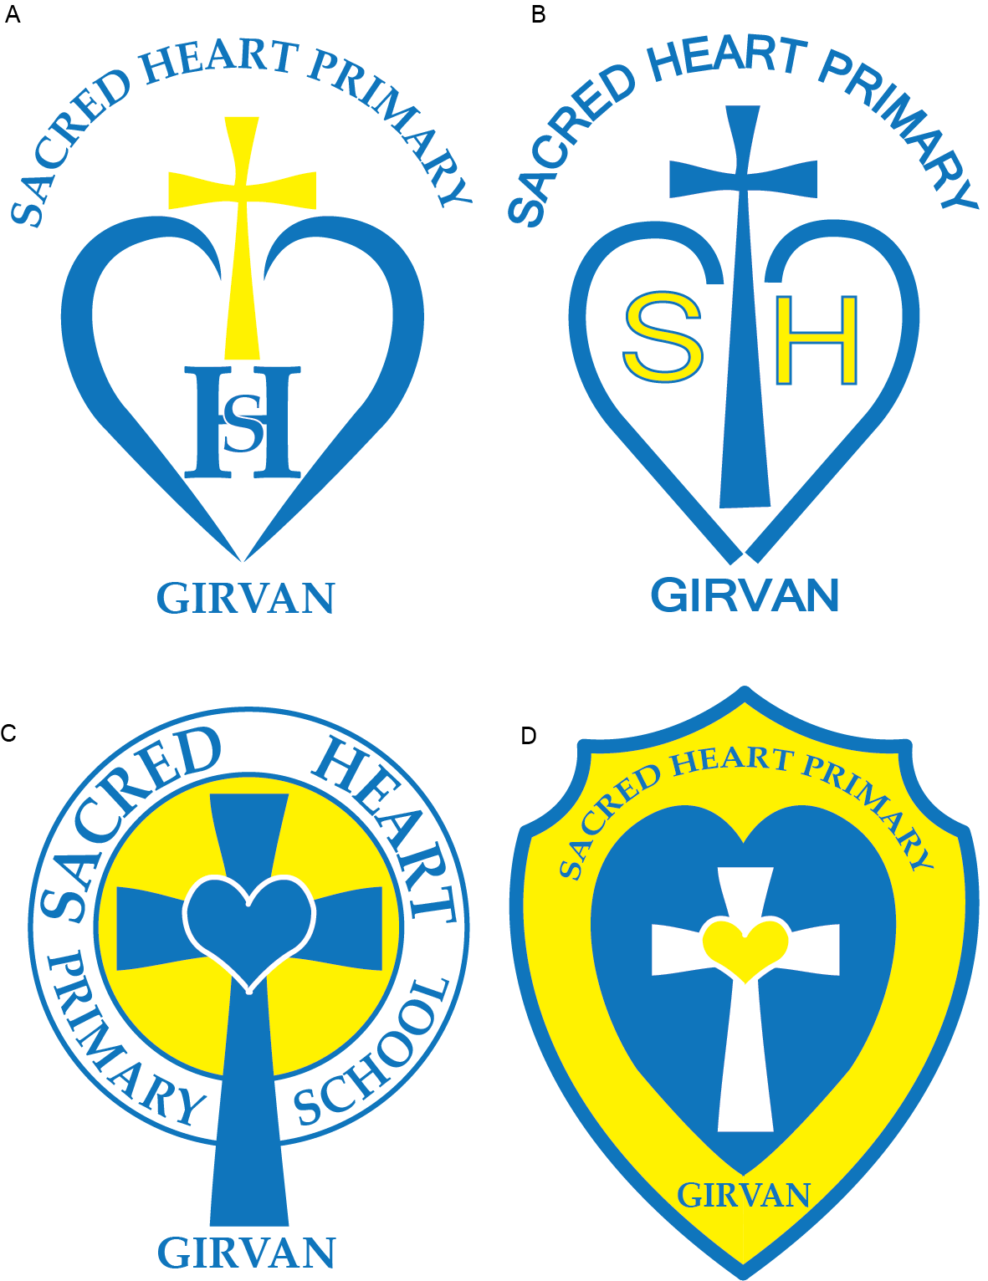

Sacred Heart Primary School
School Improvement Plan 2025/2026






Article 28 Every child has the right to an education.
Article 3 The best interests of the child must be a top priority in all things that affect children

Local and National Improvement Objectives Key Performance Indicators – NIF and HGIOS
National Improvement Framework Priorities | Improvement in attainment, particularly in literacy and numeracy Closing the attainment gap between the most and least disadvantaged children
Leadership and Management | 1.1 Self-evaluation for improvement 1.2 Leadership of learning 1.3 Leadership of change 1.4 Leadership and management of staff/practitioners 1.5 Management of resources to promote equity
Learning Provision | 2.1 Safeguarding and Child Protection 2.2 Curriculum 2.3 Learning, Teaching and assessment 2.4 Personalised Support 2.5 Family learning 2.6 Transitions 2.7 Partnerships
Success and Achievements | 3.1 Improvement wellbeing, equality and inclusion 3.2 Raising attainment and achievement/ Securing children’s progress 3.3 Increasing creativity and employability
NIF Drivers | Performance Information Assessment of Children’s Progress Teacher Professionalism School Leadership School Improvement Parental Engagement
South Ayrshire  Council Plan | - Services and Places  - Live Work, Learn  - Civic and Community Pride
Children’s Services Plan | - The Promise: Our commitment to Keeping the Promise  - Family: Promoting whole family wellbeing  - Included: Early help for children with diagnosed or undiagnosed additional support needs  - Healthy: Improving physical and mental health for children and young people  - Voice: Involving children and young people in local decision making  - People: Collaborative learning and reflection opportunities for the workforce
Education Services Priorities | - Engaged and Included  - Outstanding learning, teaching and assessment  - Developing our curriculum  - Self Improving Service
National Improvement Framework Priorities | - Placing the human rights of every child and young person at the centre of education  - Improvement in children and young people's health and wellbeing  - Closing the attainment gap between the most and least disadvantaged children and young people  - Improvement in employability skills and sustained positive school leaver destinations for all young people  - Improvement in attainment, particularly in literacy and numeracy

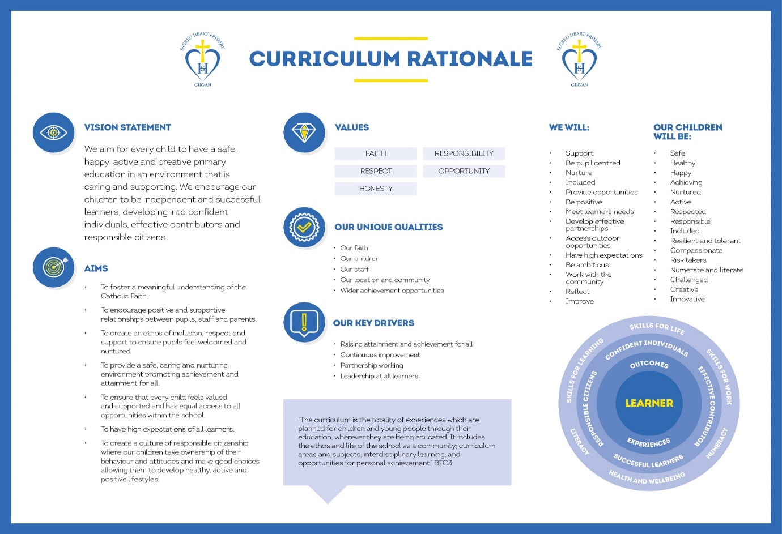
Pupil Equity Fund
This year the Scottish Government allocated £44100 to the school as PEF funding. The plan for this is robust and clearly identifies the supports to be put in place for those children that are entitled to this support.
It primarily supports children’s health and wellbeing, readiness to learn and happiness; providing opportunities for the children identified to achieve socially, emotionally and academically.
Raising attainment and reducing educational inequality is fundamentally our aim. At Sacred Heart Primary, we strive to achieve this by providing our families and young people with the best possible opportunities to succeed.
Below is an overview of how we intend to use our Pupil Equity Funding to support improvement:
Intervention
Education welfare officer to track the attendance of all children within the PEF cohort
Additional Principal Teacher to ensure an enhanced provision of Pupil Support coverage across the school
Support Assistant to support the provision of the School’s Breakfast Club and support across all classes.
Swimming and Lifesaving Skills to improve the physical and mental wellbeing of all children and develop crucial life-saving skills.
Literacy training and Literacy/Numeracy intervention resources to support improvements in literacy and numeracy outcomes for all children.

Cost of the School Day Resources and Family Support to support the wellbeing needs of parents and carers and help create a positive, stable foundation at home, which in turn supports better outcomes for children in school.

Overview of Sacred Heart Primary Priorities 2025/2026

Priority 2

Priority 1
Priority 3

3.1 Ensuring Wellbeing, Equality and Inclusion

2.3 Learning, Teaching and Assessment

2.2 Curriculum

Developing as a community of Faith and Family Learning

Adaptive Teaching
Talk for Writing

Review of Assessment Approaches
South Ayrshire Reads

Curriculum Design
Maintenance Agenda

Priority 1: 2.2 Curriculum
To improve attainment in Writing and Reading
To prioritise learner and teacher agency through Curriculum Design

South Ayrshire plan: Live, Work, Learn
Children’s Services Plan: Included
Education Services Plan: Outstanding learning, teaching and assessment/ Developing our Curriculum
National Improvement Framework: Improvement in attainment, particuarly in iteracy/ Closing the gap between the most and least disadvantage
Priority | What Outcomes Do We Want to Achieve? | How Will We Achieve This?  (Intervention Strategies) | Lead Person | End Date | How Will We Measure Impact on Children and Young People?  (Include Where Possible Current Measure and Target)
1 Writing  Continue to develop and embed Talk for Writing strategies to strengthen the teaching of writing across the school.  2 Reading  Continue to collaborate with the South Ayrshire Reads Team to enhance the school’s reading approach and better meet the diverse needs of all learners. | Improvement in attainment in writing through a well-planned, progressive literacy programme (Talk for writing)  Children in most deprived and disadvantaged background will make progress from their previous levels of attainment in Writing.  Learners will develop greater confidence in writing as they successfully plan, manage, and complete a range of writing tasks.  Improvement in attainment in reading through a well-planned, progressive literacy programme that is steered by South Ayrshire Reads priorities.  Children in most deprived and disadvantaged background will make progress from their previous levels of attainment in Reading.  Children will experience a progressive programme that supports continuous development and deepens reading skills over time.  - Confidence in Reading  - Enjoyment of Reading | Cluster writing leads to remain role and work alongside staff to lead priorities and moderation.  Cluster short and long-term planning to ensure progression and effective moderation based on Talk for writing spines.  New staff to be trained on Talk for Writing and permanent members of staff to continue engaging in Talk for Writing refresh training coordinated by writing lead.  Staff use GL, SNSA and school-based assessments with professional dialogue to identify reading next steps for individual children. Create tests of change that highlight any supports required.  Build upon What Makes a Good lesson.” Using Bruce Robertson, the Teaching Delusion  Cluster Online Toolkit continued for all staff to access and add to.  P1-7 staff to work collaboratively with cluster colleagues to engage in adaptive teacher priorities that can align with cluster writing observations.  Parent Session for Talk for Writing to support parents understanding of the approach to teaching in these areas.  Continue Photo Friday and encourage enjoyment and creativity.  Celebrate success of the writing culture in each class with pupils leading and sharing their writing interests.  Use ICT devices to enhance evidence gathering of writing and increase learner interests.  SEE SOUTH AYRSHIRE READS PLAN  Undertake baseline phonics assessments for all children in P2 & P3 and use to inform future planning for individuals and groups of children.  SAR Team to support process and meetings throughout session scheduled for staff CLPL and class visits from SAR team.  Data rich school and staff – discussions in place with all stakeholders to target specific support in all classes.  Continue Reading Wise Decoding, Vocab and Comprehension for identified learners to close attainment gap in reading.  Staff use GL, SNSA and school-based assessments with professional dialogue to identify reading next steps for individual children. Create tests of change that highlight any supports required.  Support from Ed Psych to ensure target question for professional enquiry is focused enough and appropriate baseline assessments are used.  Pupil Support Teacher to assist School Assistant Training in Catch Up Literacy and 5-minute Literacy boxes.  Ensure Communication Friendly strategies are in place.  After school family workshops and curricular evenings.  Streamline reading resources to include Bug Club decodable books, Phonics International, Bug Club fiction/non-fiction and Class Novels.  Partnership with Reading Schools and journey to achieve Gold Accreditation  Continue to develop school library and maintain strong links with local librarian for in-school support and access to town library. | S Swan  Hilary Bowie  Daniella Mancini  Linzi Richardson  S Swan  Hilary Bowie  Daniella Mancini  Linzi Richardson  J McPeake  L May  RMcCallum  R Patterson  S Swan  Hilary Bowie  Daniella Mancini  Linzi Richardson  All Staff  All Staff  S Swan  Hilary Bowie  Daniella Mancini  Linzi Richardson  All Staff  J McPeake  L May  RMcCa  LMcK  AG  All Staff  RMcC/ LMcK  LMcK  AG  All Staff  RMcC  LMcK  AC  RMcC/ LMcK  AG  AG  All staff | June 2026  June 2026  Aug - June  Aug - June  Aug - June  Aug - June  Aug - June  Aug - June  June 2026  June 2026  Aug - June  Aug - June  Aug - June  Aug - June  June 2026  June 2026 | Writing Attainment:  Baseline assessments (T4W cold tasks) will provide staff with information to support professional judgements and writing planning.  Tests of change to identify impact and form basis of accountability discussion in attainment meetings.  - T4W Assessment each term  COLD and HOT  - SNSA  P4 and P7 – December  P1 May  - GL Progress English: May  P3 and P6 (online)  P2 and P5 (paper)  - Holistic assessments in Term 1, 2 and 3  Resources:  - Talk 4 writing school texts.  - Teaching spines  - Shared texts amongst schools – glow sharing Talk 4 Writing tile.  - Power Up Pedagogy  Parent surveys and feedback responses  Pupil attitudes survey to writing.  Cluster Photo Friday Sharing initiatives.  Reading Attainment:  Baseline assessments will provide staff with data to support professional judgements and planning.  Initial baselines and tests of change to identify impact and form basis of accountability discussion in attainment meetings.  SAR Phonics Assessment Screener June 2025  - SAR Phonics Assessment each term (see plan)  - SNSA  P4 and P7 – December  P1 May  - GL Progress English: May  P3 and P6 (online)  P2 and P5 (paper)  - Holistic assessments in Term 1, 2 and 3  Pupil attitudes survey to reading.  5-minute box, ReadingWise, Catch Up targeted interventions used across the school – feedback from pupil, support assistant and teacher.  Curriculum walls used to moderate across the whole school for pupils and staff to see the progression within their learning.  Communication Friendly baselines and tracking progress records.  Parent Surveys and Feedback boxes.  SLT/ peer observations and feedback linked to the teaching of Reading  Staff feedback on SAR training  HIGIOS self-evaluation document – themes 2 and 5 – Pupils and staff  Feedback from pupil Surveys  Achieve Gold Level Reading Schools
  WRITING - CFE – Attainment over time (%)
   | P1 | P4 | P7
  2020/2021 | 93.3 | 56.3 | 50
  2021/2022 | 92 | 69 | 63
  2022/2023 | 82 | 64 | 88
  2023/2024 | 89 | 67 | 77
  2024/2025 | 85 | 70 | 78
  Stretch Aim  2025/2026 | 88 | 80 | 80
  Writing - CFE – PEF identified learners
  20204/2025 | 60%
  Stretch Aim  2025/2026 |  | 68%
  Reading - CFE – Attainment over time (%)
   | P1 | P4 | P7
  2020/2021 | 93.3 | 75 | 60
  2021/2022 | 92 | 72 | 63
  2022/2023 | 82 | 64 | 88
  2023/2024 | 100 | 80 | 82
  2024/2025 | 85 | 77 | 78
  Stretch Aim  2025/2026 | 88 | 80 | 80
  Reading - CFE – PEF identified learners
  20204/2025 | 76%
  Stretch Aim  2025/2026 |  | 81%

Sacred Heart and St Cuthbert’s
Improvement Planning 2025-2026 PHASE 2 SCHOOLS / CENTRES

Education Services Improvement Plan Priority 2: Outstanding Learning, Teaching and Assessment Education Improvement Plan 2023-2026)
SAR Strategic Plan Priority: To raise attainment in literacy and to significantly reduce the reading attainment gap between the most and least disadvantaged children and young people in South Ayrshire SAR Strategy 2023-2026
PHASE 2 SOUTH AYRSHIRE SCHOOLS
2025-2026
SAR Strategic Aim | Actions | Intended Impact | Resources | SAR Lead | Completion  Date
To develop confident and skilled readers in South Ayrshire with a lifelong love of reading and the confidence to access all aspects of education, culture and society  To support and develop all education staff in South Ayrshire to implement best practice through a culture of shared knowledge, collaboration and enquiry  To promote the implementation of an excellent reading curriculum which prioritises best practice, challenge and adapted teaching for children with additional support needs  To gather, use and analyse data effectively to drive change and improvement in children’s reading skills, reading confidence and reading attainment | By June 2025, ALL schools will have reviewed the role of their reading leader and, in collaboration with the South Ayrshire Reads team, planned how this role will be used to support reading development over the coming year. | The aims of South Ayrshire Reads are beginning to embed across Phase 2 School Communities  The values, vision and aims of  South Ayrshire Reads  is consistent and clear to all stakeholders | - Role of reading leader reviewed at planning meeting.  - Reading leader workshop dates agreed. | SAR PTs | June 2025
 | By June 2026, ALL Phase 2 schools will have participated in at least two reading leader-led workshops within their own setting, supporting the ongoing development of reading practice. |  | - All Reading Leaders may attend four half-day sessions (September 2025, November 2025, January 2026, and April 2026) focused on building capacity and providing the knowledge and skills needed to lead impactful reading workshops within their own schools—both with staff and with parents—as part of a wider drive to raise attainment in reading. | LW | June 2026
 | By June 2026, ALL Phase 2 schools will have had the opportunity to engage in collaborative activity—whether through partnership CLPL, as part of the Phase 2 cohort, or via peer school visits—to strengthen collective efficacy and support an outward-looking approach to improvement. |  | - Phase 2 collaborative launch – August in-service May 2025  - Bespoke partnership CLPL responsively planned and reviewed in line with contextual needs.  - Meeting & discussion with SLT around peer school visits  - Peer visit pre-workshops/discussion/observation guides | HM/LW/  JW/JM | June 2026
 | By August 2025 Phase 2 schools will identify new or returning staff who require catch-up sessions and will have the opportunity to develop a clear plan, in collaboration with the SAR Team, ensuring all staff have the necessary knowledge and skills to support reading development effectively. |  | - Phase 2 schools will complete a simple MS Form, identifying new/returning members of staff and their stages  - Catch-up sessions agreed & planned by SAR Team  - Phase 2 schools to identify existing members of staff to support this through coaching/modelling | HM/JW/  JM/LW | August 2025
 | By June 2026 ALL Phase 2 education staff will have had the opportunity to engage in bespoke high-quality CLPL. |  | - All CLPL based on Science of Reading, with particular focus on language comprehension whilst embedding previous work on phonics & fluency. | LW/HM/  JW/JM | June 2026
 | By June 2026 ALL Phase 2 education staff will have had the opportunity to engage in additional high-quality CLPL in an area of interest. |  | - Additional sessions planned, created and delivered by SAR Team such as, Critical Literacy, Disciplinary Literacy, Play-based Literacy and Debating  - Additional sessions will be advertised through the monthly CLPL Bulletin | SAR Team | June 2026
 | By June 2026 ALL Phase 2 education staff will have had the opportunity to develop their practice in collaboration with the SAR team. |  | - Collaboration activities include workshops; professional discussions; coaching sessions; model videos | SAR Team  HM/LW  JW/JM  SL  HM  JMc | June 2026  June 2026  June 2026  June 2026
 | By June 2026 ALL Phase 2 schools will have had the opportunity to engage with assessment implementation and data analysis |  | - Access to CLPL sessions focussed on interpretation, analysis and evaluation of their learner attainment to measure impact and determine next steps. | SAR Team  HM/LW  JW/JM  SL  HM  JMc | June 2026  June 2026  June 2026  June 2026
 | By June 2026 ALL Phase 2 schools will have had the opportunity to engage with and access support to implement and embed additional related SAR priorities |  | - Reading Schools Accreditation  - Communication Friendly Environments  - Developing Writing through SAR | SAR Team  HM/LW  JW/JM  SL  HM  JMc | June 2026  June 2026  June 2026  June 2026
 | By June 2026 ALL parents will have had further opportunity to engage with workshops and learning sessions based on supporting their child’s reading development. |  | - Reading Leader will attend SAR led session prior to delivery of Parent Engagement Workshop  - Notification and access to authority SAR family engagement session / resources | Reading Leaders  SL | June 2026  June 2026  June 2026  June 2026

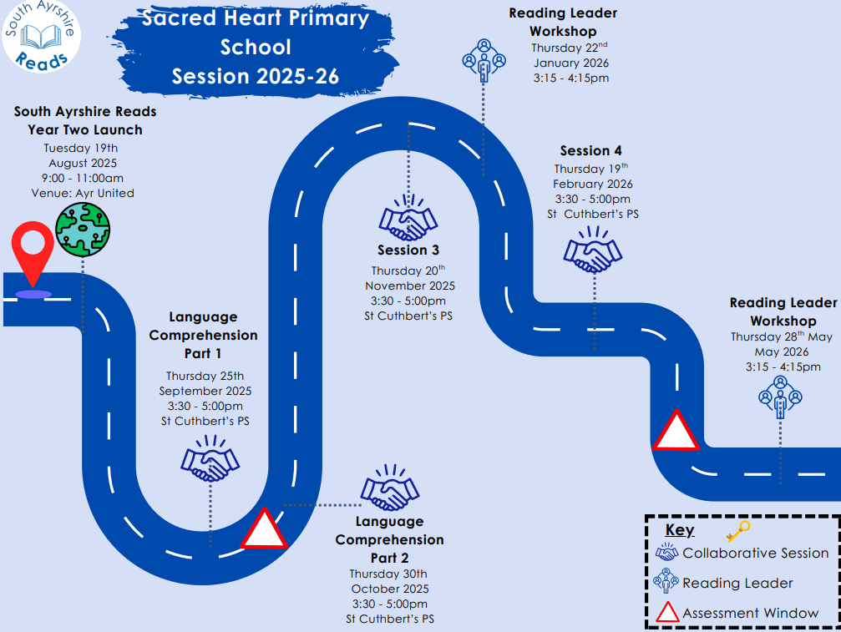

Priority | What Outcomes Do We Want to Achieve? | How Will We Achieve This?  (Intervention Strategies) | Lead Person | End Date | How Will We Measure Impact on Children and Young People?  (Include Where Possible Current Measure and Target)
Priority 1: 2.2 (continued)  3 Curriculum Design  All stakeholders work in partnership to design and deliver a context focussed and engaging curriculum that promotes creativity, challenge and enjoyment in learning. | All learners can access a curriculum that is tailored to their creative needs and be reflective of meaningful and contextual experiences. | DHT to develop learner agency. Time to consult with staff and pupils about their interests, challenges and make appropriate links with partners in our local context.  Protected time in WTA for staff to work collaboratively to develop the curriculum and consider its impact on pupils.  Staff to review current meta-skills programme and make appropraiet links with partners. Link with elective stimetabe where staff can utilse time effectively.  Parents and carers to be consulted on curriculum priorities and share local knowledge/context in support of curriculum design, | LMcK  All Staff  All Staff | Jan-June 2026  Jan-June 2026 | Pupil Surveys  Parent Surveys  Staff consultation/feedback sessions  Open afternoon - link with DYW  Parental Engagement Survey  2024/2025  68% interested in finding out more about curricular priorities and understand more about their child’s learning.  76% parents are keen to participate in curricular sessions with their child.  Session 2025/2026  Include parents in curricular consultation and take forward views. Monitor feedback cards and surveys.

Priority 2 : 2.3 - Learning, Teaching and Assessment
To improve our approaches to differentiation/adaptive teaching in our classrooms ensuring we meet the needs of all learners
To improve outcomes for al learners by ensuring all assessment procedures are robust and consistent

South Ayrshire plan: Live, Work, Learn
Children’s Services Plan: Included, Voice an
Education Services Plan: Outstanding learning, teaching and assessment/ Developing our Curriculum
National Improvement Framework: Improvement in attainment/ Closing the gap between the most and least disadvantage
What Outcomes Do We Want to Achieve? | How Will We Achieve This?  (Intervention Strategies) | Lead Person | Start and Finish Dates | How Will We Measure Impact on Children and Young People?  (Include Where Possible Current Measure and Target)
South Ayrshire Service Plan Priority 2: Outstanding Learning, Teaching and Assessment
Priority: 1
To improve our approaches to differentiation/adaptive teaching in our classrooms ensuring we meet the needs of ALL our learners.

ALL SOUTH AYRSHIRE SCHOOLS 2024-2025
Aims | Actions | Intended Impact | Resources | Measures | Completion  Date
To increase all teaching staff’s understanding of the benefits of adapting planning, teaching and assessment to meet the needs of their learners.  To enhance all teaching staff’s confidence of how to adapt planning, teaching and assessment to meet the needs of their learners.  To evidence an increase in the use of adaptive teaching strategies to meet learner’s needs through observations of teaching practice.  To indicate some improvement in the learning experience using feedback from a group of learners. | Initial meeting with SAL Team to plan 4 Inputs and 2 Sharing Sessions.  Key Lead(s) to be identified and meet SAL Team to establish role and responsibilities. |   Plan effectively to meet learners’ needs:  Identify the potential barriers to learning and plan differentiated and appropriately challenging learning experiences to ensure learning is accessible for every learner. | Adaptive Teaching Programme: Commitments. | Staff survey (pre and post).  Learner Survey (pre and post).  Learner Focus Groups (pre and post).  Classroom observation notes, feedback (peers, SLT, SAL).  Staff professional development and review process.  Staff planning and evaluation documents.  Analytics from shared online space (comments, resources, access to the tool kit and materials).  Tracking data on learner progress.  Assessment data – summative and formative including teacher professional judgement. | June 2025
 | All baseline surveys will be carried out: learners and staff online surveys and Learner Focus Groups by Key Lead(s) and SAL Team. SAL Team will collate all baseline data, produce a report, and share with Headteacher. |  | Microsoft Form: staff survey and learner surveys.  WEE HGIOS Learner Focus Group questions. |  | September 2025
 | All teachers read, discuss, and reflect on article: Adaptability: An important capacity for effective teachers – Collie and Martin (2016) before to Input 1. |  | Article – Adaptability: Collie and Martin (2016). |  | August/September 2025
 | All teachers:  - attend Adaptive Teaching Input 1: The Adaptive Learning Environment.  - Share and celebrate good practice - Whole school self-evaluation: What are we doing well?  - Introduced to Thinglink of resources to support self-evaluation and professional learning. |  | Adaptive Teaching Thinglink. |  | September 2025
 | Test of Change  All teachers:  - complete Self-evaluation Checklist with another colleague.  - explore the Thinglink/use WEE HGIOS to consult their learners.  - identify an adaptation using self-evaluation checklist and learner consultation.  - complete the Adaptive Learning Environment Planning Template.  - put adaptations in place.  Key Lead to complete the Planned Adaptation Tracker and share with SAL Team.  SAL Team visit. |  | The Adaptive Teacher Self-Evaluation of Classroom – Checklist.  The Circle Framework and the Inclusive Classroom.  The Adaptive Teacher – Planned Adaptation Tracker |  | November 2025
 | Sharing Session 1  Key Leads/HT identify members of staff to present good practice.  All teachers:  - attend Sharing Session.  - complete Self-Evaluation: Stop/Start/Continue Reflection Sheet |  | Stop, Start, Continue – Self-evaluation sheet. |  | November 2025
 | All teachers:  - complete Scaffolding Self-evaluation sheet.  - attend Adaptive Teaching Input 2: Scaffolding (visual, verbal, written and concrete).  - Share and celebrate good practice: Whole school self- evaluation: What are we doing well?  - To develop an area of scaffolding. |  | The Adaptive Teacher Self-evaluation Sheet: Scaffolding  The Adaptive Teacher Thinglink. |  | November 2025
 | Test of Change  All teachers  - complete the Adaptive Learning Scaffolding Planning Template.  - develop an area of scaffolding in their class to support/challenge their learners.  Key Lead to complete the Planned Adaptation Tracker: Scaffolding and share with SAL Team.  SAL Team visit. |  | Scaffolding Posters.  The Adaptive Teacher Thinglink.  Adaptive Learning Planning Template – Scaffolding.  Planned Adaptation Tracker: Scaffolding. |  | February 2026
 | All teachers:  - attend Adaptive Teaching Input 3: Supporting Highly Able Learners.  - Share and celebrate good practice - Whole school self-evaluation: What are we doing well?  - Identify an area of development. |  | The Adaptive Teacher Thinglink.  Highly Able Learners Top Tip Poster. |  | February 2026
 | All teachers:  - attend Adaptive Teaching Input 4: Digital OR Bespoke  - Share and celebrate good practice - Whole school self-evaluation: What are we doing well?  - Identify an area of development. |  | The Adaptive Teacher Thinglink. |  | March 2026
 | Test of Change  All teachers  - complete the Adaptive Teacher Planning Template: Highly Able Learners/Digital  - focus on challenging highly able learners/embed the use of digital tools to meet the needs of learners.  Key Lead to complete the Planned Adaptation Tracker: Highly Able Learners/Digital and share with SAL Team.  SAL Team visit. |  | The Adaptive Teacher Thinglink.  Planned Adaptation Tracker: Highly Able Learners/Digital.  Adaptive Teacher Planning Template: Highly Able Learners |  | May 2026
 | Sharing Session 2  Key Leads/HT identify members of staff to present good practice.  All teachers:  - attend Sharing Session.  - complete Self-Evaluation: Stop/Start/Continue Reflection Sheet. |  | Stop, Start, Continue – Self-evaluation sheet. |  | May 2026
 | Complete all post surveys: learners and staff online surveys a  Key Lead and SAL Team to complete Learner Focus Groups.  SAL Team to collate all endline data, produce a report and share with Headteacher.  HT/SAL Team use report to inform SQR/SIP for 2026-27. |  | Microsoft Form – staff and learner surveys.  WEE HGIOS Learner Focus Group questions. |  | June 2026

Priority | What Outcomes Do We Want to Achieve? | How Will We Achieve This?  (Intervention Strategies) | Lead Person | End Date | How Will We Measure Impact on Children and Young People?  (Include Where Possible Current Measure and Target)
Priority 2: 2.3  2 Assessment  Continue to improve the quality of assessment approached through collegiate working and shared practice.  Prioritise planning and moderation of literacy and numeracy assessment and develop teacher confidence in handling and tracking data. | Learners will experience a range of literacy and numeracy assessment that are progressive and high quality.  Learner’s progress will be tracked more robustly as staff become even more confident in their understanding of effective moderation.  All staff will manage and engage in professional dialogue about data tracking. | SLT to drive forward evaluation tasks that identify assessment gaps and strengths.  Review and refresh assessment overview.  Ensure a more consistent approach to the content and management of assessment folders.  Support all staff on identifying test of change priorities from standardised assessments.  Create opportunities for staff to engage in moderation tasks in school and across the cluster.  Facilitate data-focussed dialogue sessions that promote collaborative reflection, shared understanding, and informed decision-making.  Support all staff in using and understanding the tracker. | LMcK  RMcC  LMcK  RMcC  All Staff  All Staff  All Staff  AS | Jan-June 2026  Jan-June 2026 | Teacher professional judgement  Assessment Evidence:  SNSA  GL  SAR  Holistic  Pupil Surveys  Cluster Feedback Sessions  HGIOS evaluations

Priority 3: 3.1: Ensuring Wellbeing, Equality and Inclusion
Developing as a community of faith and family learning
South Ayrshire plan: Live, Work, Learn
Children’s Services Plan: Family, Voice and Healthy
Education Services Plan: Engaged and Included
National Improvement Framework: Placing the human rihts of every child and young person at the centre of education
Priority | What Outcomes Do We Want to Achieve? | How Will We Achieve This?  (Intervention Strategies) | Lead Person | Start and Finish Dates | How Will We Measure Impact on Children and Young People?  (Include Where Possible Current Measure and Target)
Cluster Focus  Partnership with parents | Improved communication with targeted parents  groups, leading to increased engagement.  Almost all parents feel more informed about their child’s learning. | Parent Council events throughout the year such as Christmas Fair/Summer Fair.  Parent Prayer Breakfast during Catholic Education Week and Lent.  Parent and child meetings – Sacramental and Pope Francis  Pope Francis Faith Award  Cluster Carols by Candlelight – 9th December 2025 (Aid to the Church In Need as chosen Charity)  Family Mass once a month with pupils leading liturgical aspects and Family coffee morning afterwards. | Rachael (Sacred Heart/St. Cuthbert’s)  Rona (St John’s)  Jackie(St Ninian’s)  Lynsey (St Pat’s) | Aug-June | Parent Surveys  Increased attendance at parent workshops with access to feedback board.  Increased number of children achieving Pope Francis Faith Award + Parish Commendation
Develop an Inclusive Ethos. | To develop pupil’s strategic participation in policies which are based on gospel values and promote human dignity.  Almost all P7 pupils to develop leadership skills, leadership, including the religious life of the school. | Playground Leaders to support younger Children.  Visit from Gerard Gough from Missio to share the Mission pledge and promote the Gospel values.  Pupil Faith Group to meet with Cluster Pupil Voice Group to discuss fundraising initiatives (MISSIO) and shared faith focus. Teams Meet, 4th September 2.00pm  Follow through meeting on Thursday 12th February ahead of Lenten Fundraising events.  Final Pupil Voice Meet following Fundraising - Thursday 30th April, 10.00am. Mass and Feedback session. (Gerard from Missio)  P6 and P7 Pope Francis Faith Award Launch - Cathedral. 25th September 2025.  Pupils to lead assembly – sharing common goals and the gospel values they have demonstrated. | R.P (St John’s) L.M (ST. Pat’s),  R.McC (St. Cuthbert’s)  R.Mc (Sacred Heart)  J.McP (St. Ninian’s) | Aug-June | Children feel supported through Playtimes and lunchtimes by peers or buddies – pupil focus group.  All P7 pupils to achieve Playground High Five Award  Feedback from School assistants  Pupils can demonstrate the gospel and school values through their involvement in pupil focus groups and when leading school assemblies.  P6 and P7 pupils will demonstrate their active involvement with the values centred around the Pope Francis Faith award. Cluster Verification session will measure success.
CLPL and development of staff | Almost all staff deepen their understanding of and enhance their contribution to the mission of the Catholic school through CLPL. | Input from Barbera Cooper (SCES) on the call to Catholic Teaching.  Staff retreat at Bishop’s House to start Catholic Education Week. Include colleagues from SCES with the focus being Building a Community of Faith.  School Chaplain working alongside staff to share the role of Chaplain and support the development of teacher’s contribution to the mission of Catholic schools.  Cluster HT’s to work together to identify CLPL opportunities for staff and opportunities for spiritual development.  Launch of new RE Planners during in-service day.  Gods loving plan to be delivered to all classes from P1-7 – Staff training required for new teachers – SCES training calendar. | J.W (St. John’s)  N.McN (St Ninian’s) L.M.+ A.M (St. Patrick’s)  R. McC (St Cuthberts + Sacred Heart) | Aug-June | All classes to understand that we are made in Gods Image.  Shared Policy focused on positive relationships.  Chaplain surveys.  Attendance at CLPL events (on line and in person)  Staff evaluations and feedback.

Ongoing Whole School Maintenance Agenda 2025/2026

To Improve attainment in Numeracy:  - Continue accessing WRM toolkit and workbooks. Link with WRM training.  - Continue CPA resources and methods are accessed by all.  - Update ‘The Sacred Heart Way’ Numeracy Policy  - Work alongside Authority Numeracy Lead to engage in evaluative and CLPL sessions. | RMcK  AT  All staff
  NUMERACY - CFE – Attainment over time (%)
   | P1 | P4 | P7
  2024/2025 | 85 | 77 | 81
  Stretch Aims  2025/2026 | 89 | 85 | 84
Readiness for Learning Priorities:  - To continue developing strategies and practical applications for children and families to help them become healthy, happy and included.  - Signposting children and families to wider services through continued partnership with the CLD team and Thriving Communities.  - Continue to strengthen and evaluate the reduction on costs of the school day with parent consultations.  - Extend Family Breakfast Club sessions to support all families and include active timetable. | RMcC, LMcK, LR
An improvement in the social and mental wellbeing of all learners:  - Nurture/Lego Therapy sessions to targeted groups of children.  - Ensure all Young Carers are given opportunities to access all experiences and are fully supported.  - Pupils identified using the Boxall Profiles, Staged Intervention paperwork and professional dialogue with teachers.  - Staff Emotional Wellbeing Champion identified and trained with Educational Psychologist.  - Staff to continue developing an awareness and understanding of The Promise and all that is included within the national guidance and local authority initiatives, | LMcK  LR  All staff
Improving self–confidence, self-esteem and resilience in all our young learners:  - Every child to be given musical instrument tuition across the session.  - All children to be given blocks of swimming.  - Pupil voice groups to take a lead role in consulting with peers, staff, Parent Council and parents and feedback through school newsletter (Heart Herald) and Twitter.  - Maintain Gold RRS principles and practice throughout the school.  - Wider achievement tracked and celebrated.  - VE80 Day Culture Project | MG  LR  All staff  SE
To improve and sustain the attendance of targeted pupils:  - Attendance monitored weekly by SLT using South Ayrshire management guidance on attendance. Maintain strive for 95% campaign.  - Education welfare officer to track the attendance of all children within the PEF cohort.  - Use the request for assistance process to access supports for families who require outside agency support. | LG  LMcK  RMcC

