Animated Learning Resources – Promoting Children and Young People’s Mental Health and preventing Self Harm and Suicide
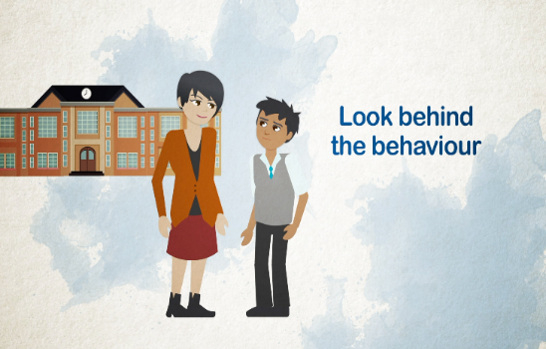 | 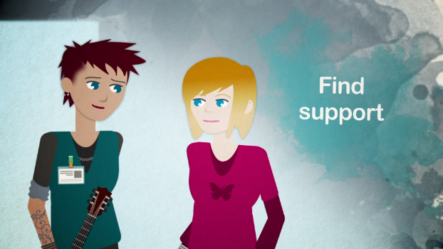 | 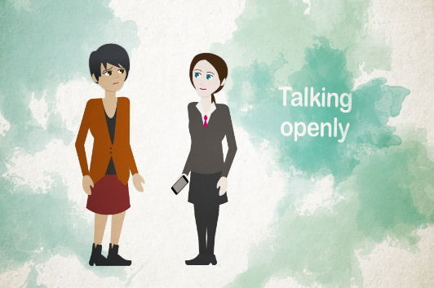
Scotland’s suicide prevention action plan, Every Life Matters sets out the ambition of developing learning resources on mental health improvement and suicide prevention for the wider public workforce. NHS Education for Scotland (NES) and Public Health Scotland (PHS) work in partnership to realise this action.
Following the success of the 2019 ‘Ask, Tell’ series of Mental Health and Suicide Prevention animations, a further series has been co-produced by NES and PHS to support learning about mental health, self-harm and suicide prevention specifically for the Children and Young People’s workforce.
These will add to the knowledge and skills of those in health, social care and the wider public sectors and who need to be informed about mental health, self-harm and suicide prevention in relation to children and young people. All of this aligns with the informed level of the Knowledge and Skills Framework for Mental Health Improvement, Self-Harm and Suicide Prevention Framework.
https://learn.nes.nhs.scot/Search/SearchResults?Type=Learning%20site&searchterm=Mental%20health%20improvement%20and%20suicide%20prevention%20framework&page=1
These new resources will help workers to understand the factors that influence mental health and resilience in children and young people; engage proactively with children and young people about mental health, self-harm and suicide; and recognise when to seek help to support those in their care.

The animations can be accessed via the NES Turas Learn platform and are titled:

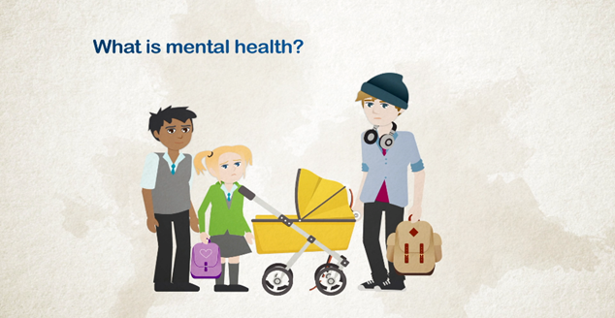 | 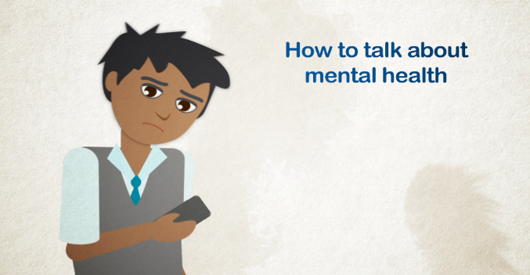
What is Mental Health | How to Talk About Mental Health
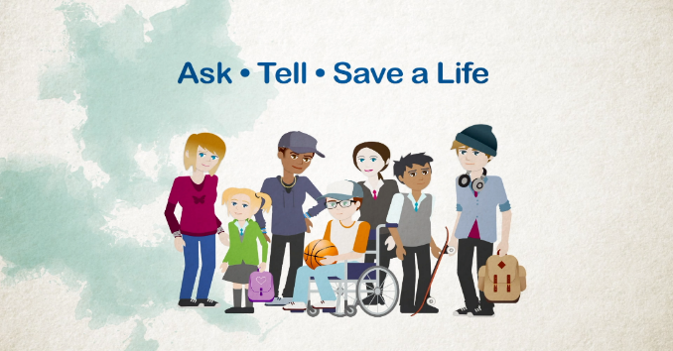
Self-Harm and Suicide Prevention

https://learn.nes.nhs.scot/17099

These resources could not have been provided without the young people, families and parents and wider stakeholders who gave us their valuable and crucial input in the development of these animations. We extend our sincere thanks to all involved.

