**Primary 1B– Mrs Doak**

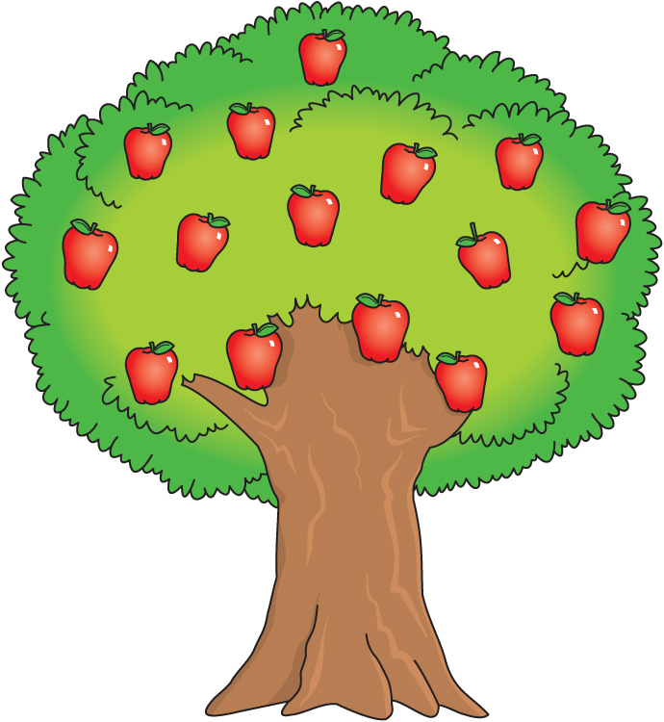

|  |  |
| --- | --- |
| Dear Parents & Carers,  Welcome to term 4 of Primary 1B. I have very much enjoyed working with and getting to know the children over the past few weeks and am looking forward to some more fun filled learning adventures.  **Mrs Doak** | |
| **Parent Information**  Hello, for those parents I’ve been unable to see at collection time, I’d just like to take this opportunity to say hello! The children have made me feel very welcome and should you have any questions or concerns, please do not hesitate to contact the school and I will get back in touch with you. | **Our New School**  We have settled into our new school and have had a lot of fun with the new resources, playground games and equipment. We are also enjoying our delicious lunches that are prepared onsite by the best catering team in South Ayrshire. |
| **Our Topic**  This term we are looking forward to learning all about life cycles and habitats!  We will be observing the life cycle of a caterpillar and butterfly with our very own butterfly farm in class. Once the have matured, we will release them into the wild.  We will be exploring our local area to view all the different habitats, wildlife, flora and fauna as well as learning how we can care for these. | **Outdoor Learning and Physical Education**  We will be regularly learning outside so will need to make sure we have a waterproof jacket and with us each day. Please label clothing in case it gets lost. As we come into the summer months, please ensure children have a sun hat and suntan lotion each day.  PE days are Tuesday and Friday, please send children to school in comfortable clothing and footwear suitable physical activity.  We have also began a daily mile challenge where the children will undertake a 15 minute walk, jog or run to increase our fitness, stamina and mental health. |
| **RME**  We will be learning about how different religions welcome a baby into the family as well as focusing on sharing, kindness and fairness both in school and at home. | **Water Bottles**  It is important that we keep hydrated, it helps us learn and concentrate. Please make sure you bring a bottle with plain water every day that is clearly labelled. |
| **Health and Wellbeing**  This term as we get ready to move to Primary two, we will be learning about change, how this can be a positive experience and how to manage our feelings. | **Homework**  Homework will be set on a Monday and due in on a Friday. It can be accessed via TEAMS where I will post links and information regarding the activities in the “Homework” tab. Please try to ensure children complete at least one activity a day which will be linked to our class learning. |
| **French**  We will be learning basic greetings, how to ask someone their name and age and how to respond. We will also learn the French words for family members, days of the week, months of the year and weather. | **Science**  In science, we will be investigating how science is used in everyday life, jobs and the impact this has on how we live. |