2025-2026
Newton Primary School & EYC School Improvement Plan


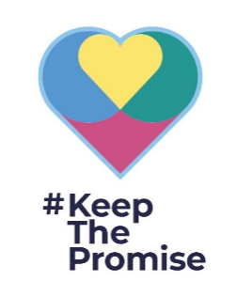

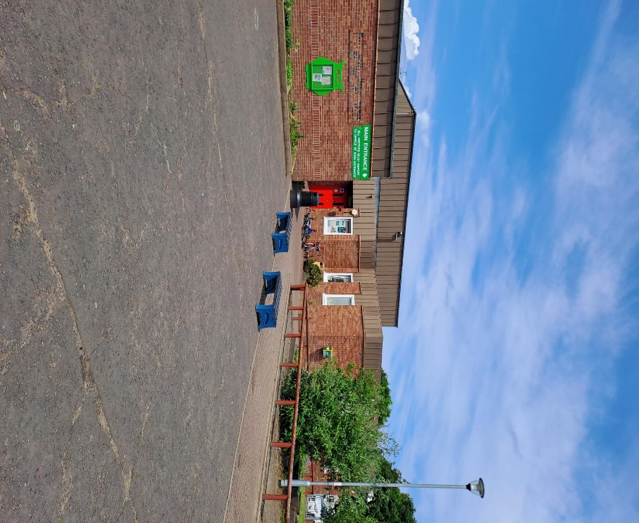


Canine Trust Reading Dog
As a Silver Accredited Rights Respecting School, we acknowledge the importance of Article 3 in all we do:
‘The best interests of the child must be a top priority in all actions concerning children.’

VISION
At Newton Primary School and Early Years Centre we provide a safe, nurturing and respectful environment which enables each pupil to achieve their potential, striving for excellence and equity. This is a welcoming, caring school where children and adults feel they contribute and are valued as individuals.
“A learning community’s well-being has a lot to do with the quality of relationships, cohesion, inter-dependence and belonging.”

VALUES
Our core values are;

- Self-belief
- Ownership
- Ambition
- Respect

Collated class affirmations have produced the mantra:
- We are kind
- We are brilliant individuals
- We are brave
- We are friendly
- We are a team
- We are strong
- We reach our goals and work together
- We are proud
AIMS
In a positive, safe, caring environment at Newton Primary and Early Years Centre we aim to:
- Close the poverty related attainment gap and achieve excellence for all.
- Make learning interesting, useful and challenging so pupils want to learn.
- Provide the appropriate support for our families so that our children are ready to learn.
National Improvement Framework Priorities
Education Services Priorities
Children’s Service Plan
South Ayrshire Council Plan
HGIOS 4 Quality Indicators
1.1 Self-Evaluation for Self-Improvement; 1.2 Leadership of Learning; 1.3 Leadership of Change; 2.2 Curriculum; 2.3 Learning, Teaching and Assessment; 2.4 Personalised Support; 3.2 Raising attainment & achievement
NIF Priorities:
Improvement in attainment, particularly in Literacy and Numeracy
Closing the attainment gap between the most and least disadvantaged children and young people
Improvement in employability skills and sustained, positive school-leaver destinations for all young people
Target: To raise attainment for all in literacy and close the attainment gap by improving attainment
Outcomes | Measures | Intended Impact
Increase average % of all learners on track to achieve expected ACEL level in reading, writing and listening & talking  Average % of all learners on track to achieve expected level maintained above 80%  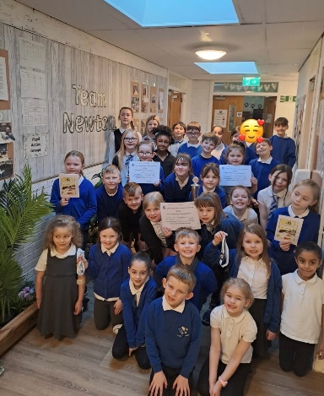  Increase by 5% number of learners achieving 10 Communication and Language Early Years milestones.  Increase by 5% of all learners achieving ‘ I can tap out syllables in words’ and ‘ I can identify rhyming words’ | ACEL level cohort tracking including December and June data uplifts  Learning conversations progress updates  Class observation feedback on teaching of writing  Various data and Standardised assessments across P1-P7 (GL, WTTT, Schonell, STAR, Early Level Vocabulary)  Data from literacy interventions (5 minute literacy box, Catch Up Literacy, Toe by Toe, ZIP, Reading Wise Decoding, Reading Wise Comprehension, 3 Read, Talkboost)  Staff and Pupils Surveys ( staff evaluation)  Milestone tracking- Sept/Oct and May/June data uplifts.  Interim completed December. | Average percentage of all learners on track in ACEL levels in reading, writing and listening & talking increase by 2%.  100% P1 learners attain expected level.  Prior attainment levels maintained for all learners.  All teaching staff are involved in cluster moderation of learning, teaching and assessment – moderation exemplars across all stages ensuring consistent understanding of national standards in literacy.  All staff will embed the South Ayrshire Reads Programme and will have improved knowledge of best practice in reading, specifically comprehension skills and literacy across the curriculum. (See Appendix 1)  All parents will have had the opportunity to engage with South Ayrshire Reads Programme through parental workshops and will have improved knowledge and understanding of how their child learns to read.  All staff understand the connection of pedagogical practices and the impact on attainment.  Increase number of learners achieving all communication and language early level milestones from 80% to 85%  All P7 learners will maintain prior levels of attainment in literacy at secondary.
Lead People: Daniella Miller(DHT), Carol Douglas (EEL) , SfLT- TBC, Fiona Hughes
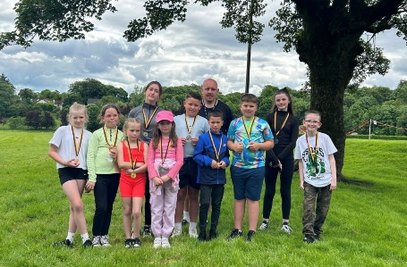
Timescales: By June 2026 (Including mid-year review)
Budget: PEF - School Assistants, EYP

HGIOS 4 Quality Indicators:
1.1 Self Evaluation for Self-Improvement; 1.2 Leadership of Learning; 1.3 Leadership of Change; 2.2 Curriculum; 2.3 Learning, Teaching and Assessment; 2.4 Personalised Support; 3.2 Raising Attainment & Achievement
NIF Priorities:
Improvement in attainment, particularly in Literacy and Numeracy.
Closing the attainment gap between the most and least disadvantaged children and young people.
Improvement in employability skills and sustained, positive school-leaver destinations for all young people.
Target: To raise attainment for all in numeracy and close the attainment gap by improving attainment
Outcomes | Measures | Intended Impact
Increase average % of all learners on track to achieve expected ACEL level in numeracy.  Average % of all learners on track to achieve expected level maintained above 80%.  Increase by 5% the number of learners achieving all 10 numeracy and maths early years milestones.  Increase percentage of all learners achieving ‘I can recognise how many without having to count’ by 5% milestone. | ACEL level cohort tracking including December and June data uplifts  Learning conversations progress updates  Class observation feedback on teaching of numeracy  Various data and Standardised assessments across P1-P7  (GL, Number Sense, Early Level Assessments, Hodder, Headstart, Arithmetic, Problem Solving and Reasoning)  Data from numeracy-based interventions (5 Minute box, Catch-up Numeracy, Number Sense, Mathseeds, CPA)  Milestone tracking- Sept/Oct and May/June data uplifts.  Interim completed December. | Average percentage of all learners on track in ACEL levels in numeracy increase by 2%.  100% P1 learners attain expected ACEL level.  Prior attainment levels maintained for all learners.  All teaching staff are involved in cluster moderation of learning, teaching and assessment – moderation exemplars across all stages ensuring consistent understanding of national standards in numeracy.  All parents will have had the opportunity to engage with further workshops including BTC and decision making in a mathematical context and the majority will have improved knowledge and understanding of how their child learns in numeracy.  All staff understand the connection of pedagogical practices and the impact on attainment.  All EYC staff engage in numeracy and maths CLPL to identify supports and strategies to be used with children who need additional support to achieve milestones.  Increase number of learners achieving all numeracy and maths early level milestones from 90% to 95%  All P7 learners will maintain prior levels of attainment in numeracy at secondary.
Lead Persons: Nicola Killick(PT), Carol Douglas (EEL) , TBC (SfLT),
Timescales: By June 2026 (Including mid-year review)
Budget: PEF - School Assistants, EYP

HGIOS 4 Quality Indicators:
1.1 Self Evaluation for Self-Improvement; 1.2 Leadership of Learning; 1.3 Leadership of Change; 2.2 Curriculum; 2.3 Learning, Teaching and Assessment; 2.4 Personalised Support; 3.2 Raising Attainment & Achievement
NIF Priorities:
Closing the attainment gap between the most and least disadvantaged children and young people; Improvement in children and young people's health and wellbeing;
Improvement in employability skills and sustained, positive school-leaver destinations for all young people.
To develop Children’s Rights Agenda across the cluster
To reach next level of Rights Respecting School Accreditation
Continue to improve children and young people’s HWB
Outcomes | Measures | Intended Impact
Children’s Rights Agenda developed across the cluster  Gold Rights Respecting Schools Accreditation achieved (January 2026)  All children empowered and inspired to think about and share their views.  Average school attendance is currently 94%; increase to 95%  Support inclusion of all learners within school.  Provide environments that are supportive and inclusive.  Introduce ‘Think Equal’- a social and emotional learning program building on six ‘I am’ precepts;  -I have a strong sense of who I am  -I am able to look after myself  -I am able to look after others  -I am able to communicate  -I am able to contribute and create  -I am a critical thinker  Continue to improve all children and young people’s HWB, ensuring improved wellbeing outcomes for learners with experience of care.  Parental and children’s knowledge of all wellbeing outcomes (SHANARRI) increased. | Staff learning conversations progress updates  Class observation feedback on pupil voice  Wellbeing indicators (through wellbeing webs)  Attendance (lates and absences) of targeted learners  Staff and Pupils Surveys  Termly reflection on Level 1 pathway  Good practice feedback following ‘Looking outward’ cluster staff visits  Wellbeing indicators (through wellbeing webs) | OUTRIGHT – Speak out on Children’s Rights – Children, pupils and staff will be inspired to speak out for change through cluster campaign.  Empower pupil voice through improved relationships within cluster RRS groups (pupil and staff)  Attendance increases by 1%  Latecomings across the school reduced by 50%. ( Ensure consistent recording system)  95% of all children will be at school on time ( currently 80%)  95% of children with attendance less than 90% increase attendance to over 90%  Raised parental awareness which will feed directly into pupil profiles and care plans, benefitting children through shared understanding.- Seesaw  Our youngest learners are guided through 22 picture books and accompanying experiences focussing on co-creating positive pro-social pathways. Children will learn about themselves, emotions, kindness and mindfulness.  Increase number of children reporting positively on the achieving and active wellbeing indicator at home with a greater understanding of what these indicators mean.  All parents will have had the opportunity to engage in workshops around the achieving and active wellbeing indicators and the majority will have improved knowledge and understanding of their child’s wellbeing.  Increase number of children reporting positively on the respected wellbeing indicator at school with a greater understanding of what this indicator means. ( link to UNCRC)  All P7 learners will maintain prior levels of attainment at secondary.
Lead Persons: Fiona McAvoy(HT), Nicola Killick(PT), Daniella Miller(DHT), Ryan McGregor(ASA)
Timescales: June 2026(and mid-year review)
Budget: PEF - School Assistants, Active Schools Assistant, EYP
UNCRC Articles  - Article 3  Adults must do what’s best for me  - Article 6  I should be supported to live and grow  - Article 12  I have the right to be listened to and taken seriously.  - Article 13  I have the right to find out and share information.  - Article 15  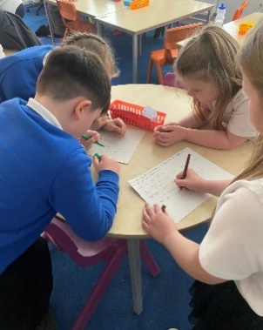  I have the right to meet with friends and to join groups.  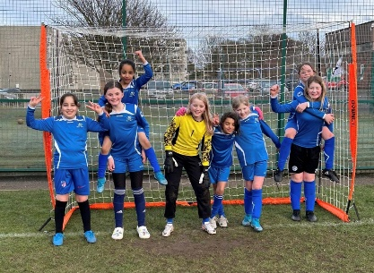 | UNCRC Articles  - Article 20  I have the right to be protected from being hurt or badly treated.  - Article 23  If I have a disability, I have the right to special care and education.  - Article 28  I have the right to an education.  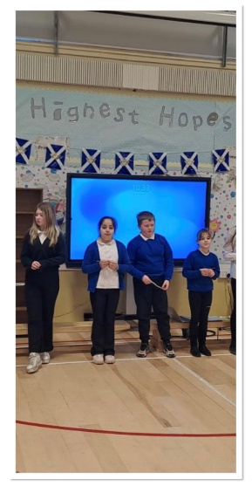  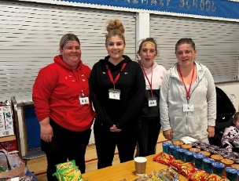 | UNCRC Articles  - Article 29  I have the right to an education which develops my personality, respect for others’ rights and the environment.  - Article 31  I have a right to relax and play.  - Article 39  I have the right to help if I have been hurt, neglected, or badly treated.  - Article 41  Where our country treats us better than the U.N. does, we should keep up the good work!  - Article 42  Everyone should know about the UNCRC.
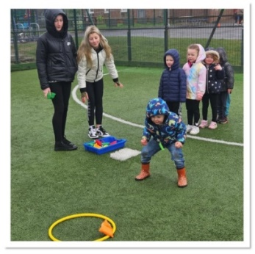

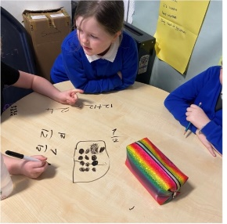
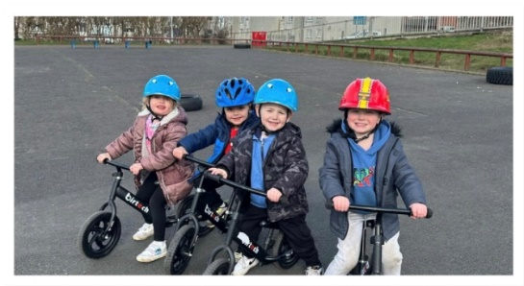
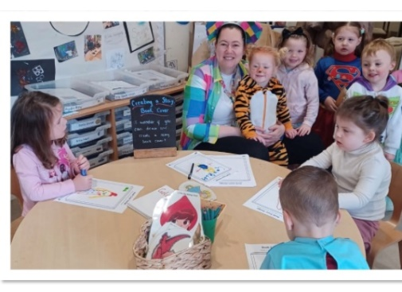
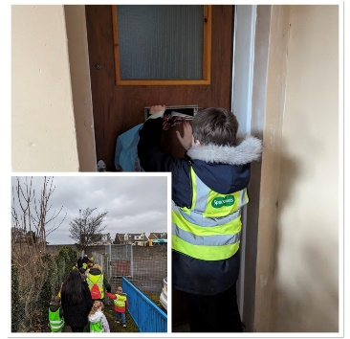
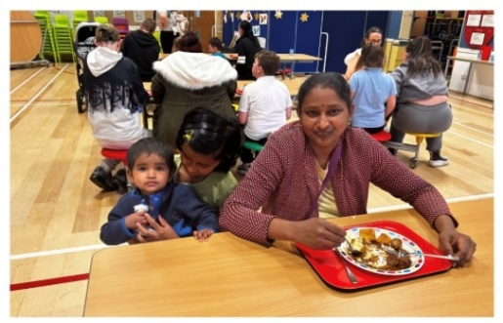
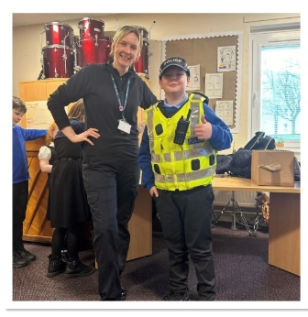
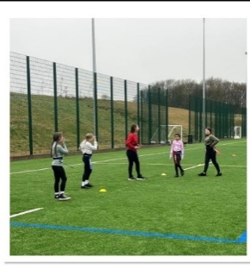

Education Services Improvement Plan Priority 2: Outstanding Learning, Teaching and Assessment Educational Services Improvement Plan 2023 - 2026
SAR Strategic Plan Priority: To raise attainment in literacy and to significantly reduce the reading attainment gap between the most and least disadvantaged children and young people in South Ayrshire South Ayrshire Reads Strategy Document
PHASE 1 SOUTH AYRSHIRE SCHOOLS
2025-2026
SAR Strategic Aim | Actions | Intended Impact | Resources | SAR Lead | Completion  Date
To develop confident and skilled readers in South Ayrshire with a lifelong love of reading and the confidence to access all aspects of education, culture and society  To support and develop all education staff in South Ayrshire to implement best practice through a culture of shared knowledge, collaboration and enquiry  To promote the implementation of an excellent reading curriculum which prioritises best practice, challenge and adapted teaching for children with additional support needs  To gather, use and analyse data effectively to drive change and improvement in children’s reading skills, reading confidence and reading attainment | By June 2025, ALL Phase 1 schools will have reviewed the role of their reading leader and, in collaboration with the South Ayrshire Reads team, planned how this role will be used to support reading development over the coming year. | The aims of South Ayrshire Reads continue to be embedded across Phase 1 School Communities focussing on building capacity and sustainability.  The values, vision and aims of  South Ayrshire Reads  is consistent and clear to all stakeholders | - Role of reading leader reviewed at planning meeting.  - Reading Leader meeting dates shared and agreed.  - Reading leader workshop dates agreed.  - RL MS TEAM accessed for updates, relevant information and collaboration. | SAR PT’s | June 2025
 | By June 2026, ALL Phase 1 schools will have participated in at least two reading leader-led workshops within their own setting, supporting the ongoing development of reading practice. |  | - All Reading Leaders may attend four half-day sessions (September 2025, November 2025, January 2026, and April 2026) focused on building capacity and providing the knowledge and skills needed to lead impactful reading workshops within their own schools—both with staff and with parents—as part of a wider drive to raise attainment in reading. | LW | June 2026
 | By June 2026, ALL Phase 1 schools will have had the opportunity to engage in collaborative activities—through partnership CLPL, Phase 1 cohort participation, or peer school visits—to build collective efficacy and promote an outward-looking approach to improvement. |  | - Bespoke partnership CLPL responsively planned and reviewed in line with contextual needs.  - Meeting & discussion with SLT around peer school visits  - Peer visit pre-workshops/discussion/observation guides | SAR PT’s | June 2026
 | By August 2025, ALL Phase 1 schools will identify new or returning staff in need of catch-up sessions and will work with the SAR Team to develop a clear plan, ensuring all staff are equipped with the knowledge and skills to support reading development effectively. |  | - Phase 1 schools will complete a simple MS Form, identifying new/returning members of staff and their stages  - Catch-up sessions agreed & planned by SAR Team  - Phase 1 schools to identify existing members of staff to support this through coaching/modelling | SAR PT’s | August 2025
 | By June 2026 ALL Phase 1 education staff will have had the opportunity to engage in additional high-quality CLPL in an area of interest. |  | - Additional sessions—such as Critical Literacy, Disciplinary Literacy, Play-based Literacy, and Debating—will be planned, created, and delivered by the SAR Team to build on and enhance existing knowledge and practice. | SAR Team | June 2026
 | By June 2026 ALL Phase 1 education staff will have had the opportunity to engage in bespoke high-quality CLPL. |  | - All CLPL will be grounded in the Science of Reading, with a particular focus on language comprehension and its connection to other areas of literacy development, while continuing to embed previous work on phonics and fluency. | SAR PT’s | June 2026
 | By June 2026, ALL Phase 1 education staff will have had the opportunity to further develop their practice in collaboration with the SAR Team. |  | - Collaborative activities include workshops, professional discussions, coaching sessions, and model video analysis. | SAR PT’s | June 2026
 | By June 2026 ALL Phase 1 schools will have had the opportunity to engage with assessment implementation and data analysis to drive teaching and learning. |  | - Access to CLPL sessions focused on the interpretation, analysis, and evaluation of learner attainment to measure impact and inform next steps.  - Opportunity to attend workshops and drop-in sessions focused on data literacy. | HMcB | June 2026
 | By June 2026 ALL Phase 1 schools will have had the opportunity to engage with and access support to implement and embed additional related SAR priorities. |  | - Reading Schools and Reading for Enjoyment CLPL opportunities  - Communication Friendly Environments  Developing Writing through SAR | JM  HMcB  SL | June 2026
 | By June 2026 ALL parents will have had further opportunity to engage with workshops and learning sessions based on supporting their child’s reading development. |  | - Reading Leader will attend SAR led session prior to delivery of Parent Engagement Workshop  Notification  - Support for RL from SAR team for workshop and parent events  - Access to authority SAR family engagement session / resources | Reading Leaders & SAR PT’s  SL | June 2026

Raising attainment in literacy through effective transition
What outcome do we want to achieve? | How will we achieve this ? | Lead Person | Checkpoints | How will we measure the impact ?
To extend the transition experience to Primary 6 pupils to ensure enhanced curricular transition. | - A cyber first graphic novel and teaching materials to be shared with all primaries.  - Pupils will visit Ayr Academy for Lesson 1 on cyber security which will include support L Robertson, A Pickard and Education Scotland.  - Ayr Academy Pupils will then lead learning in each primary school delivering lessons 2 &3.  - Primary staff will then consolidate learning to produce a graphic novel.  - Parent showcase of graphic novels from all primary schools at Ayr academy in May.  - Best novel from each primary to be printed. | E McDonagh | Sharing of teaching materials May 25  Delivery of lessons Aug-Dec 25  Jan-March 26- Decision on best graphic novel from each primary and printing of novels  May Parent Showcase | Pupil surveys of S3 leaders of learning.  Pupil surveys of P6 .  Cluster review/moderation of novels produced and staff feedback on quality of work.

Raising attainment in literacy through moderation and shared assessment standards
What outcome do we want to achieve? | How will we achieve this ? | Lead Person | Checkpoints | How will we measure the impact?
Continue to develop moderation activities across the cluster to develop a shared understanding achievement of a level and the milestones for progression across a level. | - Moderation calendar to be agreed  - Moderation event 1 – will be to review work for any pupils causing initial concern in their levels of literacy.  - Moderation event 2 will be the combined moderation of the S1 reflective essay with the evidence jotter from primary school.  - Moderation of the Rubric assessment tool for writing | S Morton  Emma McDonagh  All cluster staff  All cluster staff | August 2025  September 25- Cause for Concern moderation event.  December 25- Combined moderation of reflective essay and evidence jotter.  October 25 | Staff across the cluster will develop a robust understanding of moderation at key points of transition.  Pupils will demonstrate progress across a level in S1.  Stretch aim 60% of pupils should achieve 4th level by the end of S3

Raising attainment in literacy through shared understanding and collaboration
What outcome do we want to achieve? | How will we achieve this ? | Lead Person | Checkpoints | How will we measure the impact?
To develop a shared framework for writing skills.  To increase parental involvement to better support young people's literacy levels | - Shared Command words to be embedded in cluster schools to ensure understanding of key vocabulary. Resources produced to support this  - Common vocabulary used in S1 to be shared with primaries.  - PEEL writing structure to be used by all cluster schools. Resources produced to support this.  - A shared list of non-negotiables regarding written work by the end of P7 which moves with them to S1. These will come from the benchmark statements.  - Creation of WAGGOLL paragraphs annotated with the non-negotiables.  - 1St level rubric for marking written pieces to be created in line with current level 2-4 rubric  - One Note to be set up to aid sharing of resources .  - A parent night on how to support your child's literacy to be held with both primary and secondary staff present. | Daniella Miller  E McDonagh  Suzanne Morton  Daniella Miller & Coleen Cowie  Sally Law  Coleen Cowie & Allan McQueen  Sally Law  Allan McQueen | August 2025  August 2025  August 2025  August 2025  August 2025  Jan 2026  May 2025  October 2025 | Observation of pupils in lesson will demonstrate that they have both understanding and confidence in: shared vocabulary including command words, PEEL Structure and non-negotiables.  The work pupils produce will demonstrate this shared understanding, and this shared approach will be evident at moderation.  We will use historic data of pupils’ progress in P7 and S1 and compare this to the progress of pupils in 2025-2026 cohort.  We will survey parent’s views on our approaches to literacy and seek their feedback on next steps.

Raising attainment in literacy through Science of Reading
What outcome do we want to achieve? | How will we achieve this ? | Lead Person | Checkpoints | How will we measure the impact?
Increase secondary staffs understanding of the science of reading. | - Input on the Reading Rope at an in-service day for all Ayr Academy staff. This will include primary colleagues sharing their experience.  - Training on Read wise for wider staff .  - Faculty focus groups to review the S1 curriculum including social subjects and science. | Sally Law  Emma McDonagh | August 25  Completion of whole school input on Reading Rope and Read wise.  Jan 26  S1 curriculum review complete.  Jan 26- May 26  Observation of S1 lessons with a focus on literacy. | Staff evaluations following inputs.  Observations of lessons of S1 lesson with a literacy focus in both science and social subjects.

Raising attainment in literacy through using data effectively.
What outcome do we want to achieve? | How will we achieve this ? | Lead Person | Checkpoints | How will we measure the impact?
To develop our understanding of how to use data effectively to inform learning and teaching. | S Law team to give input to cluster staff on how to use accelerated reader data effectively to support teaching and learning. | Sally Law  Haley Milne | Ongoing through session 25-26 | Increased quiz scores and progression in level of challenge.  Greater sustained engagement by S1 pupils.  Staff track and monitor progress and can link this lesson planning.

Raising attainment in numeracy through effective transition

What outcomes do we want to achieve? | How will we achieve this? | Lead Person | Checkpoints | How will we measure impact.
To design a transition experience for P7 pupils that allows them to feel an continuity in their numeracy journey as they progress into secondary education. | - ChrisMaths event to be held in December each year. Based around the four operations, pupils will complete activities in their primary class which directly links to the activities to be completed at the ChrisMaths event.  - Fun Fair Maths transition event from January to September. Project based learning which includes 2nd/3rd level numeracy outcomes,  - Lessons to be developed from Fun Fair Maths materials.  - Lessons to be completed in Primary school with final lessons travelling with pupils to S1. | A Jamieson  Gillian Caitens  &  Dana Forrest | June 2025 – Cluster Planning Day, cluster agrees the content of the mathematical problems to be completed at Primary school in preparation for ChrisMaths event.  November 2025- Groupings and information for event shared.  December 2025 evaluations review.  June 25 - Cluster Planning Day to determine the ten (approx.) lessons from Fun Fair Maths to be used.  October 25- Fun Fair Maths Booklet (which will travel to secondary) to be created.  October 26- Moderation of booklet and pupil work. (see O.2FTE role) | Pupil evaluations after the event.  Gather views of cluster staff who attend event.  Moderation of teaching and learning materials.  Moderation of pupil’s work

