



**Muirhead Primary & Early Years Centre**

**Improvement Plan 2023 - 2024**

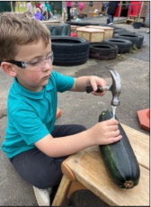

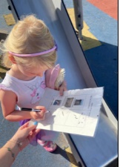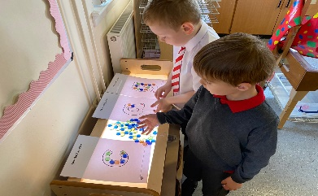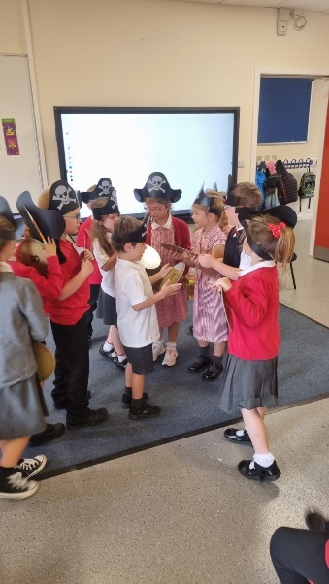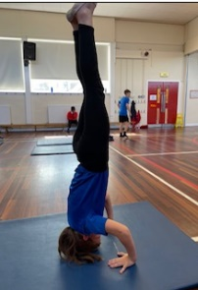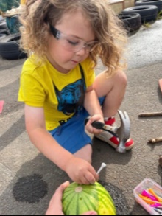

As a Rights Respecting School, we acknowledge the importance of Article 3 in all we do:

‘The best interests of the child must be a top priority in all actions concerning children.’

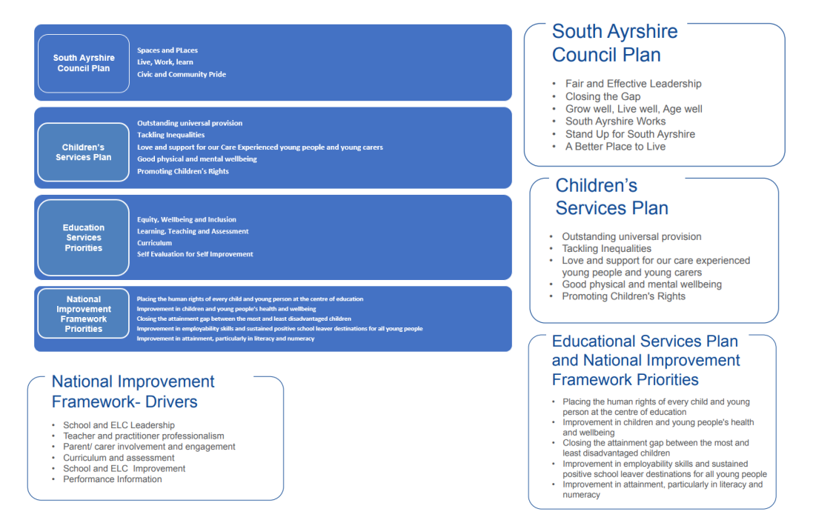

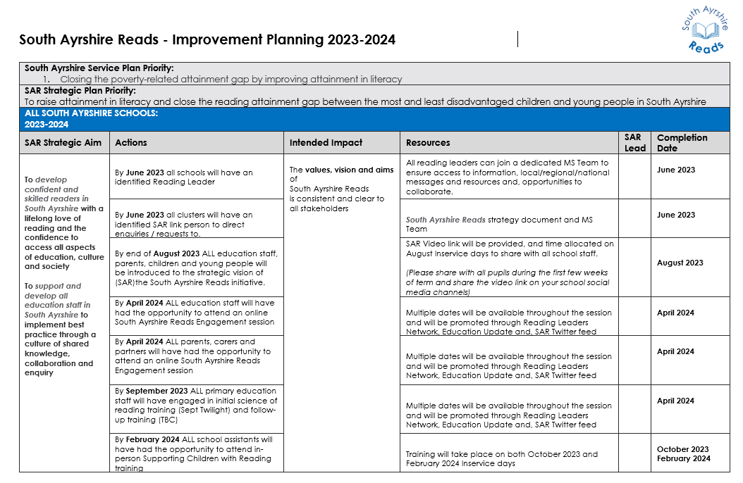

|  |  |  |  |  |
| --- | --- | --- | --- | --- |
| **PRIORITY 1: RAISING ATTAINMENT IN LITERACY AND ENGLISH** | | | | |
| **What Outcomes**  **Do We Want to Achieve?** | **How Will We Achieve This?** | **Lead Person** | **Timescales** | **How Will We Measure Impact?** |
| **Improvement in literacy attainment, particularly reading, through a well-planned, progressive literacy programme.** | **PERFMORMANCE INFORMATION** | | **HGIOS 4**  **1.1, 1.2, 3.2** | |
| * Pupil progress will be tracked and monitored. * Attainment data and attendance will be used to inform next steps. * Well-planned interventions will be offered where appropriate. | All staff  L Livingstone HT  I Lindsay DHT to monitor attendance  L Livingstone HT/C Mitchell ASfL Teacher | Sep. Dec, May  Sep, Dec, Feb, May  Monthly  March 2023 | * Gains made in attainment levels/data * Pupil Progress Meetings with all teachers on a termly basis to discuss pupil progress and impact of actions and next steps. * Increased phonological knowledge * Attendance data monitored on a monthly basis and improvement in attendance noted. * Data generated from intervention to monitor impact |
| **Pupils will develop as confident, skilled readers and be aware of the importance of reading for enjoyment** | **CURRICULUM & ASSESSMENT** | | **HGIOS 4**  **1.1, 1.3, 2.3, 3.2** | |
| * Implement the South Ayrshire Reads initiative to ensure reading approaches are explicit, systematic and targeted. There will be a focus initially on phonological awareness, phonics and fluency. * Develop PBL pedagogy to support early level literacy development together with SAR/SAL teams. * Decodable readers to be used in P1-P3. * Reading interventions linked to the science of reading to ensure needs are met, including using age-appropriate decodable readers for children still working on these skills in P4-P7. * Access to a library area in each classroom as well as access to the school library. Pupils select books for enjoyment in addition to the decodable readers. * Pupils involved in reviewing the books and genres available. * Develop a consistent approach to celebrate effort in reading through Accelerated Reader. * Embed assessment procedures to ensure consistency in professional judgement of attainment, including opportunities to share practice and moderate achievement levels. * Provide opportunities to discuss targets and next steps with pupils. * Implement adaptive teaching approaches | C Mair PT  All staff  G Brocklebank P1 teacher (PBL lead)  L Livingstone HT  C Mair  P1-3 teachers  Class teachers  C Mair PT  L Livingstone HT  Class teachers  A Clydesdale/A Harris (leads) | Jan 2024  June 2024  Dec 2023  March 2024  Dec 2023  June 2024  June 2024  June 2024  June 2024  Feb 2024 | * Quality assurance evaluations * Monitoring of classroom/playroom practice and children’s learning experiences. * Sampling pupils’ work * Pupil Progress Meetings * Tracking and monitoring of planning and assessment data * Staff feedback through self-evaluation * Tracking and monitoring of baseline data * Pupil voice gathered using HGIOURS * Monitoring EYC Care Plans * Monitoring effectiveness of STINT targets |

|  |  |  |  |  |
| --- | --- | --- | --- | --- |
| **What Outcomes**  **Do We Want To Achieve?** | **How Will We Achieve This?** | **Lead Person** | **Timescales** | **How Will We Measure Impact?** |
| **Close identified gaps and ensure appropriate pace and progression for all learners** | **SCHOOL & EYC IMPROVEMENT**  **TEACHER PROFESSIONALISM & SCHOOL LEADERSHIP** | | **HGIOS 4**  **1.1, 1.3, 2.3, 2.4, 3.2** | |
| * Review literacy pathways to ensure appropriate pace, challenge and progression across all stages. * Support staff professional learning opportunities and partnership working with SAR leads, Scottish Book Trust, authors, families and PEEP. * Provide staff training about the teaching of reading, including early years and support staff. * Engage staff in professional reading about the science of reading and effective teaching of reading. * Moderation of reading approaches through staff meetings, peer visits and work with SAR leads. * Moderation work between early years staff and primary 1 staff to ensure a consistent understanding of the development and progression of early reading skills. * Audit practice for identifying and supporting learners in order to improve outcomes and raise attainment using informed interventions. | L Livingstone HT  C Mair PT | June 2024  June 2024  March 2024  March 2024  May 2024  May 2024  June 2024 | * Quality assurance evaluations * Staff feedback through self-evaluation * Feedback from moderation activities * Tracking and monitoring of baseline data * Evidence gathered from audits * PRD/PDR meetings * Monitoring of classroom/playroom practice and children’s learning experiences. * Sampling pupils’ work * Monitoring EYC Care Plans * Monitoring effectiveness of STINT targets * Tracking progress of targeted groups of learners e.g. pupils eligible for PEF support or supported through staged intervention |
| **Provide opportunities for families to engage in their children’s learning in Literacy and English, with particular emphasis on reading** | **PARENTAL & WIDER ENGAGEMENT** | | **HGIOS 4**  **2.3, 2.5, 3.2** | |
| * Create a calendar to share events and development opportunities linked to SAR priorities. * PEEP sessions * Stay and Play * South Ayrshire Mobile library calendar – encourage parent participation * Pupils working with footballers from Ayr United as part of SAR. * Author visits | C Mair PT  S Reynolds EY Teacher  R Jeffries & M Kenney EYP Seniors | Jan 2024  Dec 2023  June 2024  March 2024  June 2024  Dec 2023 | * Annual questionnaires * Self-evaluation |

|  |  |  |  |  |
| --- | --- | --- | --- | --- |
| **PRIORITY 2: RAISING ATTAINMENT IN MATHS & NUMERACY** | | | | |
| **What Outcomes**  **Do We Want to Achieve?** | **How Will We Achieve This?** | **Lead Person** | **Timescales** | **How Will We Measure Impact?** |
| **Improvement in Numeracy and Mathematics attainment.** | **PERFMORMANCE INFORMATION** | | **HGIOS 4**  **1.1, 1.2, 3.2** | |
| * Pupil progress will be tracked and monitored. * Attainment data and attendance are used to inform next steps. * Well-planned interventions will be offered where appropriate. | All staff  L Livingstone HT  I Lindsay DHT to monitor attendance  L Livingstone HT/C Mitchell ASfL Teacher | Sep. Dec, May  Sep, Dec, Feb, May  Monthly  March 2023 | * Gains made in attainment levels/data * Pupil Progress Meetings (PPM) with all teachers on a termly basis to discuss pupil progress and impact of actions and next steps. * Attendance data monitored on a monthly basis and improvement in attendance noted. * Data generated from intervention to monitor impact |
| **Learners will display increased confidence and recognise next steps in learning.** | **CURRICULUM & ASSESSMENT** | | **HGIOS 4**  **1.1, 1.3, 2.3,2.7, 3.2** | |
| * Expand opportunities for all pupils (EYC to P7) to lead their own learning and learn through exploration and enquiry. * Provide opportunities to discuss targets and next steps with pupils. * Embed assessment procedures to ensure consistency in professional judgement of attainment, including opportunities to share practice and moderate achievement levels. | I Lindsay DHT  All staff | June 2024  Dec 2023  June 2024 | * Quality assurance evaluations * Tracking and monitoring of planning and assessment data * Tracking and monitoring of baseline data * Staff feedback through self-evaluation * Tracking and monitoring of baseline data * Pupil targets * Pupil voice gathered using HGIOURS * Monitoring of classroom/playroom practice and children’s learning experiences. * Sampling pupils’ work * Pupil Progress Meetings * Monitoring EYC Care Plans * Monitoring effectiveness of STINT targets |

|  |  |  |  |  |
| --- | --- | --- | --- | --- |
| **What Outcomes**  **Do We Want To Achieve?** | **How Will We Achieve This?** | **Lead Person** | **Timescales and CLPL** | **How Will We Measure Impact** |
| **Close identified gaps and ensure appropriate pace and progression for all learners.** | **SCHOOL & EYC IMPROVEMENT**  **TEACHER PROFESSIONALISM & SCHOOL LEADERSHIP** | | **HGIOS 4**  **1.1, 1.3, 2.3, 2.4, 3.2** | |
| * Review numeracy pathways to ensure appropriate pace, challenge and progression across all stages. * Support staff professional learning opportunities e.g. block play, CPA, Numbertalks, authority training for teaching and non-teaching staff * Develop staff confidence in ensuring appropriate pace and progression through working with the South Ayrshire Learns team on Adaptive Teaching. * Promoting mathematical language and creativity through block play * Moderation of professional judgement of attainment * Moderation work between early years staff and primary 1 staff to ensure a consistent understanding of the development and progression of early reading skills. * Audit practice for identifying and supporting learners in order to improve outcomes and raise attainment using informed interventions. | L Livingstone HT  I Lindsay DHT  A Clydesdale/A Harris Class Teachers (leads)  C MacPhee EYP  L Livingstone HT  S Reynolds EY Teacher/ G Brocklebank P1 Teacher  L Livingstone HT/C Mitchell AsFL Teacher | Jan 2024  June 2024  June 2024  Feb 2024  Jan 2024  May 2024  Feb 2024 | * Quality assurance evaluations * Staff feedback through self-evaluation * Feedback from moderation activities * Tracking and monitoring of baseline data * Evidence gathered from audits and assessment data * PRD/PDR meetings * Monitoring of classroom/playroom practice and children’s learning experiences. * Sampling pupils’ work * Monitoring EYC Care Plans * Monitoring effectiveness of STINT targets * Tracking progress of targeted groups of learners e.g. pupils eligible for PEF support or supported through staged intervention |
| **Engage families and wider partners in collaborative working opportunities to enhance and enrich learning in numeracy and mathematics.** | **PARENTAL & WIDER ENGAGEMENT** | | **HGIOS**  **2.3, 2.5, 2.7 3.2** | |
| * Create a calendar to share events and development opportunities linked to numeracy priorities. * PEEP sessions * Block Play * Stay and Play | I Lindsay DHT  S Reynolds EY Teacher  R Jeffries & M Kenney EYP Seniors | Jan 2024  Dec 2023  June 2024  June 2024 | * Annual questionnaires * Self-evaluation |

|  |  |  |  |  |
| --- | --- | --- | --- | --- |
| **PRIORITY 3: DEVELOPING SHARED STANDARDS & EXPECTATIONS THROUGH MODERATION** | | | | |
| **What Outcomes**  **Do We Want to Achieve?** | **How Will We Achieve This?** | **Lead Person** | **Timescales** | **How Will We Measure Impact?** |
| **Robust and reliable teacher judgements around attainment and achievement of a level** | **PERFMORMANCE INFORMATION** | | **HGIOS 4**  **1.1, 1.2, 1.4, 2.3, 3.2** | |
| * Pupil progress will be tracked and monitored. * Improve reliability of teacher’s judgements through moderation opportunities | All staff  L Livingstone HT | Sep. Dec, May  Sep, Dec, Feb, May  June 2024 | * Gains made in attainment levels/data * Pupil Progress Meetings with all teachers on a termly basis to discuss pupil progress and impact of actions and next steps. * Staff feedback through self-evaluation * Staff feedback from moderation activities |
| **Continue to develop shared expectations of learning and understanding of standards across all levels from EYC to P7 and beyond.** | **CURRICULUM & ASSESSMENT**  **SCHOOL & EYC IMPROVEMENT**  **TEACHER PROFESSIONALISM & SCHOOL LEADERSHIP** | | **HGIOS 4**  **1.1, 1.2, 1.4, 2.3, 3.2** | |
| * Provide opportunities for a collegiate approach to the moderation of planning of learning, teaching and assessment ​ * ​Opportunities for practitioners to moderate assessment judgements by taking account of a sample of evidence from different sources to discuss standards and the progress of learners * Opportunities to work with colleagues across the cluster (see Marr Cluster improvement plan) * Continue to develop staff skill in analysing data to inform learning, teaching and assessment * Working collegiately with South Ayrshire Learns team to develop shared understanding around appropriate pace and progression | L Livingstone HT  All staff | Jan 2024  Jan 2024  June 2024  Jan 2024  June 2024 | * Quality assurance evaluations * Peer monitoring of classroom/playroom practice and children’s learning experiences in order to moderate – feedback from learning visits * Moderation of pupils’ work * Tracking and monitoring of planning and assessment data * Staff feedback through self-evaluation * Tracking and monitoring of baseline data * Moderation of EYC Care Plans * Moderation of STINT targets * Improvement in the quality of assessments * Feedback from parents ​ * Coherent and progressive links between stages and across levels |

