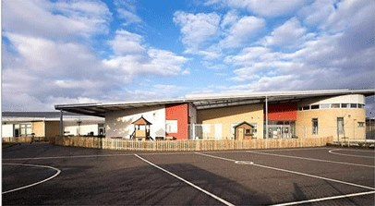

Monkton PS and EYC Newsletter September 2025
We are already in September and we have been back in school for one and a half weeks – time flies!
Our children have all settled in very well and seem happy to be back in the school and EYC routines. There have been very few tears from all of our new children (and staff) which has been great. Staff are enjoying being back and leading learning – we feel very lucky to have fantastic children who work hard and are keen to learn.
A special mention goes out to our P7 pupils who have been great buddies to the new P1 children – thank you for all of your help! P1 happily play outside at break and lunch time with the whole school.
If we can support in any way, please do not hesitate to get in touch. As always, we are here to help.
Mrs Miller
Head Teacher

In This Newsletter
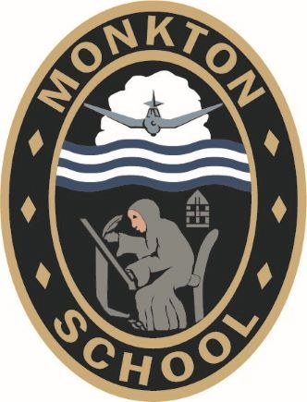

This monthly newsletter has lots of information about the school and the EYC including:
- Dates for your diary
- Updates
- Learning, Teaching and Assessment Zone
- Community Noticeboard
- Communication
- Contact Us

Dates for your Diary (UNCRC Articles 28, 29 and 31)

Monday 1st September 2025 - Home learning (homework) will start for pupils.
Wednesday 3rd September 2025 - Photo Studio, Ayr in school / EYC to take photographs of all children
Friday 5th September 2025 - P1-3 Parents workshop - how to support reading at home, 1:45-2:25pm.
Meet the Teacher (classroom / EYC open for parents to come in and see classroom and meet staff) 2:30-3pm
Wednesday 10th September 2025 - EYC PEEP Bookbug Welcome session, 2:15-2:45pm
Wednesday 17th September 2025 - Parent Council AGM at 6:30pm in the school meeting room - all parent / carers welcome including new members who would like to join. The Parent Council are still looking for a secretary - please contact them if interested.
Thursday 18th September 2025 - Fundraising Event for school / EYC fund (more details to follow)
Class Newsletters to be sent to parent / carers and added to website
Friday 19th and Monday 22nd September 2025 - School / EYC closed for long weekend
Monday 6th - Thursday 9th October 2025 - Foodbank collection
Thursday 9th October 2025 – EYC Stay and Play at 2:30pm
Parents afternoon / evening with Book Fair
Monday 13th to Friday 17th October 2025 - School / EYC closed for holidays
Monday 20th October 2025 - In-service Day - school and EYC closed for pupils
Thursday 30th October 2025 - Parent Council Halloween Discos - details to be confirmed

Updates (UNCRC Article 17)

This section contains important updates and information.

Reminders
Uniform
The wearing of school uniform is very much encouraged at Monkton and P1-7 children should wear full uniform to school every day except for special activities / events which we will notify you of in advance. Children should not come to school dressed for PE but instead should use the items stored in their gym bag or bring their PE kit in for their gym days.

Water bottles, Book Bags and Homework Diaries
All children in the school should bring a filled water bottle (water only - no juice) to school each day. Children should also bring their blue book bags and homework diaries to and from school each day - especially those in P1-3. Please check the homework diary each night as staff may write notes in them. You may wish to write a short note in the diary to staff although please note if it is something urgent or regarding medication, please contact the office to ensure that the message gets to the member of staff immediately. Thank you.

ParentsPortal
Please remember that you can now report your child's absence through ParentsPortal. f you have not already signed up for this, please do so asap. You can contact the school office if you need help to do this. Thank you.
parentsportal.scot

Parent Council
The next Parent Council meeting is the AGM which is on Wednesday 17th September 2025 at 6:30pm in the school - all parent / carers are welcome to join! There is a vacancy for secretary, this role includes agenda writing and minute taking. We may be unable to continue the Parent Council if we do not have all committee members so any volunteers would be greatly appreciated. Thanks.
Halloween Disco will be Thursday 30th October 2025 - more details to follow.

Health and Safety (UNCRC Articles 24 and 25)
Please remember the importance of playing your part in keeping the school community safe and healthy.
We respectfully remind everyone:
• Please bring your child / send your child to school / EYC for 9am (and not earlier). The front and back gates will open at 8:50am and the EYC doors will open at 8:55am.
• Please do not double park, park on the pavement or where there are double yellow lines at front of the school. Please be courteous to our neighbours and do not park over their driveways. Also please do not park in the bus bay which is clearly marked at the front of the school as buses use this. The police continue to monitor this.
• Please be aware that the traffic is very congested especially at pick up time when there are additional cars and buses around the school / up to the cross and main street. Please be extra vigilant and remind your child(ren) to be too.
• When you are dropping off / picking up your child from school / EYC, please do not park in the school car park or drive down the back lane unless you are a blue badge holder. Please remember that residents may be accessing the back lane therefore everyone should be extra vigilant if walking through that area and where possible, please walk down the path from Fairfield Park.
• Please do not walk your child through the school car park at any time. Thank you!

School Meals Update
We have noticed a decline in the number of pupils ordering and eating a school meal since we have returned from the summer break - in particular P1 and P6 pupils. Sandra and her amazing team prepare and cook fresh, healthy lunches on the premises each day which are available for all EYC -P7 children. Please encourage your child to try the school lunches when they can as it saves you the time, money and effort of making your child a packed lunch. The lunch hall is well supervised and we will always try to accommodate and offer alternatives to ensure that each child eats well . Please be reassured that we will get in touch with you / let you know if we have noticed that your child has not eaten well. More information on school meals can be found here including the South Ayrshire menus.
If your child is choosing to bring a packed lunch, please limit this to 4 or 5 items per day in order to reduce waste as children want to eat lunch quickly to get out to play.
Can we also ask that all parents where possible order lunches from home on Parent Pay to avoid any issues and save time in class, thanks.
Free School Meal/Clothing Grant applications for 2025/26 are available here: Free school meals and clothing grant - South Ayrshire Council
The Scottish Government has committed to providing a free school meal to all P1 to P5 pupils, however we are requesting that parents/carers who meet the eligibility criteria submit an application as this information will be used to pay free school meal payments during school holiday periods.
If your child is not eligible for a free school meal they will no longer be able to order lunch in school if there is no money on their account. They will be given a sandwich, piece of fruit and cup of water until their account has been topped up through ParentPay. To clarify, the whiteboard in class will not hide your child's name it will simply prevent them from seeing the meal choices.
Parents will be notified by email on Fridays if their child's account shows a negative balance.
Please note that using One Click or top ups on ParentPay can take longer to show on your child's account so please top up the day before to avoid any issues.
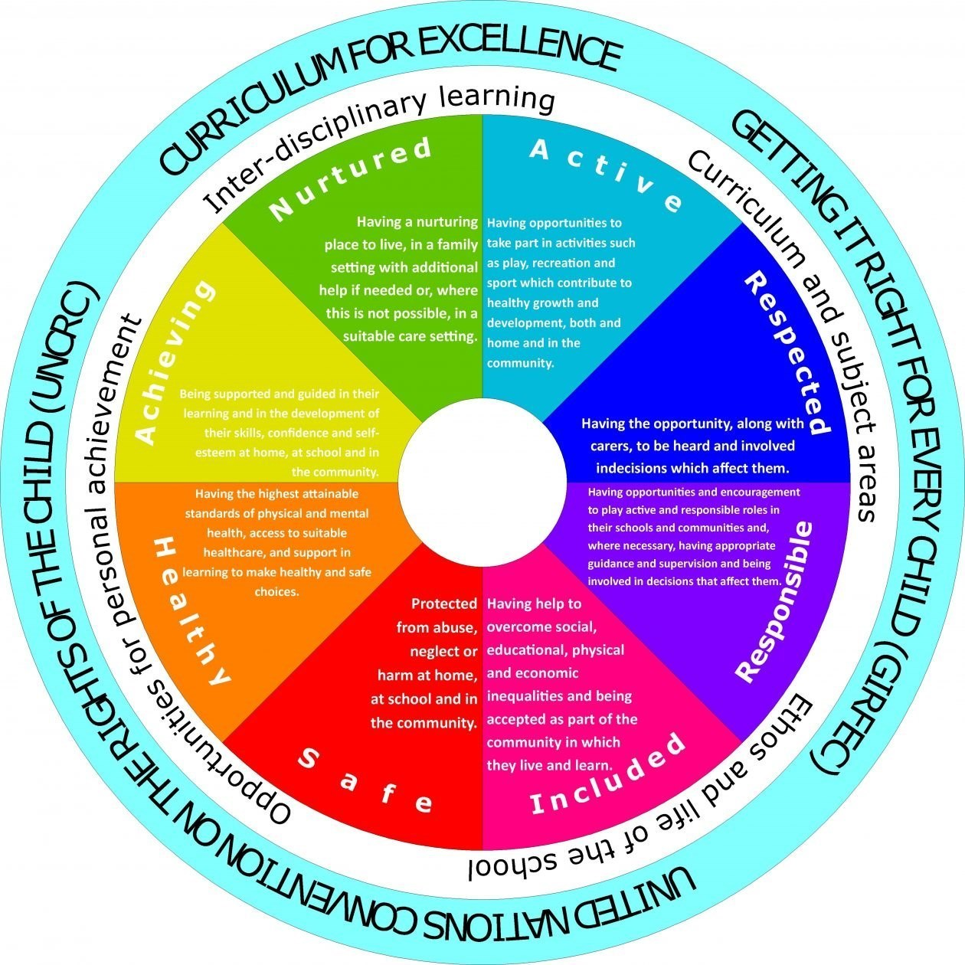
Safeguarding at Monkton
The safety and wellbeing of children at Monkton Primary School and Early Years Centre is our upmost priority. If you have any concerns about a child protection matter, please contact the school to make an appointment with Mrs Miller (Child Protection Coordinator) or Mrs Ramsay (Depute Child Protection Coordinator). Both the HT and DHT are also PREVENT officers.
Our Child Protection Guidelines can be found on the school / EYC website.

Learning, Teaching and Assessment (UNCRC Articles 28 and 29)

School Improvement Plan for 2025/26 and Standards and Quality Report 2024-25
These annual reports have now been finalised and approved by the authority. They are available to view on the school website. These show the EYC and school priorities for the year ahead which includes South Ayrshire Reads (see parent workshop on offer below).

Parent Volunteers for Extra Curricular Activities
HELP NEEDED - we still don't have any volunteers to help with extra curricular activities, in particular the school football team.
Active Schools play a key role in providing opportunities during the school day and after school - they also provide many of the resources required. They also organise a competitive calendar of competitions and events across the year - we try to attend as many of these as we can so that children have opportunities to take part and compete as well as meet new friends. Over the past two years, we have tried to make sure that we attend all of the cluster school events . Each event costs us money to travel to venues - buses are very expensive but we try to travel with Symington, where possible, to reduce costs. Moving forward, we are planning on asking parents of children involved, for a small donation to help towards the cost of the bus travel, if they are able to contribute to it.
Most other schools have parent volunteers who coach the school football teams therefore we are asking if there are any parent / carers who are willing to give up some time, after school or at lunchtime to provide training / support to lead our football team. At the moment, due to very tight staffing capacity and the fact that no volunteers have come forward, it is looking like we will only be able to run one mixed football team consisting of only P7 pupils this session. They will take part in some after school matches and occasional lunch time training sessions.
We would also love to be able to offer more extra-curricular clubs either at lunchtime or after school including art, music or games so if any parent / carers would be able to offer any time to help share their expertise in any areas, please get in touch. Please email Monkton.mail@south-ayrshire.gov.uk if you would like to help out in any way and let us know your availability. We would be very grateful for any help that you are able to offer, even just a few hours - thank you!
Please note that parent volunteers may need to be PVG / Disclosure checked.

Home Learning
Starting this week, class teachers will set tasks which reinforce the learning from the classroom which is to be completed at home.
Children in P1-7 will have the following learning at home:-
•1 Phonics / Spelling task per week (to reinforce sounds or words)
•1 Reading task – reading a book or allocated chapter(s) per week
•1 Maths task per week
It is very important that children bring their reading books, blue book bags and homework diaries to and from school each day.
Children are encouraged to read for enjoyment each night at home. They should be encouraged to read what they enjoy including books, comics or magazines either with an adult / sibling or themselves. Children in P4-7 can read a book at home and then complete the quiz (if there is one) on Accelerated Reader when they come into school.
Each week, details of the home learning to be completed will be written in the homework diary along with the date it was issued and the due date. This will help parent / carers know what is to be done and, for older children, will allow them to keep track and learn independence skills which will help them when they move into secondary school. The homework diary should be signed by the parent/carer when home learning tasks are complete/at the end of the week.
We know that households are busy in the evenings but parent / carers should complete homework with their child(ren) each week. As children move up the school, children can do this more independently with parents checking that the work is correct / complete and signing their homework diary.

P1-3 Parent Workshop - Friday 5th September 2025 - 1:45-2:25pm (before Meet the Teacher)
This session will be run by the South Ayrshire Reads Team who have been training staff and supporting the teaching of reading in schools for the past few years. They are offering this short workshop to all P1-3 parent / carers to help you to support your child's reading development and progress at home. Please try to attend if you can - thank you.

Sharing Achievements
This year, children will continue to be encouraged to share achievements in the school and EYC. If your child has an achievement, they can bring it into school / EYC to share with their teacher, EYP and peers on a Friday. Alternatively, a photo can be emailed to Monkton.Mail@south-ayrshire.gov.uk - which will be passed on. We will continue to display achievements on the Achievement Board in school and sometimes on Instagram. Thank you!

Reporting to Parents this session
This session the school will report to parents of P1-7 pupils the same way as we did last session in line with the authority's guidance on this. There will be two formal opportunities for parents to meet their child’s class teacher and one detailed written report each school year. EYC children will have care plans written and shared with parents three times per year.
As a school (and in line with the cluster schools), we have scheduled in our parents meetings for:-
Thursday 9th October 2025 3:15-5:15pm or 5:45-8pm
and
Thursday 26th March 2026 – 3:15-5:15pm and 5:45-8pm
(Appointments will be available to book on ParentsPortal, so please set up if you have not already done so, thanks)
We will offer afternoon and evening appointment options to try to help to accommodate work patterns and hours as well as childcare. In advance of these dates, you will be sent an email inviting you to book an appointment with your child’s class teacher. On the day of your appointment, you will meet your child’s class teacher(s) in the gym hall and then will have the chance to go along to your child’s class to have a look at their work.
At the beginning of June 2026, all Pre-school and P1-7 children will receive a written report from their key worker / class teacher which they will bring home to share with parent / carers. The format will be very similar to the final report from last session and is used across the cluster by all the primary schools.
In addition to the two formal parents meetings this session, we have decided to hold an informal ‘meet the teacher’ session on Friday 5th September 2025 where you can drop into your P1-7 child's classroom from 2:30-3pm to meet their class teacher and look at their classroom. Please note that teachers will not be able to discuss your child individually during this session. As we have done for the past few years, we will offer family learning opportunities throughout the year in order to share learning (more details to follow).
As always, we operate an open door policy so if you have any concerns or questions about your child’s learning or progress throughout the year, please contact the school to make an appointment with their class teacher to discuss.


Community Noticeboard (UNCRC Articles 18, 24, 29 and 31)

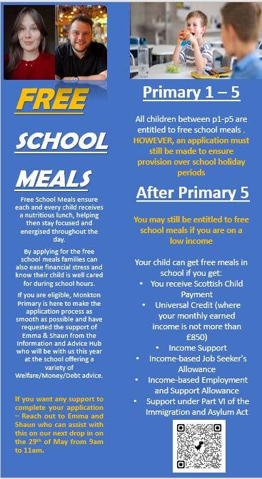
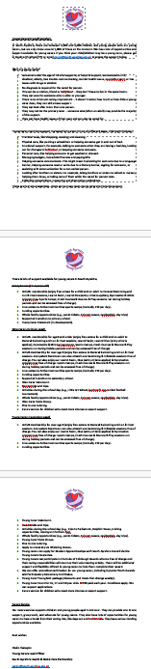

Communication (UNCRC Articles 3 and 5)

Communication with parents / carers continues to be of upmost importance to us and we will communicate in a variety of ways.
Please report absences before 9:30am each morning via ParentsPortal if you can. Use the 'Absence Reporting; tile to do so. This can also be used to record appointments or any time that our child is required to be out of school.
Important updates / information will be sent to you by email so please check daily for these. SMS text messages will only be sent if your child is absent (if you have not informed us) or for urgent information.
Instagram is being used for reminders and to share learning in class (2 posts per week per class). You will receive 2 class newsletters per year outlining what your child will be learning in class: EYC - P7.
We have created a summary of the online platforms that we use and what information will be sent using each one - Communication-Strategy-Jan-25.pdf
If you have any feedback, questions (however small) or information to be shared, please phone the school on 01292 473456 or email us – Monkton.Mail@south-ayrshire.gov.uk
If you have any class based / individual pupil concerns, please contact the office to arrange to talk to your child’s class teacher or EYC key worker as first point of contact. In some circumstances, you may wish to talk to -
•Mrs Miller if your child is in EYC, P1, P2 or P3 or Mrs Ramsay if your child is in P4, P5, P6 or P7.
Please do not email class teachers, HT or DHT directly as they may be out of school with no access to emails. Instead, please contact the school office to make an appointment or email the school mailbox with your enquiry. It will be passed on and they will respond to you during school hours, usually within 5 days.
If you are not happy with the outcome of your enquiry, you have the right to escalate your complaint to the authority - https://www.south-ayrshire.gov.uk/complaints/

Contact Us (UNCRC Articles 5 and 18)


01292 473456

1 -
Monkton.Mail@south-ayrshire.gov.uk

https://blogs.glowscotland.org.uk/sa/monktonpsandeyc/

m_p_s_2_r_h (Primary Instagram)

@MonktonPS – Primary and Early Years

Our Vision, Values and Aims (UNCRC Article 2 and 29)
Our Vision
At Monkton, we encourage and support every child to be the best they can be. Our ambition is to close the attainment gap by stretching and challenging all children. Children are encouraged to have high standards and be aspirational about their future. A school in the community as well as a community in the school. At Monkton We Fly As High As The Sky!

Our Values
The school values are Honesty, Compassion, Respect, Responsibility and Equity.
For a number of years, the school has shared values with the other schools in the Prestwick Academy cluster. The cluster schools have also created ‘Our Prestwick Promise’ which is-
“We aim to work collaboratively across the cluster, supporting and challenging each other to improve outcomes for children and young people and to help raise attainment for all. We will work together across establishments to support equity and address gaps by sharing time, expertise and resources. By working collaboratively, we endeavor to reduce workload and provide consistent approaches, pedagogy and systems to promote high quality learning and teaching.”
Each year, we create a Prestwick Cluster Action plan which we work together on throughout the school session.

Our Aims
Fantastic futures for all!
Learning life skills!
You have pride in the school!

Hard working children and helpful staff!
In Monkton, everyone is included!
Great learning experiences (including play)!
Heart of the Monkton community!

