Welcome back!
I hope you all had a lovely Easter break.
P7 will be very busy this term – it’s the final few weeks of primary. We are already preparing for the Leaver’s Assembly in June. Pupils have been writing about their memories here at Holmston and will be talking to you about their Dolphin House residential trip.
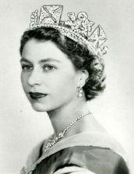
Pupils are excited to be visiting their future secondary school this term and will have the chance to meet some of the new teachers and pupils. Please look out for dates and information being sent home about this.
We are currently learning all about the 1950’s which is our new topic this term, pupils will be learning about the fashion, music, dancing, key events and the Queen’s Coronation. We are looking forward to our Jubilee Garden Party on the 1st of June and hope you will all be able to come along and celebrate with us. We will be performing a song from the 1950’s and we are currently learning how to do the hand jive!
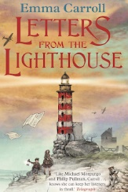
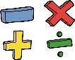
In maths we have been learning about statistics, pupils have been interpreting and analysing bar graphs, line graphs, pictographs and pie charts. We will also be learning about Time, Distance and Speed, Ratio and money linked to foreign exchange and best buys.
In literacy we will be reading and working on activities based on the novel ‘Letters from the Lighthouse’. Pupils will have a chance to continue to develop their visualisation, metalinguistic and comprehension skills.
Primary 7 pupils will be preparing for Sports Day this term. House Captains will be organising activities and games for classes to take part in and will lead the organisation of the relay and tug of war. Pupils are looking forward to Sports Day on the 10th June.
Our Digital Leaders are working with Mrs Davies delivering a lunchtime coding club to younger pupils in the school.

Miss McKenzie

