Primary 5 Newsletter

We are excited to welcome Primary 5 back into class after the Easter break and we hope that plenty of fun was had with friends and family! In our last term of the year, we are going to make the most of the lovely weather to get more involved in the school allotment and taking our learning outdoors! Primary 5 also have the opportunity to participate in Bikeability to make progress in our cycling.

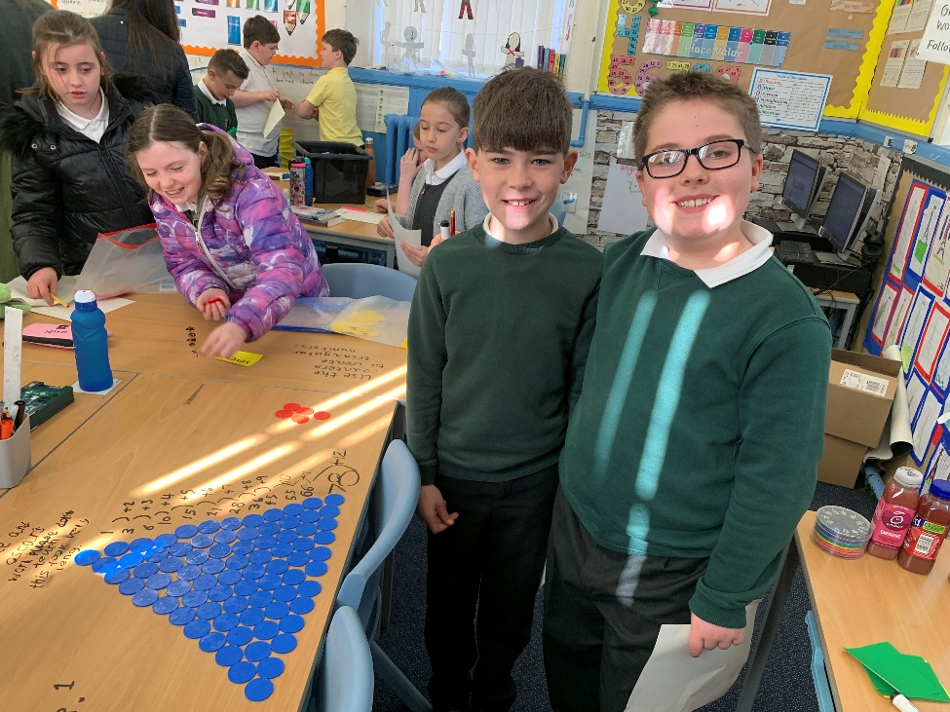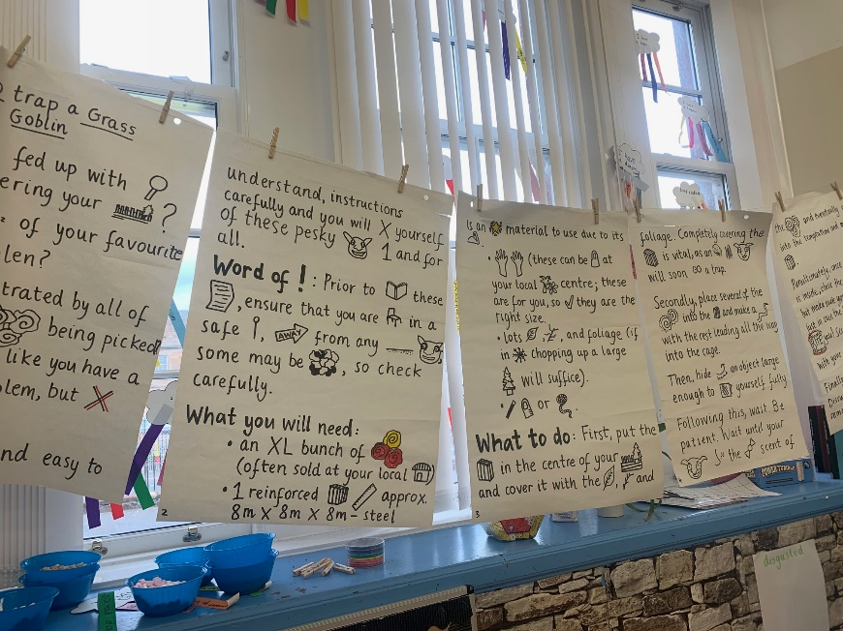

Numeracy

With Miss Creasey, the class have been exploring fractions, decimals, and percentages. P5 have suggested many reasons why this topic is important in the real world – especially when it comes to sharing food! Future topics within Numeracy will include Expressions and Equations, Patterns and Relationships, and Co-ordinates.

With Mrs Cox, the class have been exploring Data Analysis using a range of techniques and materials to present and interpret information.

Primary 5 are enjoying participating in active learning and using concrete materials and visuals to further their understanding, and to strengthen their maths mindsets!

Literacy

Our focus this term is non-fiction writing, specifically information and instructional writing. Using our Talk for Writing process, we have been looking at our model text “Goblinology”, which the class have enjoyed creating a story map and drama about. They have been demonstrating their improving writing skills through their short burst writing, which are always full of imagination! The class novels we are reading this term to develop our strategies are; Harry Potter, Kaspar Prince of Cats, Rascal Facing the Flames, and Tilly and the Badgers. We will continue to consolidate our spelling strategies by revisiting past phonemes and tricky words.

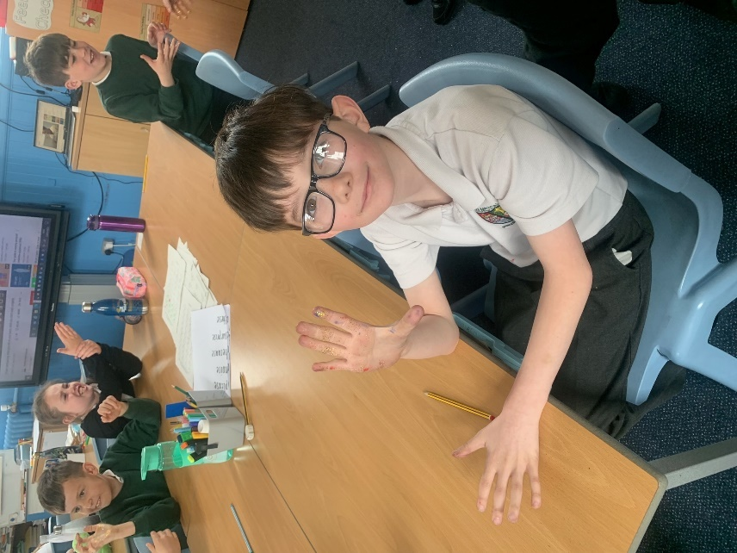

Health and Wellbeing

Primary 5 will first be learning about Personal Hygiene and the importance of keeping clean. They will also be looking at the impact of the healthy and unhealthy choices they can make. We will continue to work on our communication skills, and consider how we can ensure of respecting and understanding individual boundaries.

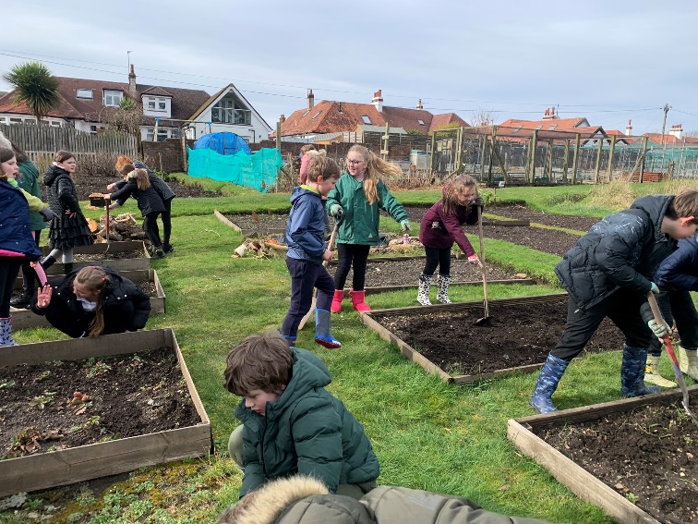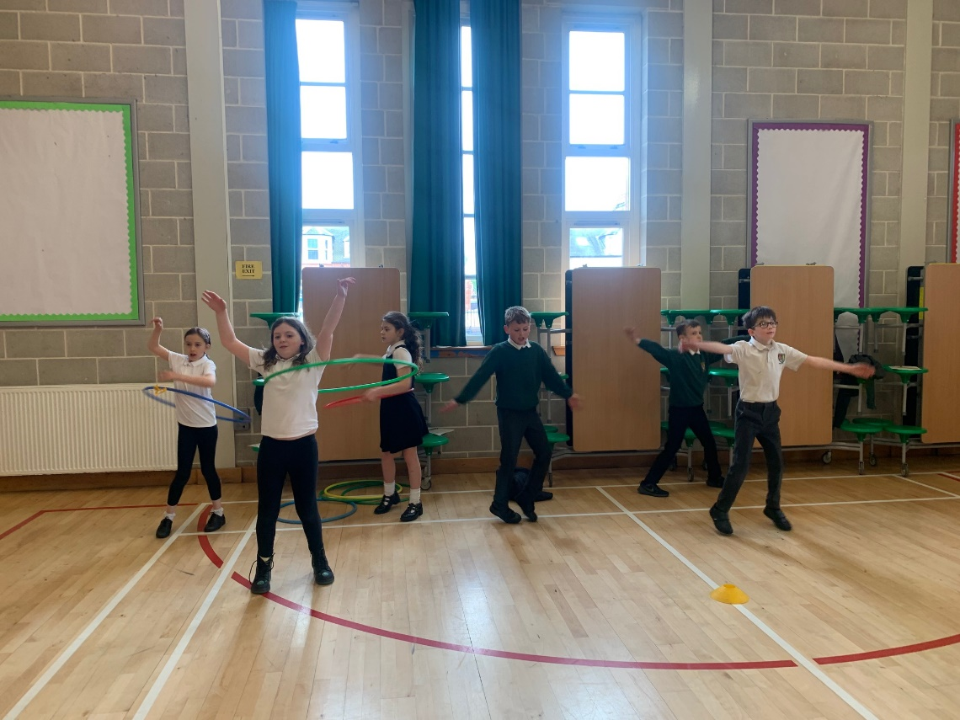

PE

Primary 5 have been enjoying Bikeability on Wednesday afternoons, giving them the chance to improve their cycling skills and gain a better understanding of road safety. We have also been working on fitness stations and have been motivating each other to do our best.

RME

This term, Primary 5 are learning about Hinduism. This will cover the main beliefs, festivals, and common practices.

Allotment

This term, Primary 5 have been visiting the allotment every fortnight in their afternoon groups to work with Jimmy and Dorothy, helping the Holmston Plot grow! Recently, we have been planting onions, nasturtiums, and radishes, alongside doing plenty of weeding! We have even refreshed the small pond in our plot which is looking and smelling much better now!

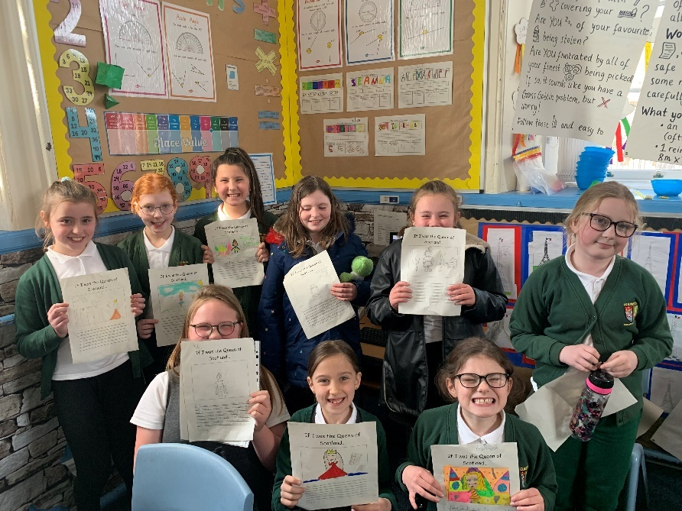

We are very excited about the amazing term we have ahead, and preparing the class for their next big adventure into Primary 6. We know that we will continue to see Primary 5 progress in their learning and confidence with such exciting topics and experiences.

If you have any questions, please don’t hesitate to get in touch.

Miss Creasey and Mrs Cox

Topic

Our main topic this term is the Scottish Wars of Independence, and how it is relevant and important to us in Scotland today. Using different artworks, listening to music, and participating in drama, we will gain a better understanding of the history of the Scotland we live in today.