

**Holmston Primary School**

**December Newsletter 2020**

We have made it to the end of a very busy – if very different - term. As you will know, the First Minister has extended the holidays for pupils until the **11th January**. After this, until at least the 18th January, we will be working remotely through Teams. P1 and P2 will continue to use the *‘2 Simple’* package and send out the home learning newsletters. They will also have a Class Team for communicating with each other. Details about this will be sent home for P1 parents. Please would all parents and carers make sure they are familiar with logging on and accessing Teams through Glow. You can find guides for this on the school website in the Home Learning section. Pupils have previously been issued with Sumdog and Education City passwords and for pupils in P4 – P7, guides for using Accelerated Reader, the quizzes and book-finder can also be found on the website.

Here is the link for the school website. In the Home Learning section, you will find a range of additional work split into year groups. There is also a ‘useful links’ section with links to lots of educational websites.

<https://blogs.glowscotland.org.uk/sa/holmstonps/>

**Festive Fun!**

We have had lots of fun learning during December, with many Christmas themed activities including quizzes, crafts, problem solving, Christmas lunches and language activities. We even had a visit from Isla the pony and Santa sent in a video message for the P1, P2 and P3. He also left presents for all the pupils. Here are just some of the photos.

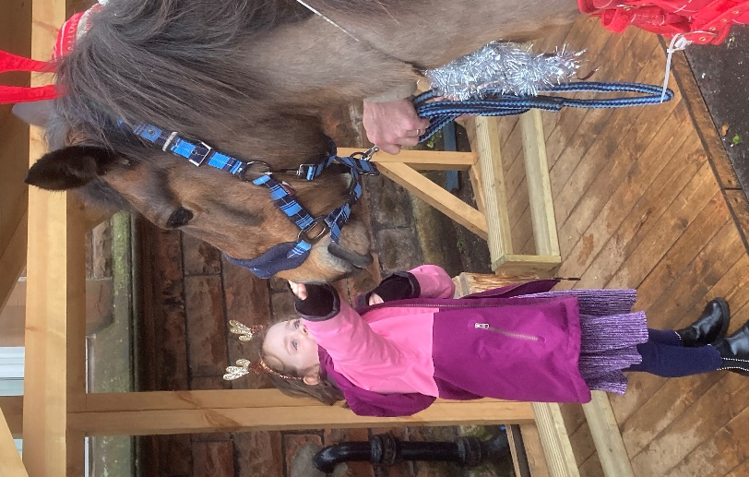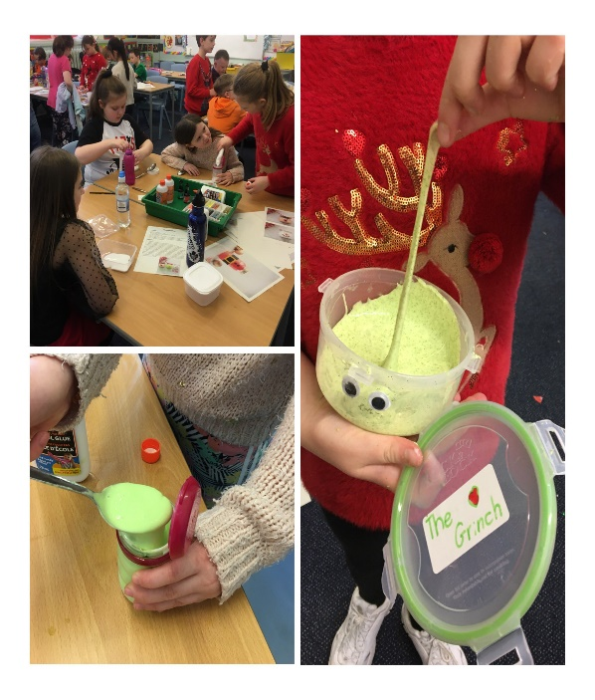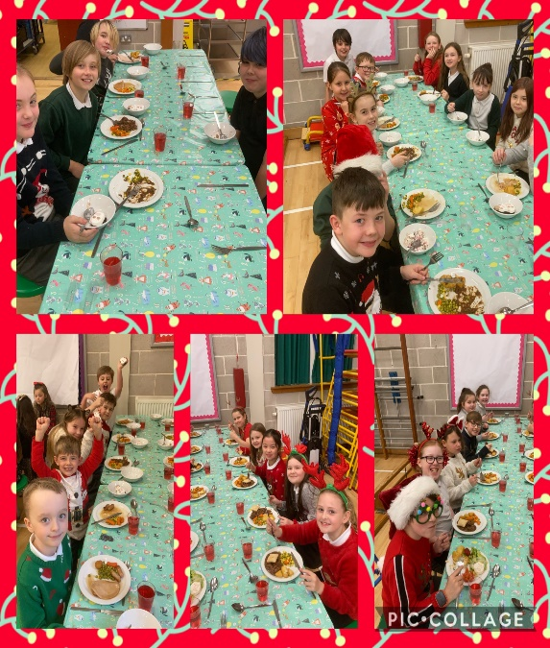

Primary 1 performed a Nativity which unfortunately had to be cancelled but we were able to share it online with the parents. So far there have been 146 views. Primary 2 posted an online music video with some great dance moves including from Miss Audino and Miss Johnston. That has been viewed over 300 times! Well done to both classes!

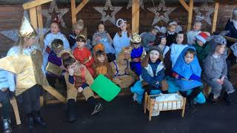

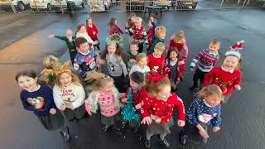

**Hamper Winners**

Thank you to everyone who sent in items for the class Christmas Hampers. These were raffled last week and congratulations to the following pupils who won their class hamper. Fletcher (P1), Orla (P2), Andrew (P3), Emily (P4), Max (P5), Isla (P6) and Amy (P7).

**Family Xmas Quiz**

Well done to all our families that took part in the quiz – we have a lot of movie buffs out there! I never knew we had so many families knowledgeable about the life of Martin Luther! Just for the record – Jesus Christ was not a famous physicist, ‘too much vodka’ is not how Boxing Day gets its name, reindeers don’t fly and Elvis was never a priest, professor or monk! Our winning team was We Wish You a Quizzy Quizmas. In second place were The Allens. Our joint third place winners were Team Christmays and Christmas Pies.

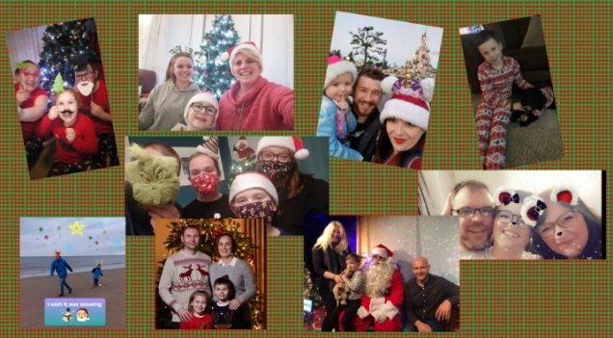

**Bikeability**

Our Primary 6 and Primary 7 have completed their Bikeability programme. Well done to all of those achieving level one or level two. We would like to thank all the volunteers and helpers. Hopefully, later on in the year we will have the annual P6 bike ride.

**Uniform**

We have had lots of fun wearing our Christmas jumpers and festive accessories during December. We would like to remind you than when we start back normal uniform should be worn. Please ensure you child comes to school in the correct uniform. Pupils should not come in with painted or false nails, jewellery or items of clothing that are not school uniform. We are the Holmston Community and part of being at the school is to wear the correct uniform.

**Staffing**

We will be saying farewell to Miss Reid. Miss Reid has been working at the school for over a year now. She will be taking up a new post in January at Forehill Primary. We wish her all the best and thank her for all her hard work.

Miss Dickson will be returning in January after finishing her maternity leave.

**Return to Schooling January 2021**

We will keep you updated with information in the event of any changes but initially teachers will be delivering classes via Teams from Monday 11th January. Pupils are planned to return on Monday 18th January. We will continue with the staggered timings to ensure we are as safe as possible. Please ensure that you inform the school if you change your email or phone number. Email is our first form of communication at this time. If you need to contact the school, please use [Holmston.mail@south-ayrshire.gov.uk](mailto:Holmston.mail@south-ayrshire.gov.uk).

**Learner Engagement During Remote Learning**

Monitoring learner engagement during periods of remote learning is essential. In line with the Authority guidance, daily attendance registers will be maintained to highlight those children or young people who have engaged in online learning. This information will be submitted to the Authority and reported to Scottish Government.

We have lots of exciting opportunities already planned for our pupils in the new term. Including some very exciting developments for the playground – watch this space!

We wish all our families a restful, peaceful and safe Christmas and a Happy New Year.

Richard and the Holmston Team

