We love reading!
Have you seen pictures of our Primary 1 children reading outside in the play barn?! (Follow us on Twitter!) Many are choosing to read (independently) in our reading den inside the classroom, too. It’s amazing! Thank you for your continued support at home, it really makes such a difference!

Oxford Owl Reading
We are loving this online reading resource; it enables us to facilitate home reading. Please follow the instructions in the ‘Accessing Oxford Owl’ document to find the assigned e-books. There are fun follow-up activities for the children to practise key literacy skills.

Reading Books
Please search for the reading book allocated to your child’s reading group.
 |  | 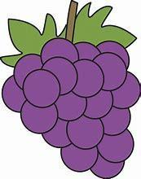
Hit and Miss  (Pink Level) | The Lemon Pip  (Pink Level) | Cats  (Pink Level)

Reading Tips
- Identify the red ‘tricky’ words in the text.
- Sound-out and blend to read words you are unsure of.
- Track and follow the words with your finger.
- Look out for punctuation . “” ? and !
- Try to change your voice and use expression to show when someone is speaking.
- Ask questions to check understanding.
- Most importantly, make reading a special time where you snuggle up and enjoy reading together.

