We love reading!
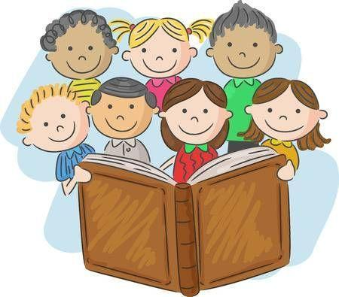
We are so impressed with the children’s reading! Thank you for practising at home, this really makes a difference. Please try to read at home as much as you possibly can. Thank you so much!

Oxford Owl Reading
We are loving this online reading resource; it enables us to facilitate home reading. Please follow the instructions in the ‘Accessing Oxford Owl’ document to find the assigned e-books. There are fun follow-up activities for the children to practise key literacy skills.

Reading Books
Please search for the reading book allocated to your child’s reading group.
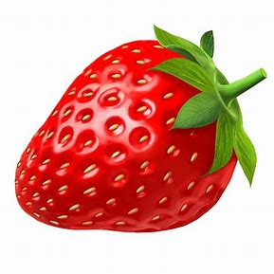 | 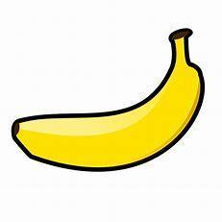 | 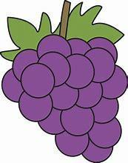
Hats  (Pink Level) | Big, Bad Bug  (Pink Level) | Tin Can Tracks  (Lilac Level)

Reading Tips
- Identify the red ‘tricky’ words in the text.
- Sound-out and blend to read words you are unsure of.
- Track and follow the words with your finger.
- Look out for punctuation . “” ? and !
- Try to change your voice and use expression to show when someone is speaking.
- Ask questions to check understanding.
- Most importantly, make reading a special time where you snuggle up and enjoy reading together.

