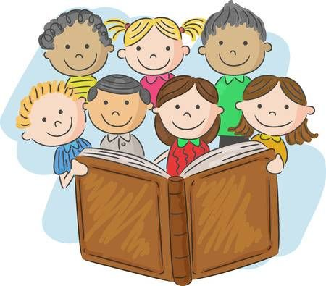
We Love Reading
6/11/20

Oxford Owl Reading
We have been taking part in some fantastic reading in class and we are now able to access ‘Oxford Owl E-books’ for you to read together with your children at home. There are also fun follow up activities to complete relating to each story book. Please see the steps below on how to access the website:

Instruction
- Copy this link into your web browser https://www.oxfordowl.co.uk/
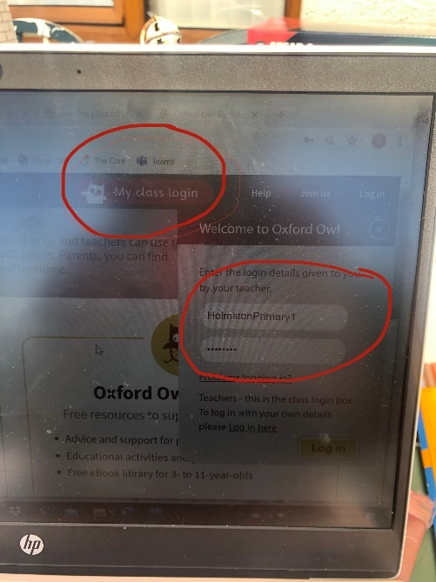
- Log into ‘My Class Log In’ at the top right-hand side of the web page. Log in using the details below:
- Username – holmstonprimary2
- Password – holmston123

- Select ‘Oxford Owl ebook Library’ and search for the name of the book assigned by your class teachers: according to your reading group. See table below.
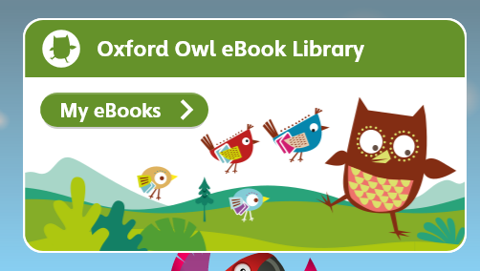

- Use the audio button to listen to the story together and turn the pages using the left and right arrows.
- Read the story supporting your child when needed and complete the ‘Play activities’ located at the top of the page.

Reading Books
Spiders & Bumble Bees  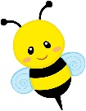  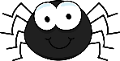 | 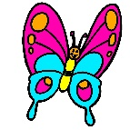  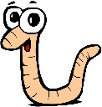  Worms & Butterflies | 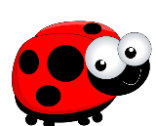  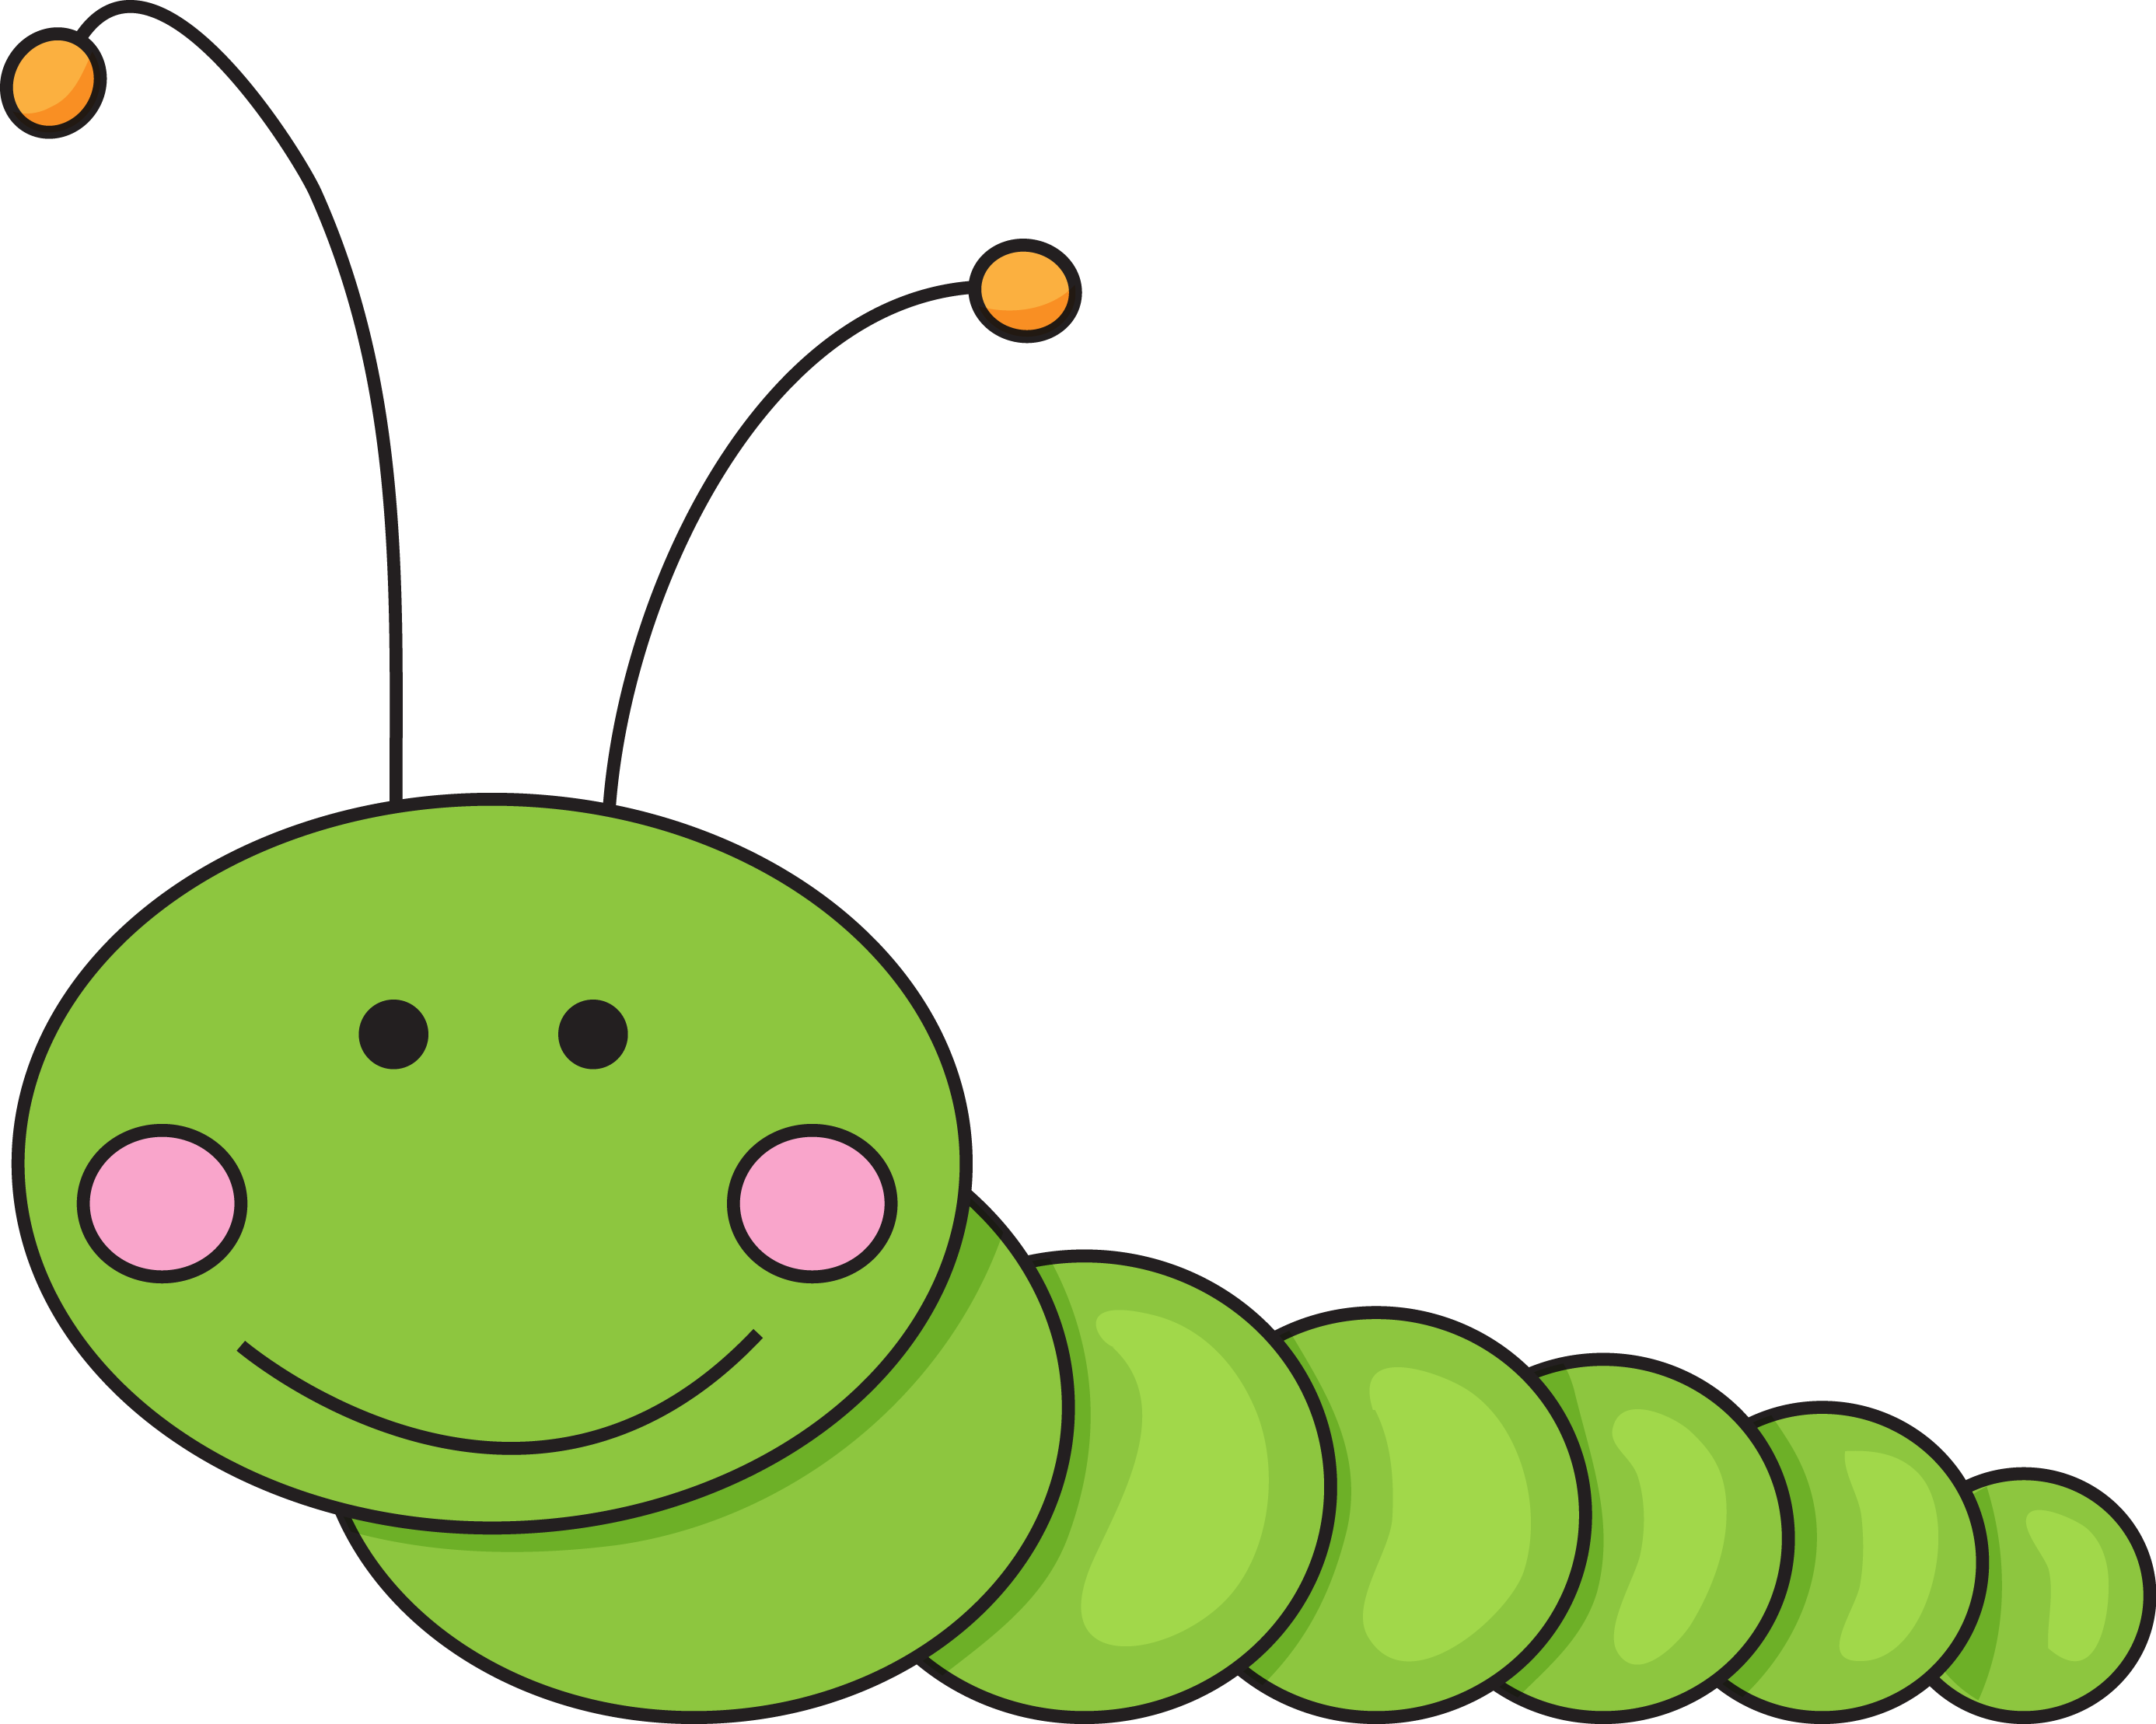  Caterpillars & Ladybirds
‘Run Run’ | ‘Toads in the Road’ | ‘Posh Shops’

Reading Tips
- Say each sound before blending to read the word.
- Use your finger to follow the words on the page.
- Watch out for punctuation e.g. speech marks “”
question marks? and exclamation marks!
- Try to change the tone of your voice and use expression when someone is talking.
- Continue to read the book to build on the children’s confidence and discuss the story/characters and setting.
Most Importantly HAVE FUN and continue your shared reading.
You are all FANTASTIC

