**Primary 1 Newsletter & Home Learning - 30th October 2020**

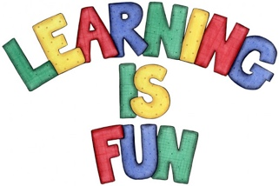

Our P1 children have settled back in nicely after the half-term holiday and we are pleased to say they have returned happy and eager to learn. What a fabulous bunch they are!

**Indoor Classroom**

We have changed things up a little and enhanced our play-based learning environment with lots of new and exciting invitations to play…your children are thriving and it is wonderful to see such high levels of engagement! As always, this is both Literacy and Numeracy rich to enable them to continually build on those core skills. They are progressing at a fast pace in Phonics and enjoying the Number challenges in both our indoor and outdoor classrooms. We are impressed!

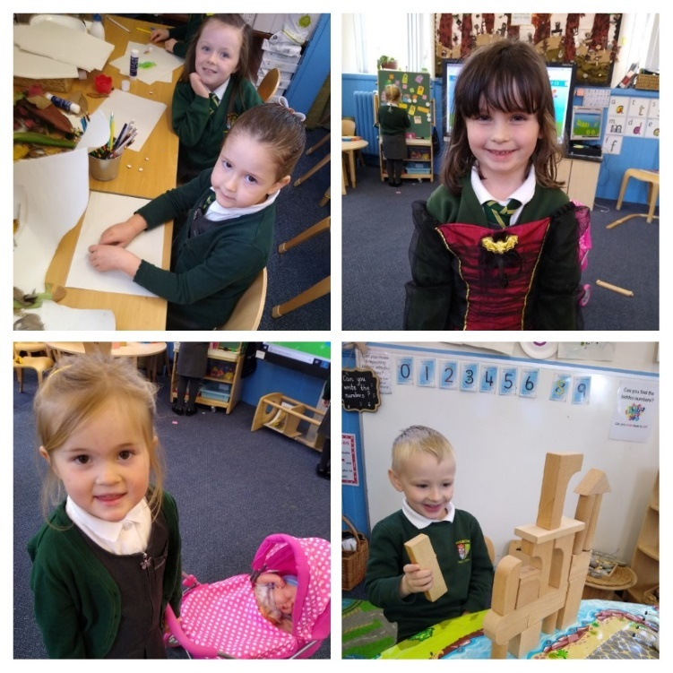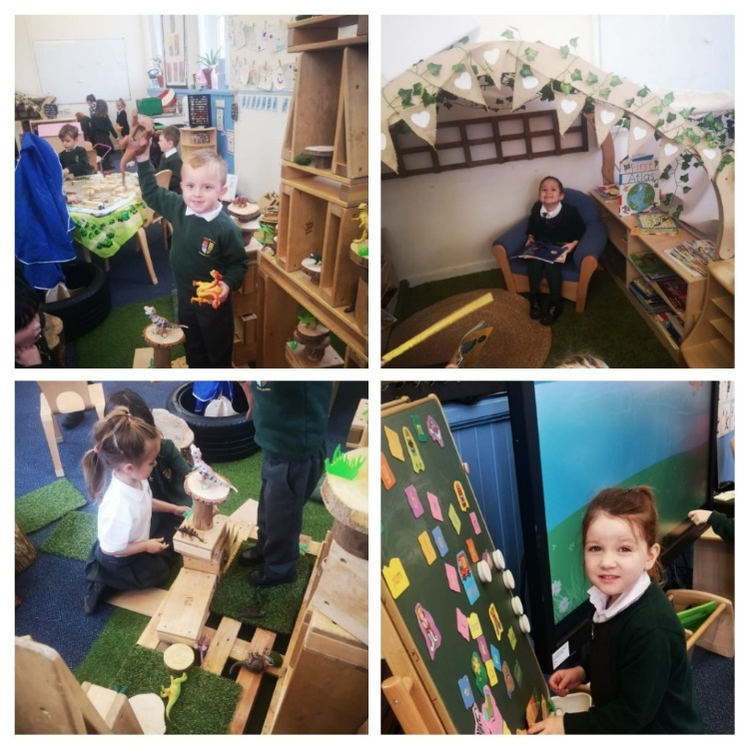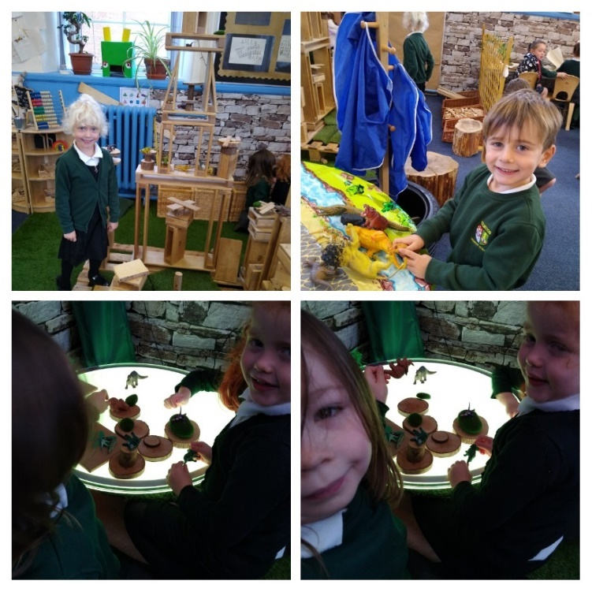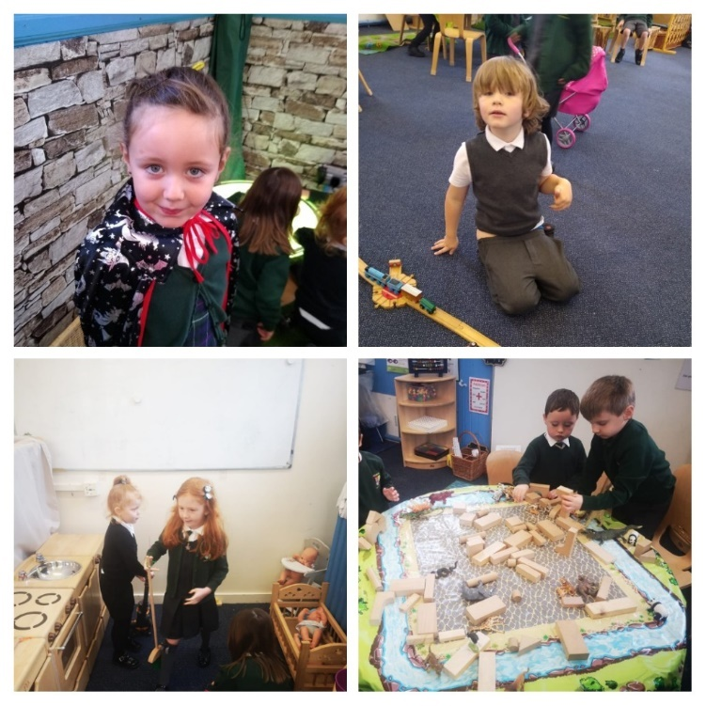

**Outdoor Classroom**

The children LOVE being outdoors and our Mud Kitchen has proved a big hit! While this can get a little messy, it is such a wonderful vehicle for investigative and sensory play. We will be carving pumpkins and making some spook-tacular potions in it this week…woooooo! We will be continuing to make use of the outside space as often as possible, so please do ensure that your child has appropriate clothing.

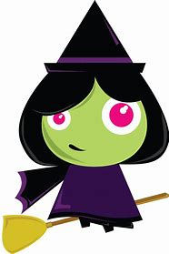 [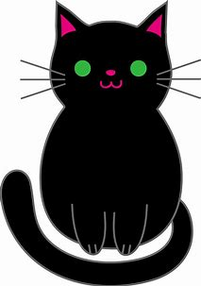](https://www.bing.com/images/search?view=detailV2&ccid=iFlRyNXK&id=462DA00317905F7E89B3BBB98968831CAFC9808F&thid=OIP.iFlRyNXKY3f8A6CbE5Q51QHaKl&mediaurl=http%3a%2f%2fcliparts.co%2fcliparts%2fpc5%2f8gE%2fpc58gE7zi.png&exph=5039&expw=3526&q=black+cat+clip+art&simid=608055262146200942&ck=A5F03B6D6C65B7F4E9FCA0EE32E7D7EC&selectedIndex=0&adlt=strict&FORM=IRPRST) [](https://www.bing.com/images/search?view=detailV2&ccid=d9lNhQ76&id=DC61CE589949F1FEF61C317DE205B607D547127C&thid=OIP.d9lNhQ76NtPJ0Q4FQ7M_xgHaHX&mediaurl=http%3a%2f%2fimages.clipartpanda.com%2fcute-pumpkin-patch-clipart-Large_Transparent_Halloween_Pumpkin_Clipart.png&exph=2486&expw=2500&q=pumpkin+clipart+images&simid=608030042149684168&ck=AA810239711AC47964C261685878DE43&selectedIndex=0&adlt=strict&FORM=IRPRST)

**Numeracy & Mathematics**

We have continued to use **Numicon** as a resource to further the children’s understanding of **partitioning** and how numbers are made. For example, number 14 would be represented as:

 

“**14** is one **TEN** and four **MORE**.”

Please encourage your children to use this language as they try other examples from 11-20 (and more, if they are feeling confident). Thank you!

Please see the attached PowerPoint ‘**Numicon Numbers**’ and work through this with your children. You could also cut out the Numicon pieces from our last newsletter and use these to make different numbers. You can also access the ‘**Numicon Shapes**’ document online. As always, please do encourage your children to count (using the ‘**move**/**touch**-**and**-**count**’ method) items in their everyday environment.

**Phonics**

We have continued with our learning journey in Phonics.

**Phonics Song**

<https://www.youtube.com/watch?v=jPVbJ-IaHIw>

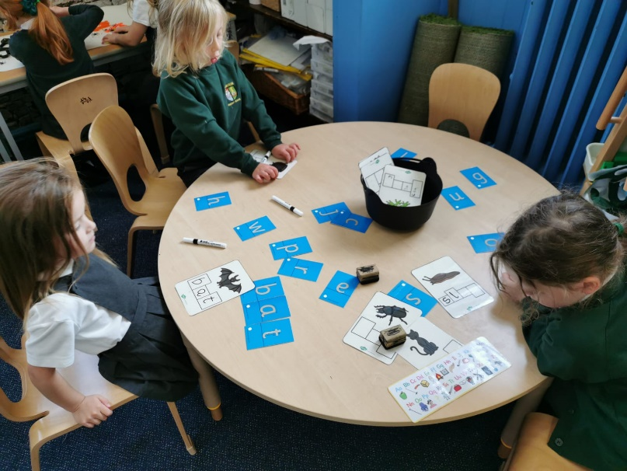 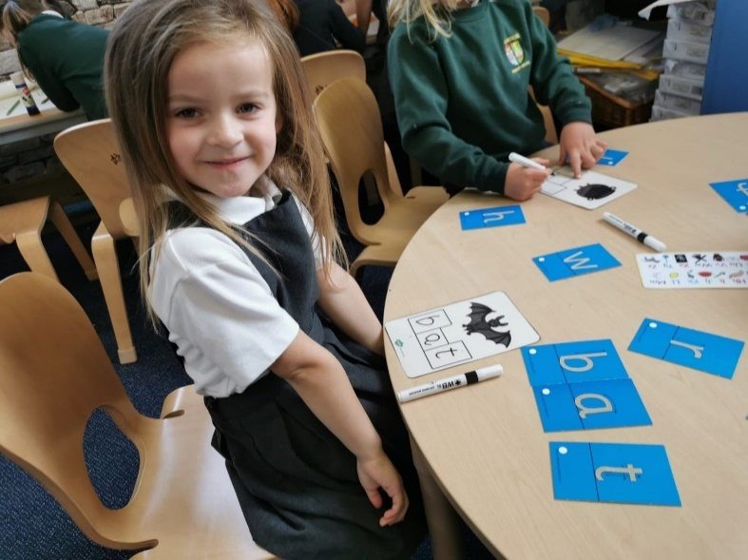

**a, t, s, i, p, n**

**r, m, d, e, c, k**

**g, l, f, o, b, u**

Within phonics sessions we focus on the **sounds** (**phonemes**) that the **letters** (**graphemes**) make. For example:

*The* ***letter name*** *is ‘****f****’ and the* ***letter sound*** *is ‘****ffffffffffffffff****’.*

During phonics the children have a try at making the sounds and writing the letters for the sound being taught.

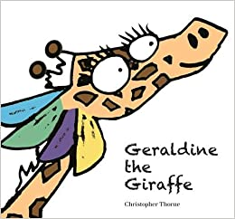

<https://youtu.be/YIQQo9eYVqk>

<https://youtu.be/ztsfsOl9l9Q>

<https://youtu.be/kmmewEew6lM>

One of the resources we use to introduce new sounds to

children is:

**Geraldine Giraffe**

When teaching the children how to form the letters we use the following verbal patterns:

|  |  |  |
| --- | --- | --- |
|  |  |  |
| Around the girl’s face, down her hair and give her a curl. | Down the long leg. | |  | | --- | | Down the stem and draw the leaves. | |
|  |  |  |
| |  | | --- | | All around the orange. | | |  | | --- | | Down the laces to the heel and around the toe. | | |  | | --- | | Down and under, up to the top and draw the puddle. | |

|  |  |
| --- | --- |
| **Blending** | **Segmenting** |
| As children learn their sounds, they are taught how to **blend** sounds together for **reading**:  b-u-g…b-u-g…bug  *Children ‘sound out’ the words, gradually increasing the speed until they can* read *the word.* | They are also taught to write words by stretching them out to **segment** the word out for **writing:**  *The word is ‘fog’*…  *ffffffffff oooooooooo gggggggggg*  What sound can you hear first? What sound can you hear next? What about the last sound?  *ffffffffff oooooooooo gggggggggg*  *As children identify the sounds in the words, they have a try at writing them down*. |

As the children have learned enough sounds to begin **blending** for **reading,** each week we will be sending home:

**Green Words**

Green words are words that children will be able to use their phonics knowledge to decode and read. Remember to **sound out** each letter before attempting to **blend** and **read** the word.

Now that we have introduced more sounds, why not try to make some new words of your own?

We will also be practising in school and sending home:

**Red Words**

Red words are words that cannot be read using phonics strategies. These are words that children will have to learn to recognise and ‘sight read’. They are **tricky words**.

Please find our 6 new tricky words to practise.

You will find a copy of new sounds, green words and red words at the end of this newsletter. Please encourage children to cut these out to practise blending and reading.

Do speak with a member of the P1 team if you would like a printed copy from school.

**Reading**

[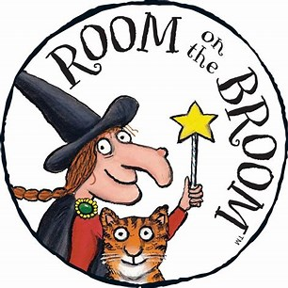](https://www.bing.com/images/search?q=room+on+the+broom+images&id=3BBFDBD01E623126DE3961D17013EAA14D425CFA&FORM=IQFRBA)We are continuing to read in class every day…the children love stories! Our current book study is ‘**Room on the Broom**’ by Julia Donaldson, one of Mrs P-B’s favourites! The children have loved dressing up as witches and wizards and casting their own spells. If you have this book at home, why not snuggle up and read it together? If not, here is a link to the short animation online:

<https://www.bbc.co.uk/iplayer/episode/p0102qfj/room-on-the-broom>

**At Home**

You can continue to support your child’s learning in many ways:

* Get active! Swinging on ‘Monkey Bars’ (and therefore developing those upper arm muscles) will lead to greater fine-motor strength and readiness for writing.
* Be a Number Detective! Continue to look for numbers in and around your environment at home.
* 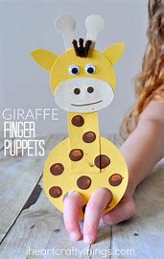Be a Sound Detective! Make your very own ‘**Geraldine Giraffe**’ finger puppet…go looking for things beginning with each of this week’s sounds around the house. Click on the link for instructions:

<https://youtu.be/rIkUlbk7zdg>

* Read and enjoy stories every day! We will soon be issuing instructions for accessing **Oxford Owl** and allocating every child their very own book to read at home. This is so exciting!!! We think you will be **most** impressed with just how well your child can read…watch this space!

**Upcoming Events**

**30th October –** Dress up for **Hallowe’en** and enjoy lots of spook-tacular activities in class!

**10th/11th/12th November** – **Parents’ Evening Consultations** – more information will follow.

*Thank you again for all of your support and please remember to come and speak with us should you have any questions or concerns.*

*Many thanks,*

*Mrs P-B, Mr Locksley and Sharon *

**Phonics Home Learning Pack**

Green Words:

bug

log

golf

leg

frog

gap

Red Words:

come

all

some

are

have

there

Sounds:

f

o

l

g

u

b