Story of ‘ck’

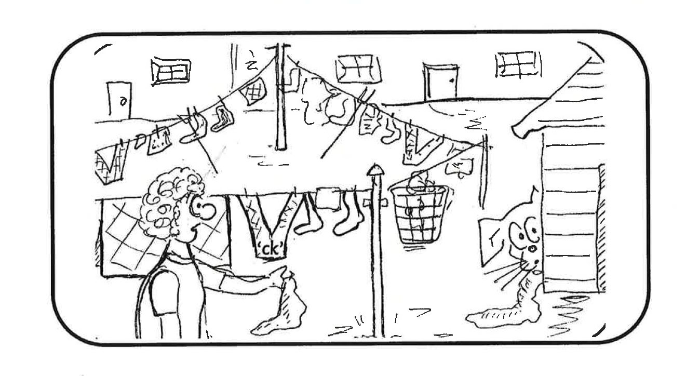

When Dasher was just a puppy he used to play in the back garden and Mum would hang out the washing. One day Mum dropped a sock. Dasher picked up the sock and ran off with it. He tried to squeeze behind the shed but he got stuck. Mum had to use a stick to get her sock back! What a naughty pup he was!

