Primary 4 Newsletter

Welcome back to Holmston and Primary 4!

It has been wonderful to see everyone back. We can’t believe how everyone has grown over the last few months and are so excited to get team P4 learning – loads! Please read on for some important information for our class.

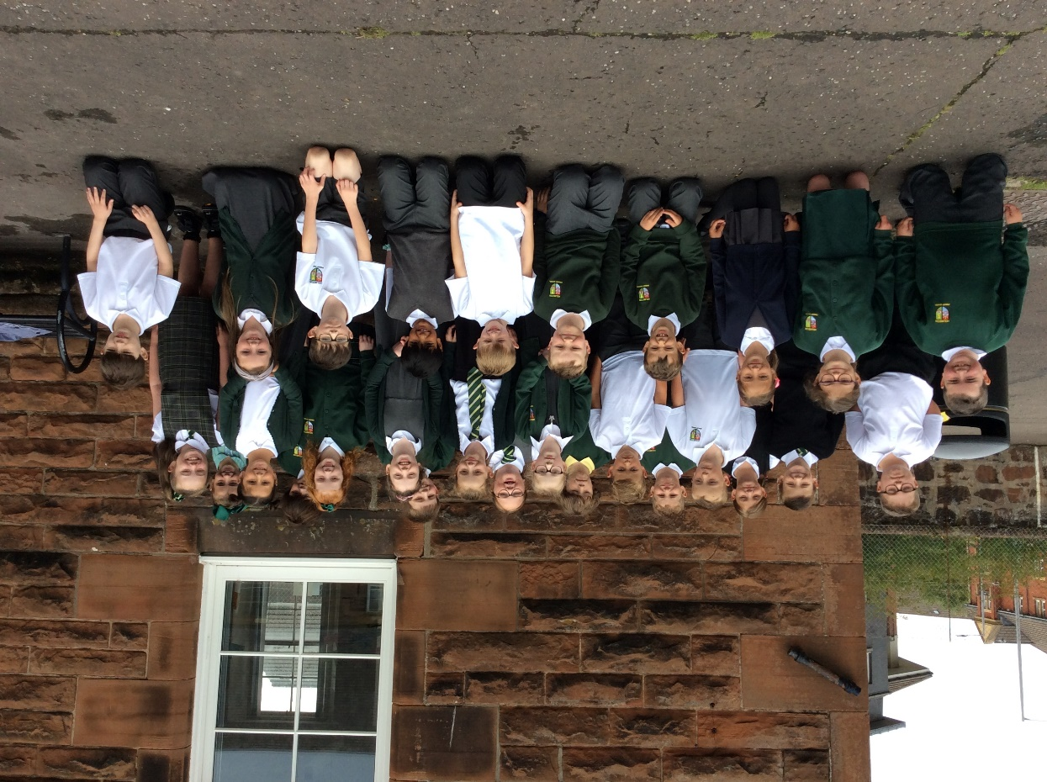

Our priority for the next few weeks will be on ensuring the children’s emotional wellbeing; building relationships, confidence and encouraging independence. We have been working on talking about our feelings and emotions. Everyone has their own feelings ‘check in’ and we encourage these to be shared throughout the day as a prompt for discussions.
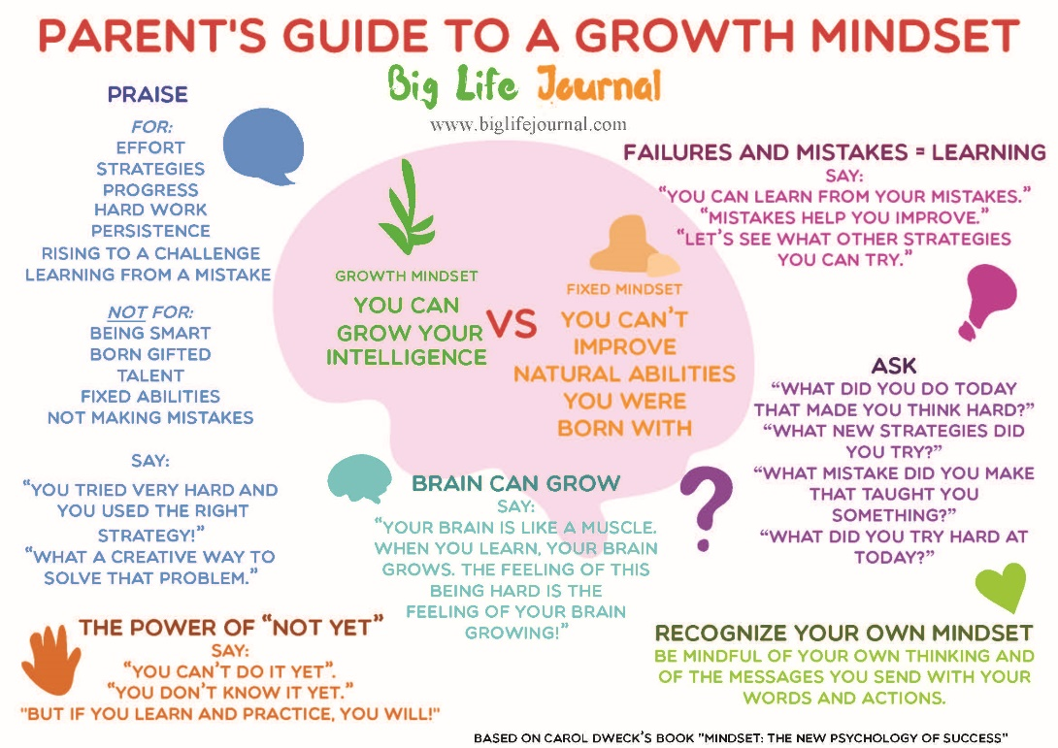

We are currently working through Growth Mindset lessons to encourage perseverance, self belief and resilience in Team P 4. We have included a brief ‘Parent Guide’ to Growth Mindset …enjoy
OUTDOOR P.E SESSIONS
TUES 11.20AM-12.00AM
THURS 9.30AM – 10.00AM
P.E sessions will take place outdoors.

LITERACY

Phonics
READING
In a very real sense, reading is power. Being a lifelong reader means you can use literacy to fulfil purposes in your life. It’s the key to success’ (Fountas and Pinnell 2001)
As you may have already heard our class novel is ‘The Iron Man’. The class are absolutely loving the story so far and the book provides a great opportunity for us to formally introduce the Active Literacy Reading Strategies. These strategies are first taught in Primary 4 and are developed from now until Primary 7. We are excited to provide a strong foundation on this reading journey. Initially we are focussing on explicitly teaching the first 3 strategies which are as follows…
- Prior Knowledge – Using Active Thinking (Metacognition)
Prior knowledge is discussed for each section of any books read. Pupils are encouraged to deepen their thinking processes, making links with what they already know about the subject and discussing how their thinking changes / develops about a story or topic as they read.
- New Words and Phrases – using Active Thinking (Metalinguistics) about Words and Phrases
Children are aware of the importance of language, our word rich classroom provides opportunities to explore new phrases. This strategy allows us to identify new and unknown words and phrases and explore their meanings. Learners are encouraged to discuss and suggest their own thoughts and then check the meanings with a partner / in the dictionary
- Visualisations – Using Active Thinking (Visualisations) about Sensory Images
Primary 4 will be encouraged to ‘visualise’ images or pictures from extracts of their stories using the following
- Illustrations (labelled with quotes from text)
- Diagrams
- Story plans
- Timelines
- Mind maps
These visualisations lead to a better understanding of the text. Learners will be able to make sense of what they have read allowing them to share their own thoughts about characters, structure and the writer’s message. They will also be better equipped to respond to different kinds of questions regarding the text.

We continue to work through phonics sounds and common words at a steady pace. We cannot stress enough the importance of your child exploring these sounds and working on their ability to read words with these sounds…

Common Words

Your child will be provided with their own set of common (and phonics words) to practice. Sight word recognition helps with fluency and understanding when reading larger texts.

TALK 4 WRITING
We will be using The Iron Man by Ted Hughes as our stimulus for writing this term.
Our focus will be on…
- Creating detailed character descriptions
- Identifying and using similes
- Correct use of punctuation when writing, eg. Question marks, exclamation marks, commas, full stops and capital letters
- Identifying proper nouns, adjectives and plurals

Numeracy

So far, we have been revising place value, multiplication strategies and number words and digits. We are keen to build on Primary 4’s Multiplication, Addition and Subtraction strategies. These will be ongoing and will be worked on consistently (and repeatedly) as the year goes on.
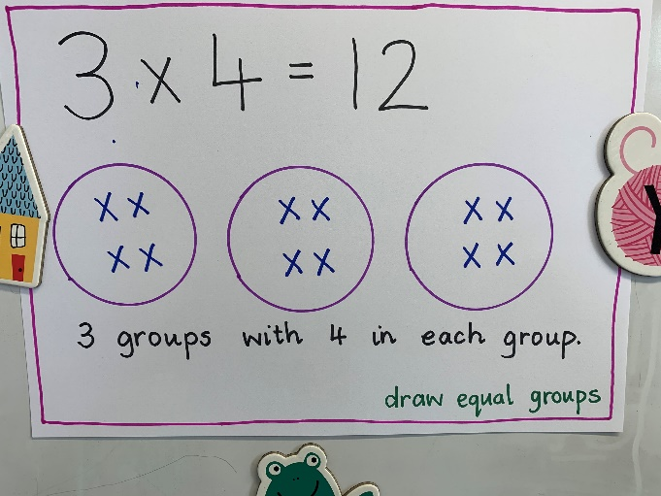
We have included some strategies that can be used when solving multiplication strategies. Please spend time with your child discussing and exploring these strategies. This will support them to become more independent when solving problems. Have fun!
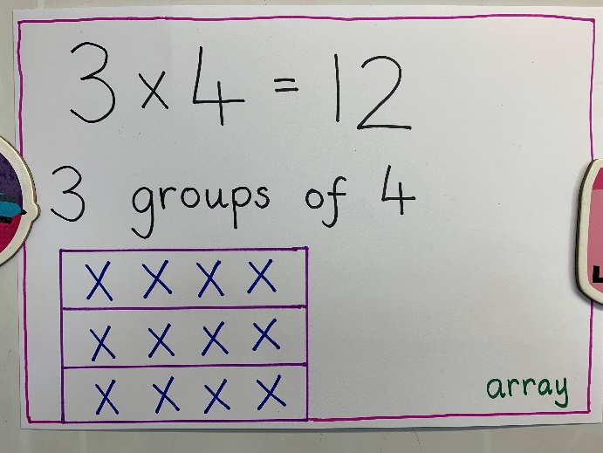

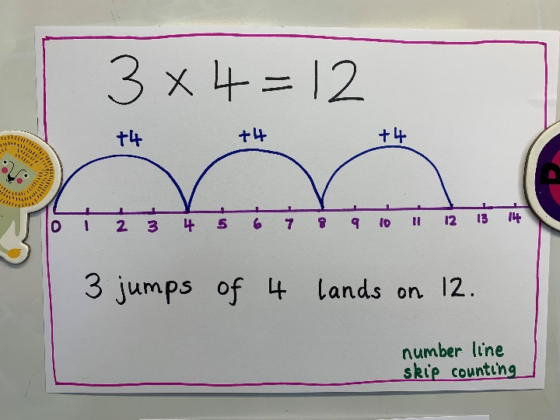
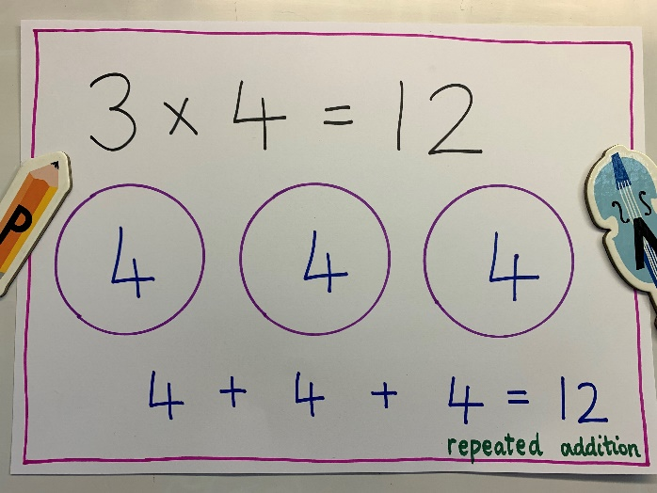

Science
This term we are going to be studying the human body, in particular we will be looking at the brain, kidneys and digestive system. Part of this topic will include:
*Discussing the purpose of organs.
*Identifying the location and purpose of the digestive system, kidneys and brain.
*Investigating how the digestive system words.
*Explaining how we can keep organs healthy.

Here’s to a great year!

