Primary 1 Newsletter- 4th September 2020

We have been so impressed with all of the children in P1- what superstars they are!

All of the children have settled quickly into their new routines and have been very busy learning through creating and playing. It has been wonderful to see them coming to school with big smiles, so thank you for supporting them to feel secure on their new learning adventure!

Outdoor Classroom

Over the past few weeks we have been trying to enjoy our outdoor classroom as much as possible, going on ‘Bear Hunts’ and giving our children the chance to develop their gross motor skills through running, climbing, balancing, pushing and pulling. They have really enjoyed being able to use the outside space and we hope to continue to provide opportunities for this. As we are approaching a wetter time of year, it would be really helpful if children could come to school with a waterproof coat and appropriate footwear to ensure that they are still able to access and enjoy the outdoor classroom in all weathers. Many thanks for your support in this.
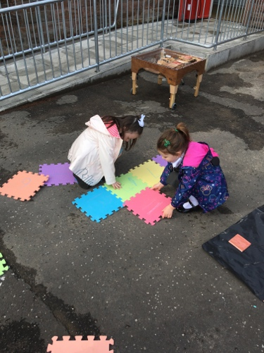
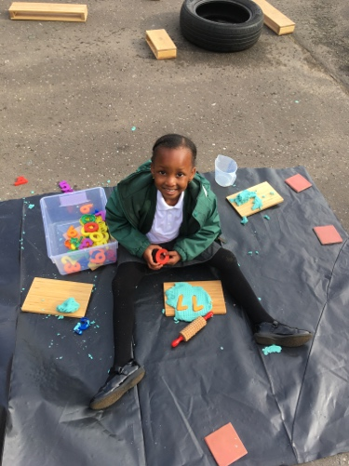
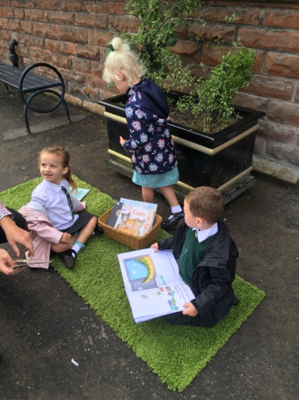
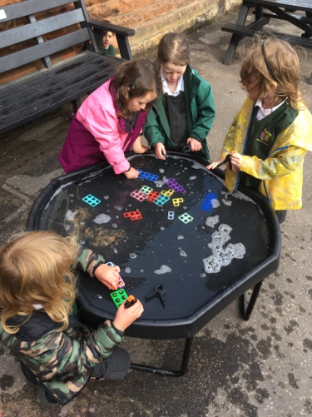

Numeracy & Mathematics

We have been doing lots of work exploring number including: counting objects, ordering numbers and recognising & writing numerals. The children in P1 have really impressed us with their knowledge and confidence in talking about number!

As well as this, we have been talking about the days of the week, regularly using the name of the day and language such as:
A song the children have enjoyed is:
https://www.youtube.com/watch?v=HtQcnZ2JWsY
‘yesterday was’
‘today is’
‘tomorrow will be’
‘weekend’

With the start of the new month, we have recently introduced the names of months of the year, making links with the children’s birth months.
A song the children have enjoyed is:
https://www.youtube.com/watch?v=Fe9bnYRzFvk

Writing, Reading & Phonics

The P1 children have impressed us so much with their literacy skills! Our children have enjoyed opportunities for mark making in different environments (including the outdoor classroom), reading and identifying their names and having a go at ‘building’ their names- through using magnetic letters, lettered lolly sticks or writing with a pen.

We have been enjoying a daily story- sometimes two!- and the children always engage with discussing the book. Some of the questions we use are:

-What might happen next?
-Why do you think ____ did that?
-What can we learn from this story?
-How might ______ feel about that?

As well as stories read by adults, it has been wonderful to see how interested the P1 children are in accessing the book corner to explore books themselves.

This week we began structured phonics sessions which last between 15 and 20 minutes. The sessions are lots of fun and the children are kept very busy and active. At this stage of the school year we are focusing on identifying and reading single-letter sounds (phonemes), as well as encouraging the children to write the corresponding letter (grapheme). For example:

The letter name is ‘s’ and the letter sound is ‘ssssssssss’.

Over the next two weeks the children will be introduced to the following letter sounds

s a t p i n

Below, you will find these sounds which can be cut out and used to support your child practice to read and write at home. If you are unable to print and would like a copy, please let us know.

Health and Wellbeing

As we said in our last newsletter, we have been and will continue to focus on supporting the children with their emotional wellbeing and it has been lovely to see new and existing friendships blossoming, as well as witnessing individuals becoming increasingly confident with each new day.

The children have been focusing on identifying and discussing their feelings and emotions so that they are able to express when they are feeling happy, as well as when they might be feeling anxious or upset. We have also been keeping physically active in our outdoor classroom and through participating in some short yoga sessions.
We have been using some videos from here:
https://www.youtube.com/user/CosmicKidsYoga

At Home

You can support your child with their learning in many ways:

-Keeping active and physical which will help to develop fine motor skills for writing.
-Number hunts on the walk to school or when out and about.
-Sound hunts when at the shops ‘what sound does this letter make?’
-Reading every day- comics, newspapers, stories, non-fiction books. It is so important that our children develop a love of reading- a great way to help with this is for children to see you enjoying reading at home too, as well as exploring a book together.

Thanks so much for your support so far and please do come and speak with us should you have any questions or concerns.

Many thanks,
Kind Reminder
Please ensure that every item of your child’s uniform and belongings are clearly labelled with their names.

With 31 children all wearing the same or very similar clothes, it can be very tricky to locate misplaced belongings.

Thank you for your help with this.

Mrs P-B, Mr Locksley and Sharon

Phonics Sounds:

s | a | t
p | i | n

