We love reading!
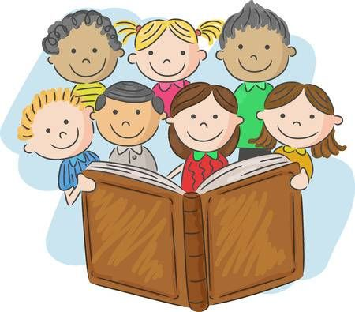
We have loved seeing and hearing you read this week; we are amazed at the progress you are making! Keep uploading your videos so we can give you feedback. Thank you so much!

Oxford Owl Reading
This is a wonderful online reading resource! It enables us to allocate reading books to the children in each of our reading groups. We would therefore be most grateful if you registered with Oxford Owl to access the e-books. There are fun follow-up activities for the children to practise key literacy skills.

Reading Books
Please search for the reading book allocated to your child’s reading group.

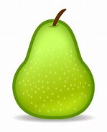 | 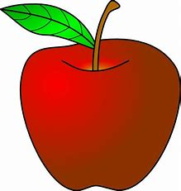  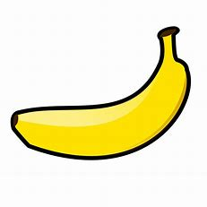 | 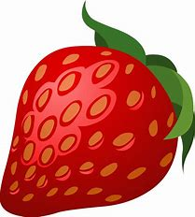  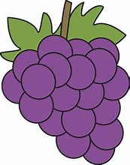 | 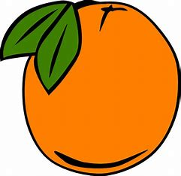
‘The Haircut’ | ‘By the Stream’ | ‘The Big Carrot’ | ‘Can You See Me?’

Reading Tips
- Identify the red ‘tricky’ words in the text.
- Sound-out and blend to read words you are unsure of. Remember digraphs are sounds made from two letters.
- Track and follow the words with your finger.
- Look out for punctuation . “” ? and !
- Try to change your voice and use expression to show when someone is speaking.
- Most importantly, make reading a special time where you snuggle up and enjoy reading together.

