Primary 1 Phonics
Monday 27th - Friday 1st May, 2020

Good morning, boys and girls! It has been wonderful to see you working so hard on your sounds, Geraldine the Giraffe is super impressed!!

This week, we will be revising two more sounds. These are:
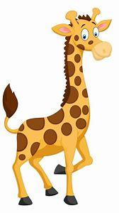

Long ‘oo’ and Short ‘oo’

- When saying our long ‘oo’ sound we say, “poo at the zoo”
- When saying our short ‘oo’ sound we say, “look at the book”

Please watch the links for Gerladine the Giraffe to help identify between long ‘oo’ and short ‘oo’

Remember, these are digraphs; two letters that come together to make just one new sound. We know how much you love Geraldine Giraffe so click on each of the links to see her looking for things featuring each of these sounds.

- How many words can you think of?
- Can you identify which words have long ‘oo’ and which words have short ‘oo’?

Challenge: Can you think of 10?

Long ‘oo’ Short ‘oo’
- broom - foot
- shampoo - book
- moon - shook
- zoo - cook
- cool - whoosh

VowelsConsonantsDigraphs

It would be super if you could colour-code each of the sounds when writing your long ‘oo’ and short ‘oo’ words.

We can’t wait to see what you do at home! Ask a grown-up to help you upload your learning to GLOW. 😊

Challenge: Can you use each of the words in a sentence?
Remember to say them out loud.

Can you write one of your sentences?

Remember:

- A CAPITAL letter at the beginning and for special names.
- Finger spaces!
- A full stop at the end.
- To check for sense!

Links for Geraldine Giraffe:

Long ‘oo’

https://www.youtube.com/watch?v=atlb2jPdFd0

Short ‘oo’

https://www.youtube.com/watch?v=-3UUnmNk1UM

Just for fun!

You might want to make a video of your own, using the giraffe puppet you made before. We loved seeing your videos last time!

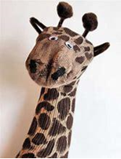
For a sock puppet, click on:
https://youtu.be/IL8uXeefyM4

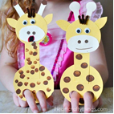
For a cardboard puppet, click on:
https://iheartcraftythings.com/giraffe-finger-puppet-craft.html

