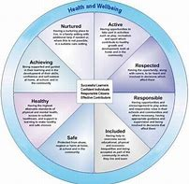
Health and Well-being
Monday 27th April – Friday 1st May, 2020

We have been super impressed with just how much you are doing at home to keep your bodies and minds healthy. We love seeing your updates on GLOW!
This week, we thought it would be a lovely idea for you to write some positive, affirmative statements about yourself. We know how AMAZING you all are but thought it would be nice for you to share just how much with each other!

So, here’s what you have to do:

Each morning, as part of your Morning Jobs, choose ONE of the sentence openers to write about. These are:

- I am good at…
- I am most happy when…
- I like myself when…
- I am proud of me when…
- I am special because…
- I am a good friend when I…
You might want to write each sentence inside an arc on the rainbow. When you are finished, decorate this…be creative!

Success Criteria
- I can use a capital letter at the beginning of each sentence

- I can use a full stop at the end of each sentence

- I can use some joining words (and, but, because) to add more detail to my sentences

- I can use finger spaces

Template
There is a rainbow template available for you to download on our P1 Teams page. This will also be attached to the assignment. If you are unable to print this, you could try drawing one at home.

Support Materials
It would be great if the children could use the ‘Read Write Inc.’ sounds mat to help with correct letter formation.

The children could also use this writing prompt.

ABC  Capital Letters | Finger Spaces | Full Stop | Read  Read it again and check for sense!

