Let’s Get Writing
27.04.20 – 1.05.20

We have been super impressed with your Easter postcard writing Primary 1, it sounds like you have had lots of fun.

This week we thought it would be a lovely idea to write a ‘Thank you’ letter to the keyworkers for helping to look after us all.
Below are some instructions and an example to help get you started

Letter Writing
Success Criteria
I can write 3 sentences
I can use a capital letter at the beginning of each sentence

I can use a full stop at the end of each sentence

I can use some joining words (and, but, because) to add more detail to my sentences
I can use finger spaces

Letter Template
There is a letter template available for you to download on our P1 Teams page attached to the assignment, but it is easy to make one at home. Here are some simple steps on how to make your own letter:

- You will need an A4 piece of white paper.
- Using a ruler draw lines across the page using a light-coloured pencil (yellow).
- Continue to draw equally spaced lines to the bottom of the page.
- As support, write ‘Dear’ on the top line, ‘Thank you for’ on the second line and ‘From’ on the last line.
- On the other side of the paper you could draw a picture to go with your writing.
Here is one I made earlier!
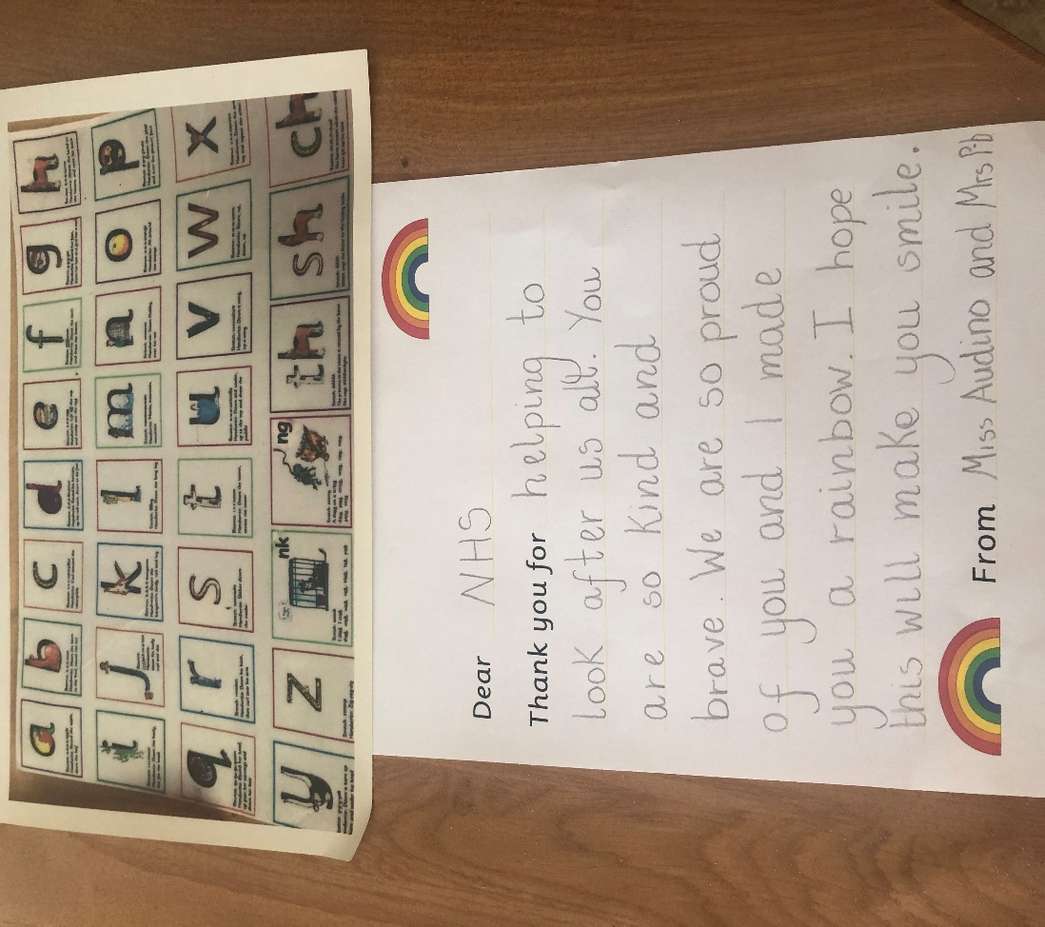

Support Materials
It would be great if the children could use the ‘Read Write Inc letter formation cards’ to remind them of how to form the letters correctly: just like in the example. The full set can be found in the ‘Phonics’ file named ‘Phonics Set 1 Sounds’.
The children could also use the writing prompt which we use in class to remind them to use ‘Capital letters’, ‘Finger spaces’, ‘full stops’ and to ‘Read their work again’. This can also be found in the ‘Literacy’ file channel named ‘Writing prompt’.

ABC  Capital Letters | Finger Spaces | Full Stop | Read  Read it again

Have fun super star writers!

