Oxford Owl
Instructions for accessing e-books
- Copy this link into your web browser:

https://www.oxfordowl.co.uk/

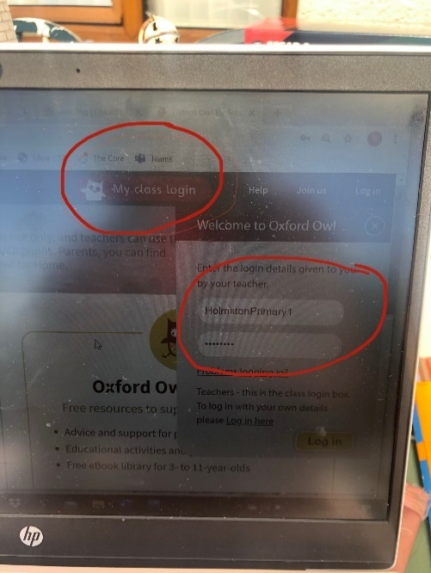
- Log into ‘My class login’ at the top right-hand side of the page. Login using the details below:

- Username HolmstonPrimary1
- Password Scotland

- Select ‘My bookshelf’ and search for the name of the book assigned by your class teachers, according to your reading group.

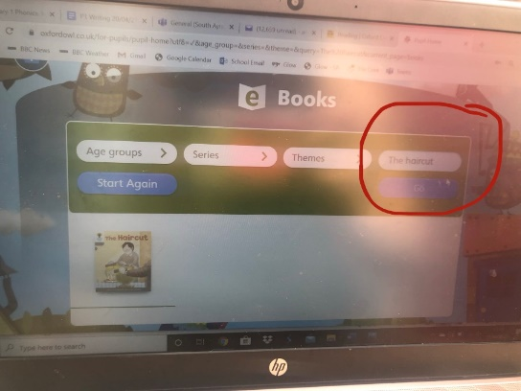

- Use the audio button to listen to the story first, turning the pages using the left and right arrows.
- Encourage your child to read the story out loud, supporting them if needed. Complete the ‘Play activities’ located at the top of the page afterwards.

