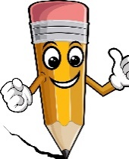
Handwriting

It is just fantastic to see you all trying so hard with your writing, you are ‘Super Stars’. It is also just as important to work on your handwriting skills.

It would be great if you could practise your letter formation at home using the ‘Read Write Inc’ picture cards and matching rhymes e.g.
- s – ‘slither down the snake’
- a – ‘around the apple and down the leaf’
- t – ‘down the tower, across the tower’
- p – ‘down the plait and over the pirates head’
- i – ‘down the body, dot for his head’
- n – ‘down Nobby, over his net’
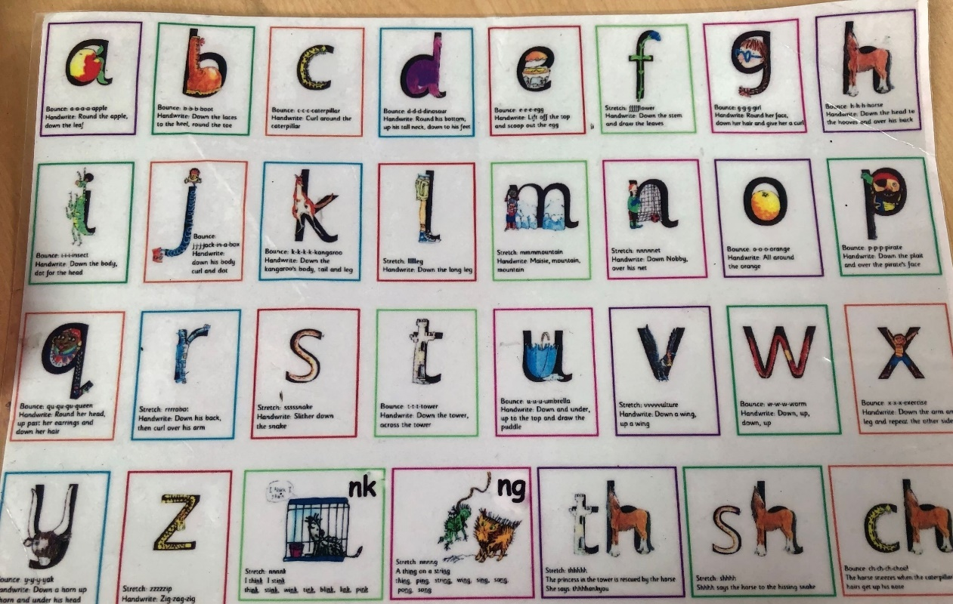

The full set of the cards can be found in the files section under the ‘Phonics’ channel named, ‘Phonics Set 1 Sounds.’
Online Resources
It would be great if you could watch the following link which supports the ‘Read Write Inc’ letter formation and rhymes that we use in class. This will also give you an idea of how to ‘say the rhyme’ while forming each letter.
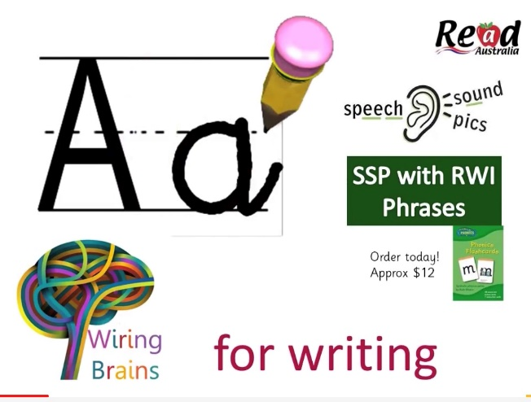
https://youtu.be/4T_EE6PcZbY
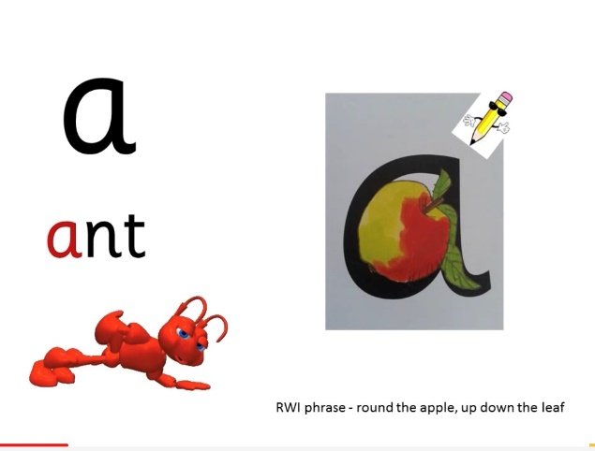

It is so important to also use a variety of materials and resources to practise your handwriting. Here are a few of our favourites:
- Air writing (big and small movements)
- Painting letters outside: we enjoy using water and a paintbrush on the walls and ground.
- Use sticks to form the letters.
- Sensory box writing (sand, foam, jelly, slime, soap, mud, flour etc)
- Playdough letter formation

Check out this website for more fun ideas https://outsidetheboxlearners.com/pre-handwriting-activities/

Have Fun Primary 1

