Words and Phrases
In our classroom we have our magpie display board, which is full of words and phrases that we love and have taken from other authors.
We would like you to start your own collection of words and phrases that you find during your reading or listening to stories time. You can choose how you wish to organise your collection, be it a poster display, a notebook or at the back of your jotter.
Here is one we have been working on at home, to perhaps give you some ideas. It is just pieces of paper folded and stapled and then we decorated.
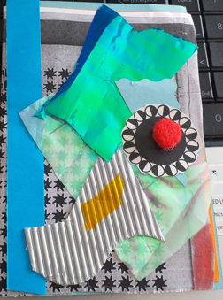
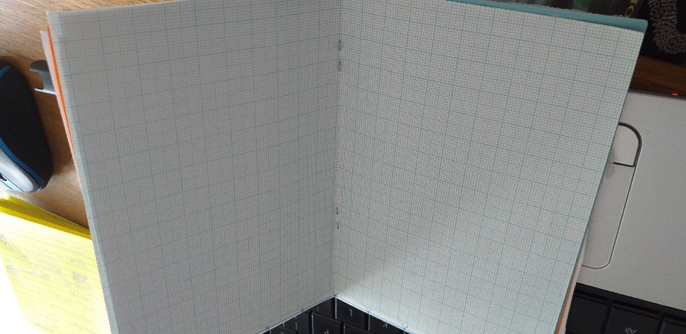

To get us started, let’s focus on words which we like to describe characters.

Do you remember the book I was telling you about, The Legend of Podkin One-Ear? Here are two paragraphs from the story describing one of the characters. Highlight and magpie any words or phrases you like to get your collection started.

“This wasn’t a rabbit any more. If it ever had been, it was now something else entirely. A walking slab of metal and meat, pierced through with rusty thorns and nails. Its armour overlapped in sheets of jagged, dented iron; mottled with rust and splashes of dried crimson that looked very much like old blood.
Its head was completely covered by a helm, dotted all over with cruel shard-like spikes and curved metal horns that almost scraped the ceiling. From the shadowy eye slits, two dim scarlet pupils glowed: blank and mottled with rusty red veins.”
