Talk for Writing
Last week, you were asked to picture map the story of “Kassim and the Dragon.” Please continue to retell this story so that you can confidently tell the story, using your map to help. Add actions, if this helps. I found it useful to add actions to help me remember how to describe the dragon.

Whilst you work on learning the story, I would like you to try some of these exercises to help us to strengthen our imaginations.

What if?
This is an easy game to play. Look at this picture and then brainstorm as many “What if…?” scenarios as possible.
Eg.
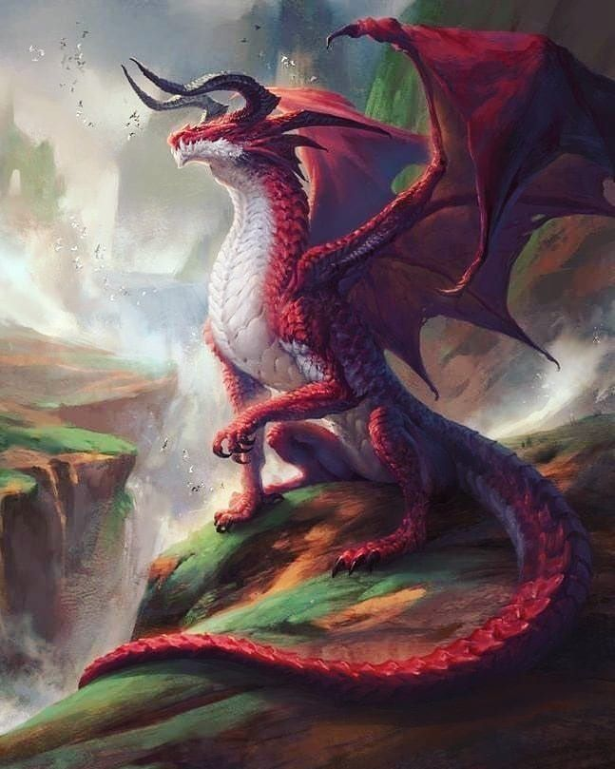
What if the dragon cannot see Kassim?
What if the dragon destroys the cosy cottage?
What if the dragon is a vegetarian?

Bring the picture alive
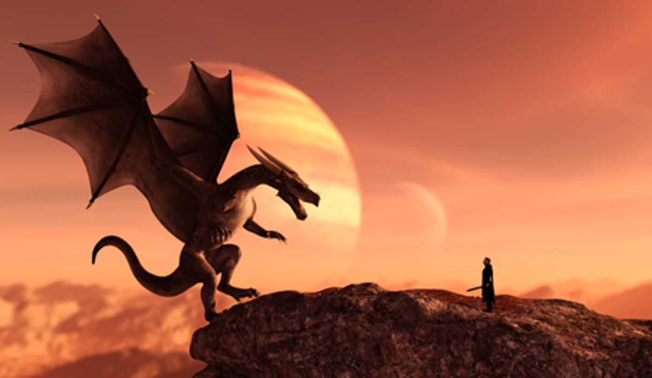
Imagine that you are in the picture. Write a list of what you can see, hear and what you might think or feel if you were actually there.
I can see……..
Think carefully about your selection of describing words – uplevel your ideas. Let’s say nice and big are banned!

Punctuation
Before the holidays we had started to look at using speech marks. Let’s revise what we were doing.
Remember to write your , . or ? before finishing the “

“Speech Marks”
We use speech marks when we are writing to show what somebody has said. It is very important to also write who has been talking.
Example :
I love this book
“I love this book,” said Lucy.

Put the speech marks in the correct places in the sentences below:
1) What time is it? asked Angel.
2) I want chicken for dinner, said Monica.
3) Can I play on the computer Mum? asked Kayla.
4) I would like an ice cream please, said Sarah.
5) That costs 12 pounds said the shop-keeper.
6) Would you like to read a book? asked the teacher.
7) John hit me, said Henry.
8) Where is the cheese? asked Kayleigh.
9) It is time to go to computers, said the teacher.
10) What is 10 + 2? asked Miss Byrne.
11) Hooray shouted the children
Remember to check your work when you are finished.
Then draw a face to show how you think you did.

