Health and Wellbeing

Here is a pick and mix of activities for you to dip into.

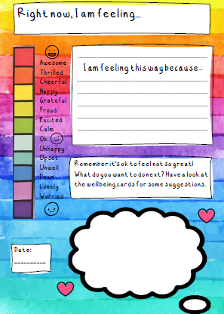
Have a check in – talk over how you are feeling or you may wish to keep it in a journal. It’s good to talk and share.

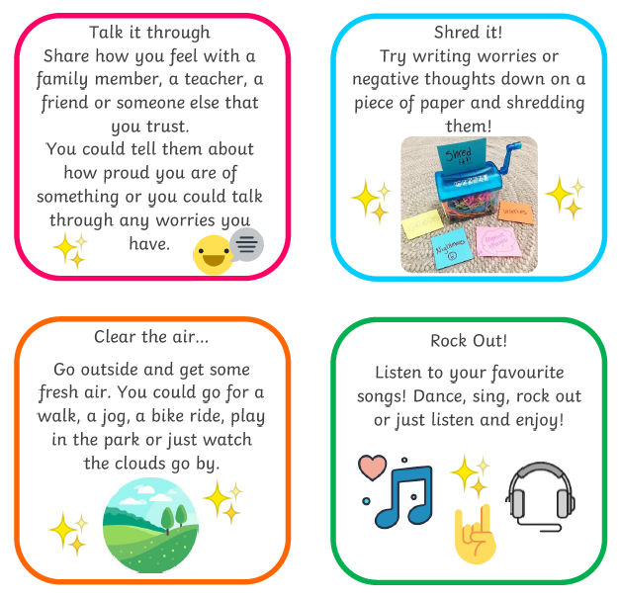
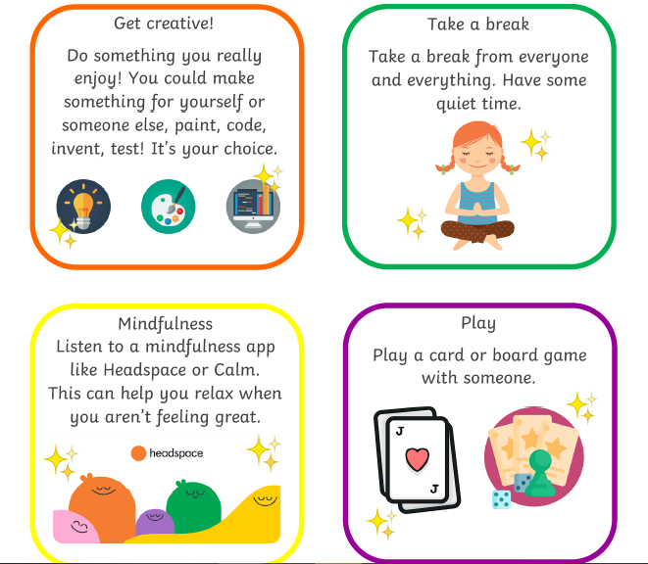
Perhaps try something new?
Listening to music can help lift a mood, calm you down or make you feel full of energy.
Experiment in making your own music
https://musiclab.chromeexperiments.com/

Computer programming take your fancy?
https://scratch.mit.edu/

Relax your body and mind

https://www.youtube.com/user/CosmicKidsYoga

Thinking about others
Little acts of kindness
Make a card for a neighbour.
Help someone in your house to tidy up.
Send a nice text to someone.
Tell a joke to make someone smile.
Offer to do a helpful job in the house.
Give a friend a compliment.
Draw a cheerful picture to put in the window
Read a story to someone you love.

Outdoors?
