Multiplication Pick and Mix Activities

X3 x6
We want you to be able to visualise what is happening when we make groups of 3 and groups of 6.

Use building bricks/lego/ counters to show what the groups of 3 and 6 look like.

Eg.

1 tower of 3 = 3 2 towers of 3 = 6 3 towers of 3 = 9
1 x 3 = 3 2 x 3 = 6 3 x 3 = 9

Try this for making towers/groups of 3 and then for groups/towers of 6.

Record what your towers look like by drawing them and writing what they mean underneath.

Legs!
Ask children to count the number of legs of each of the things below in their home and record each as a number sentence:
• legs of tables in my home, e.g. 3 × 4 = 12 (3 tables with 4 legs = 12 legs)
• legs of people in my home
• legs of cats, dogs or other 4-legged animals, in my home. (Could be Cuddlies!)

Add and multiply
Ask children to find packets in cupboards at home that contain more than one of the same item, e.g. 8 cheese triangles, 4 tins of beans, 8 bars.
Write how many of each would be in several of these packets, showing this as an addition and as a multiplication, e.g. 4 packets of 8 chocolate bars = 8 + 8 + 8 + 8 = 4 × 8 = 32.

Create a number line showing what happens when you add 3 each time and repeat for adding 6.
+3 +3 +3 +3 +3 +3 +3
Eg. 0 3 6 9 12 15 18

Use this number line, cover up some of the numbers and try to work out which number is hiding.

Play ping pong, where you work with a partner, and you count up in 3s, backwards and forwards.

Work on doubling numbers. From your number line you will notice that if you double your answers from the x3 you will find out the answers for x6. Ask someone to give you a x3 station and double it. Practise this lots.

Singing along to songs can help to commit the tables to memory. Here are some songs you may wish to master
https://www.youtube.com/watch?v=dzVyBQ5uTbo

https://www.youtube.com/watch?v=iLln96C-BxY
https://www.youtube.com/watch?v=9XzfQUXqiYY
https://www.youtube.com/watch?v=9os1VUUp5io

Ideas to help you put into use all the thinking you have been doing about x3 and x6

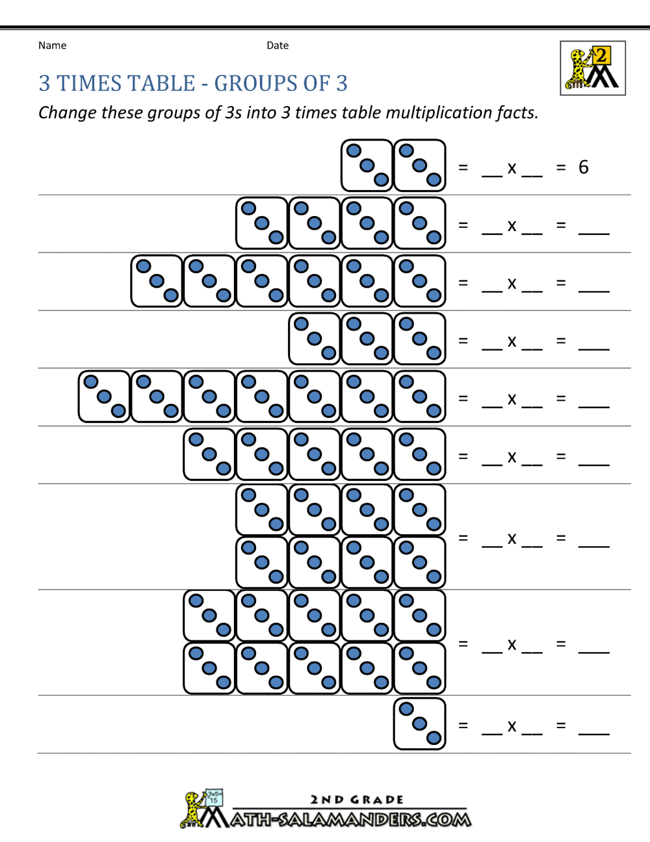
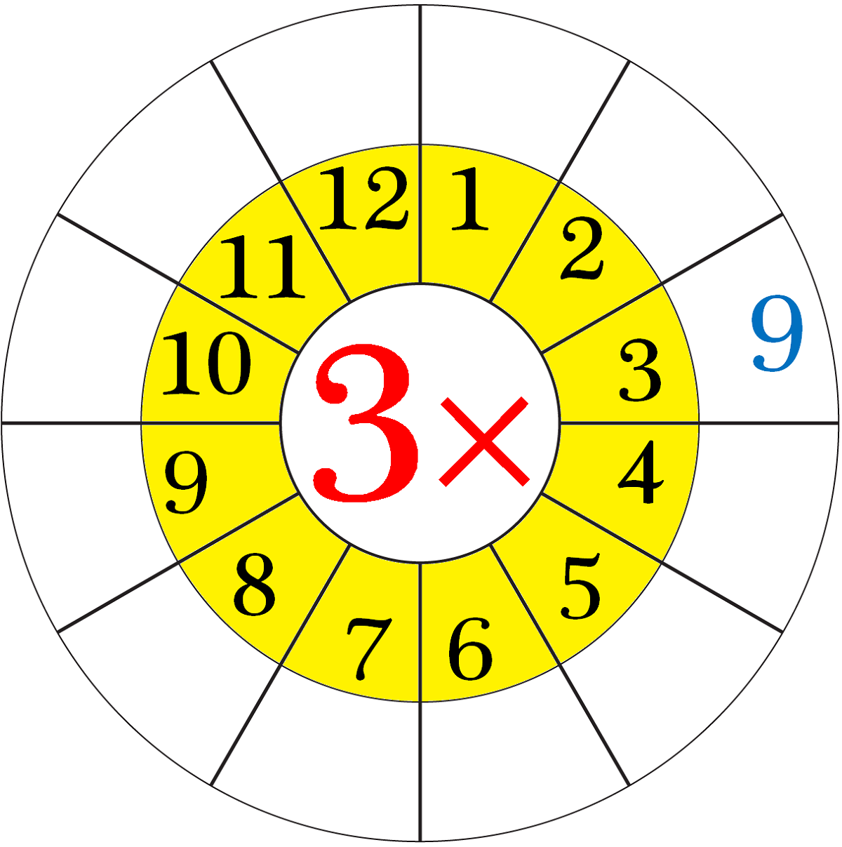
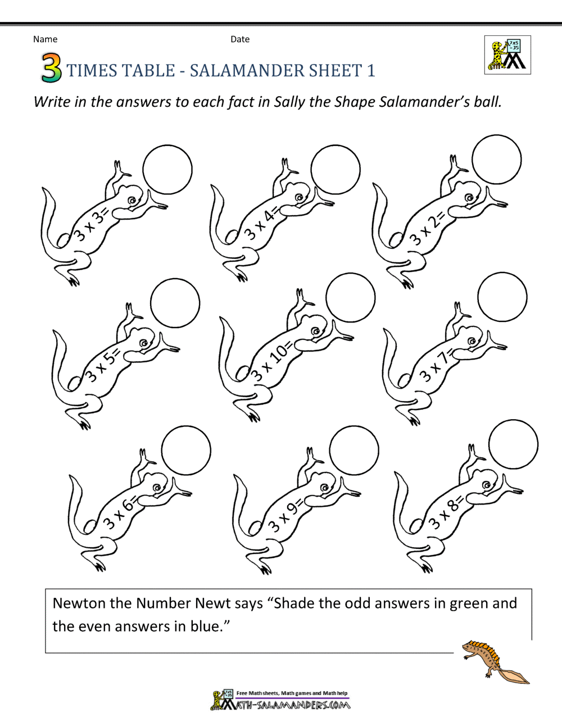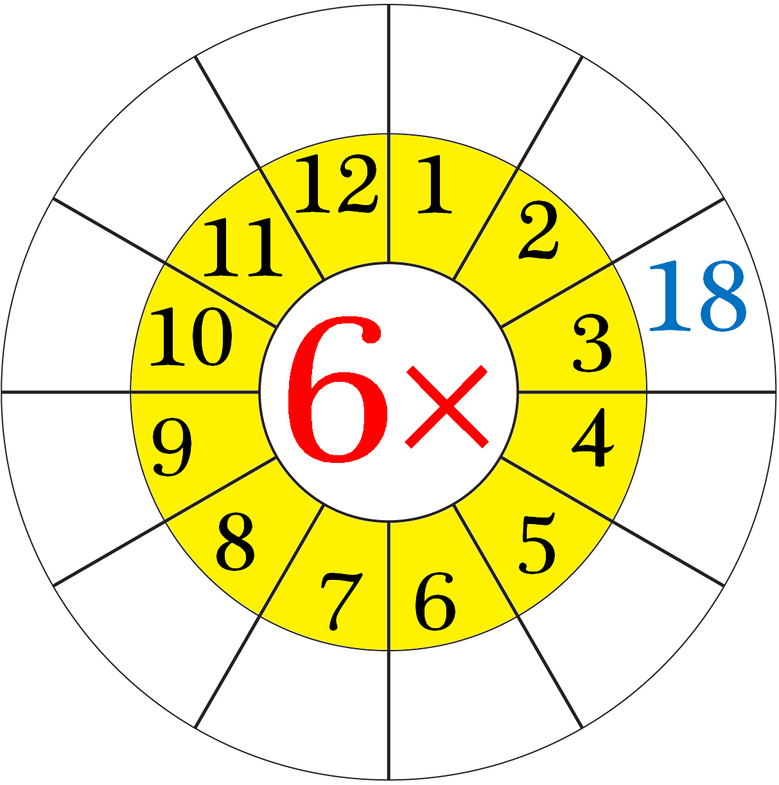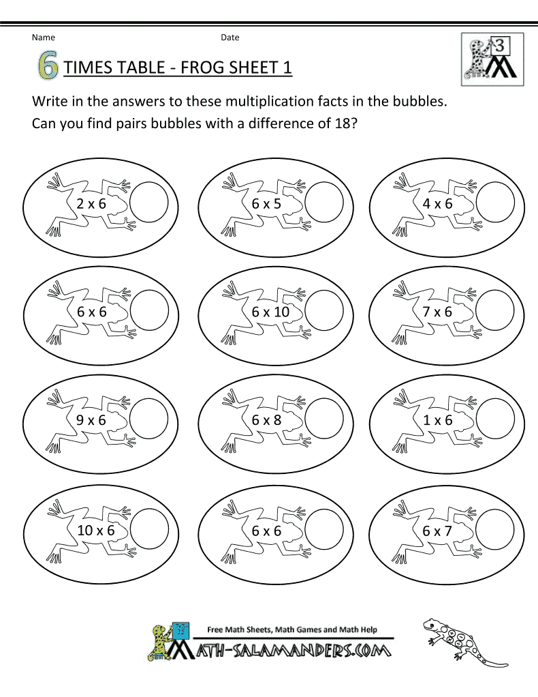
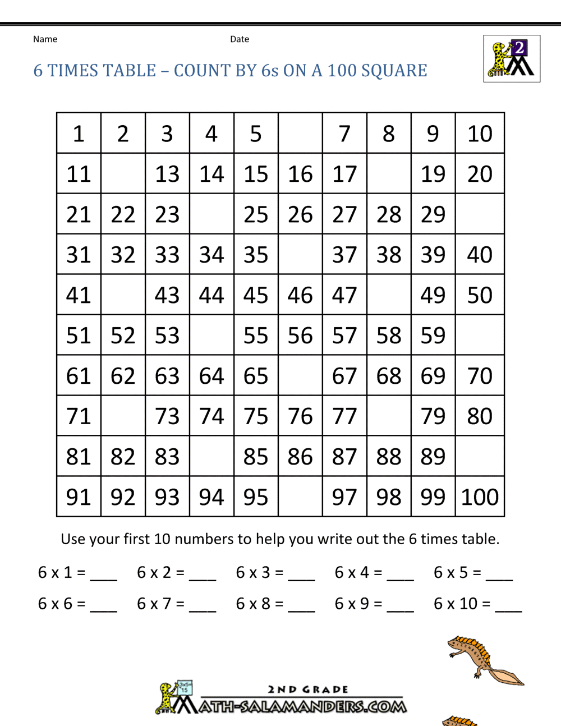

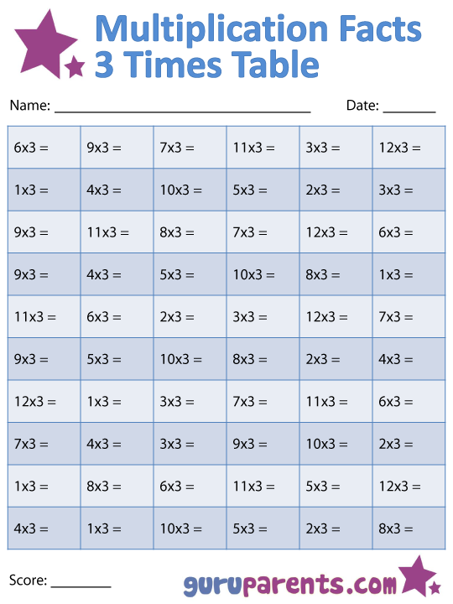

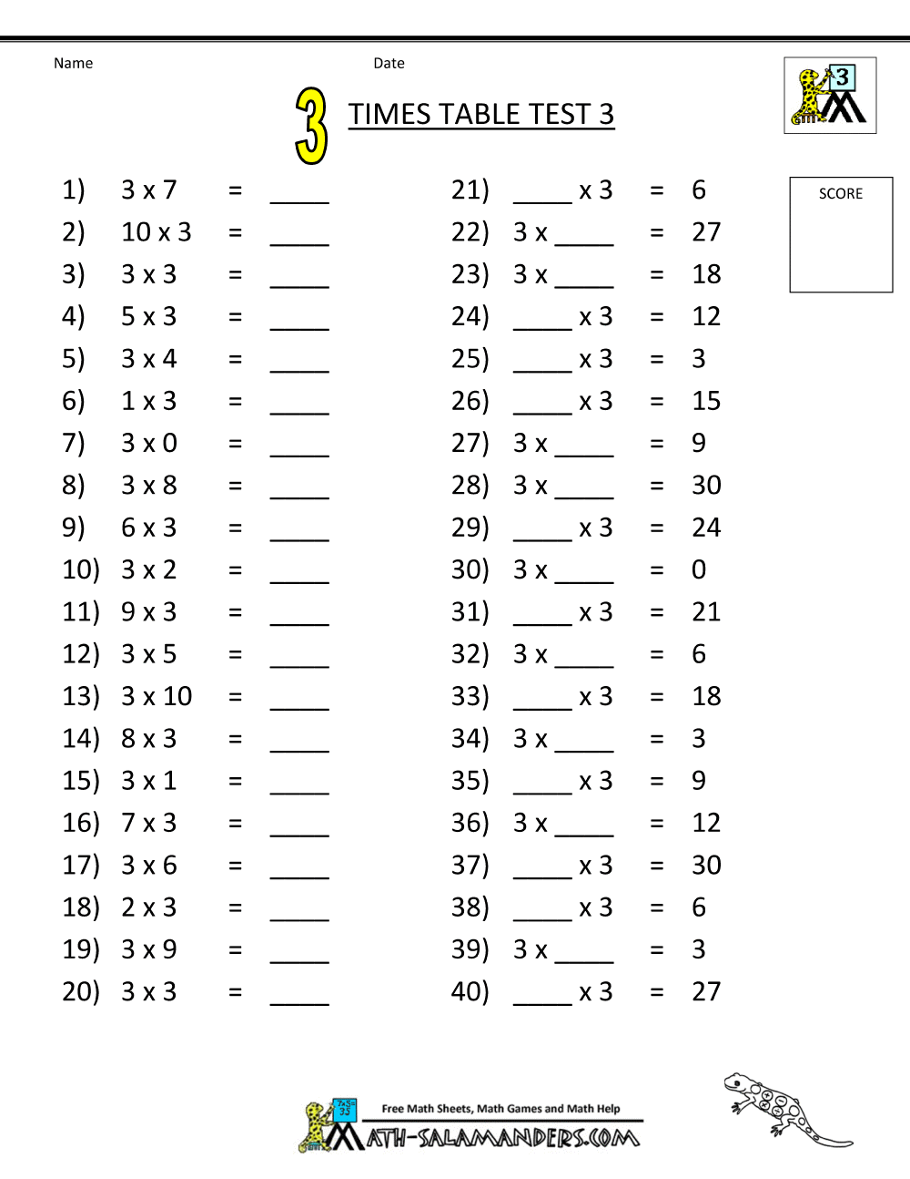

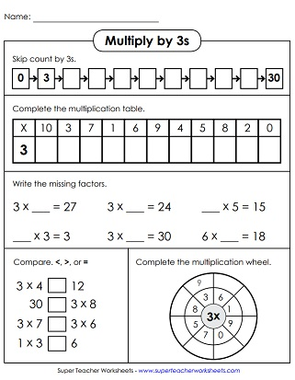

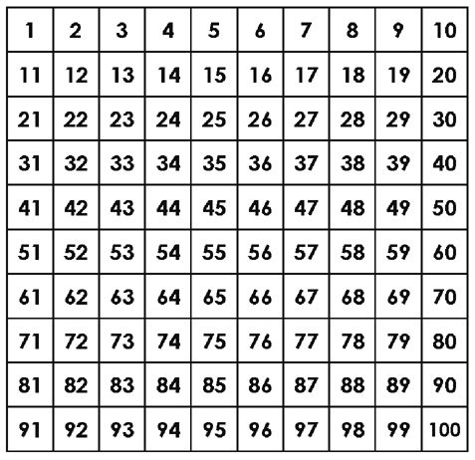
Cover/colour the x3 and x6 answers

Can you work outside?
Draw and play hopscotch, but with the answers to your x3 or x6.
Can you write/post the table about your outside area and then jump/hop/ run to the x3 in order?

Games
https://www.topmarks.co.uk/maths-games/hit-the-button

http://www.ictgames.com/tablesTennis/mobile/

Linking Multiplying to Dividing

