Health and Wellbeing
We hope you have enjoyed your break from school and are eager to get back into school jobs.
We would like you to focus on your own needs as well as thinking about and responding to the needs of others.
We want you to be kind to yourself. Not being at school and in touch with family and friends is tough and so we would like you to focus your energy on helping others and possibly trying new projects on the way.

Here is a pick and mix of activities for you to dip into.

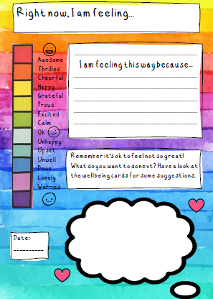
Have a check in – talk over how you are feeling or you may wish to keep it in a journal. It’s good to talk and share.

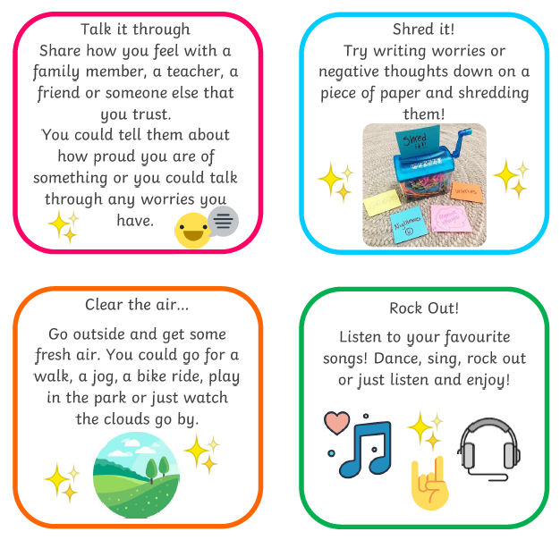
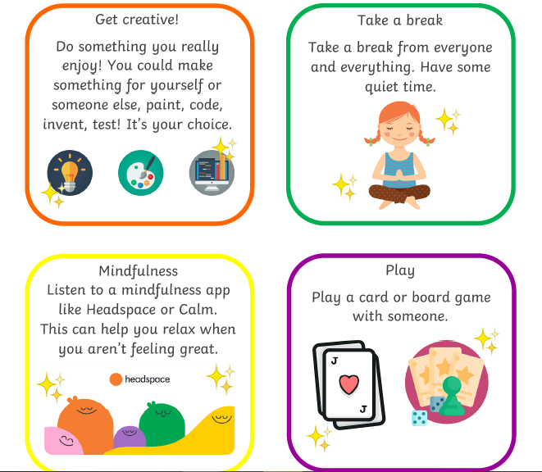
Perhaps try something new?
Listening to music can help lift a mood, calm you down or make you feel full of energy.
Experiment in making your own music
https://musiclab.chromeexperiments.com/

Computer programming take your fancy?
https://scratch.mit.edu/

Relax your body and mind

https://www.youtube.com/user/CosmicKidsYoga

Thinking about others
Little acts of kindness
Make a card for a neighbour.
Help someone in your house to tidy up.
Send a nice text to someone.
Tell a joke to make someone smile.
Offer to do a helpful job in the house.
Give a friend a compliment.
Draw a cheerful picture to put in the window
Read a story to someone you love.

Outdoors?
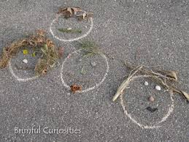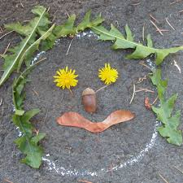

Positive Thinking
Sometimes we can think negativity about a situation or an event that has happened or we are in. When we think negatively, we are likely to carry on thinking in that way. This can make the feelings more powerful and strong. While it is ok to feel sad sometimes, it can be helpful to think of the positives so you don’t only have a one sided view.

Create a poster, piece of writing, drawing (be creative it’s up to you) describing all the positives relating to our current situation.
For example;
We are having to stay at home and off school right now but…
I get to spend longer in my pyjamas
I am enjoying spending more time with my family
I can do my school work on the couch

Have fun!

