Linking division and multiplication – notes for learners and parents
(Keep scrolling for activity ideas)

When we talk about division facts, we mean the division number sentences related to times tables. Therefore: 30 ÷ 3 = 10, 27 ÷ 3 = 9 and 24 ÷ 3 = 8 are all division facts for the three times table.
First, children learn to count in 2s, 5s and 10s. Their first introduction to division will be sharing groups of objects into equal groups of 2, 5 or 10 (although the word 'division' and the division symbol will most likely not be mentioned at this point).

Next, children are expected to know their 2, 5 and 10 times tables. Ideally, they should have very quick recall when asked questions such as: 2 x 4, 5 x 6, 9 x 10 etc. When practising division, they will probably still be moving groups of objects into equal groups, but we also explain the inverse to children, that is, that these number sentences are related:
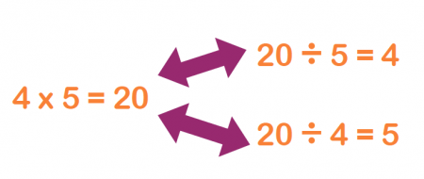
This can be demonstrated by an array:

We use this diagram to explain that there are 4 lots of 5 dots, or 4 x 5. This is the same as saying there are 20 dots that can be divided into 4 groups of 5 (they could circle each row of 5 to demonstrate this).
Once children have understood the inverse, they need to move onto learning their division facts. The more adept children are at knowing their times tables and related division facts, the easier subsequent learning in multiplication and division will be.

Primary 3 focus this week is to explore division facts for the 3 and 6 x tables. The following activities will help…

Write out the multiples of 3 on a number line to help you with these activities…

Draw arrays
For example… 6÷3 = or

This VISUAL work is a very important basis to the understanding of division facts.
Writing facts for 3 and 6x tables like this…
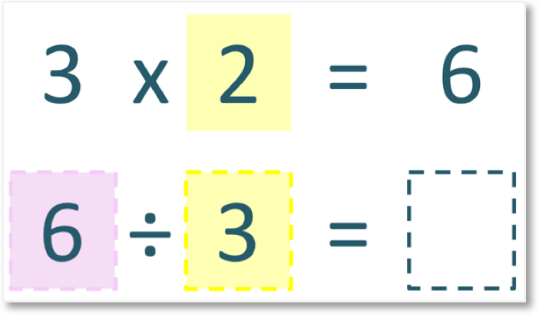

Division Matching cards
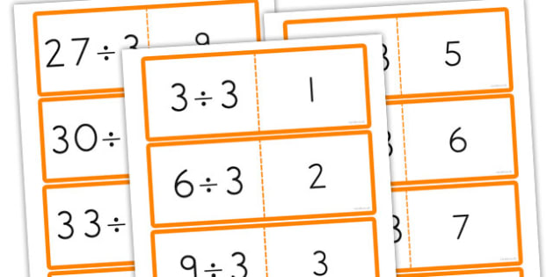
Using paper or card make up calculation and answer cards to play matching games

Written calculations… remember to always use number lines or draw arrange to help if you need to
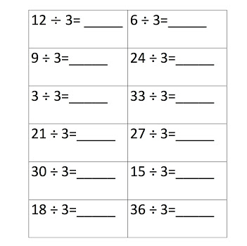
Division bingo – Children have to draw a grid of nine squares. They write any numbers between 1 and 12 in the grid, making sure that they don't repeat any numbers. Ask them division questions relating to the times table they are learning at the time, for example, if they are learning the 3 x table they may ask: 'I have 9 beads which I need to divide equally into 3 bags. How many beads will be in each bag?' or: 'What is 15 ÷ 3?' Children need to work out the answers and then cross off that number if they have it in their grid. The first child to cross off all their numbers is the winner.

Speed Grids – give your child grids like the one below (use multiples from the 3 times tabe, if ready use multiples for 6x table in different grip)
 | 12 | 9 | 15 | 24 | 30 | 27
÷3

 | 12 | 18 | 32 | 36 | 60 | 66
÷6
They need to divide each number in the top row by the given table, putting the answer in the box below it. The idea is that a timer is set (ideally a visual one on the interactive whiteboard that they can see). When finished their grid, they write down their time. They can then repeat, seeing if they are beating their own time on each go.

