Let’s Get Writing
30/04/20 – 24/04/20

We have been super impressed with your writing Primary 1 and we cannot wait hear all about what you have been doing over the Easter Holidays.
It would be fantastic if you could write a postcard to your teachers detailing some of your favourite activities from your holiday.
Below are some instructions and an example to help get you started
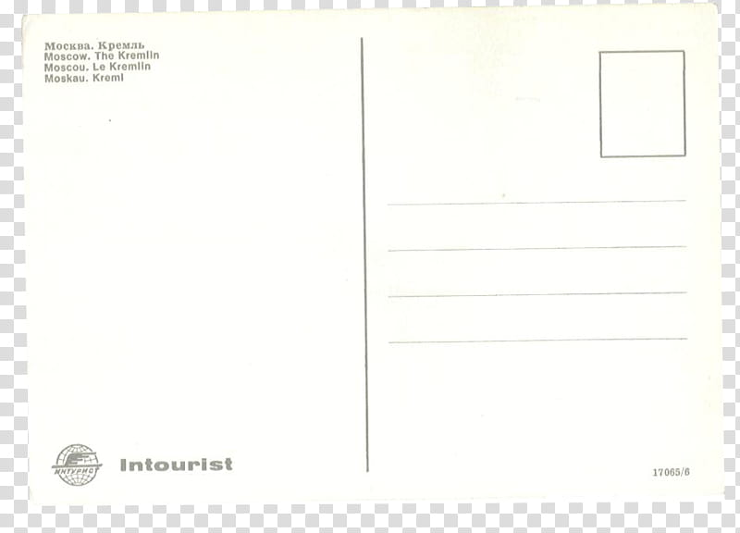
Postcard Writing
Success Criteria
I can write 3 sentences
I can use a capital letter at the beginning of each sentence

I can use a full stop at the end of each sentence

I can use 3 joining words (and, but, because) to add more detail to my sentences
I can use ‘Dear’ at the start of my writing and ‘From’ at the end of my writing

Postcard Template
There is a postcard template available for you to download on our P1 Teams page but it is easy to make one at home. Here are some simple steps on how make your own postcard:

- Fold a piece of A4 white paper in half or leave the writing side (left) slightly bigger.
- Using a ruler draw a line down the crease of the fold to make two parts.
- Using a ruler draw lines across the left page to the crease using a light-coloured pencil (yellow).
- On the right side draw a small box for the stamp and some lines below for the address.
- On the other side of the paper you could draw a picture to go with your writing.
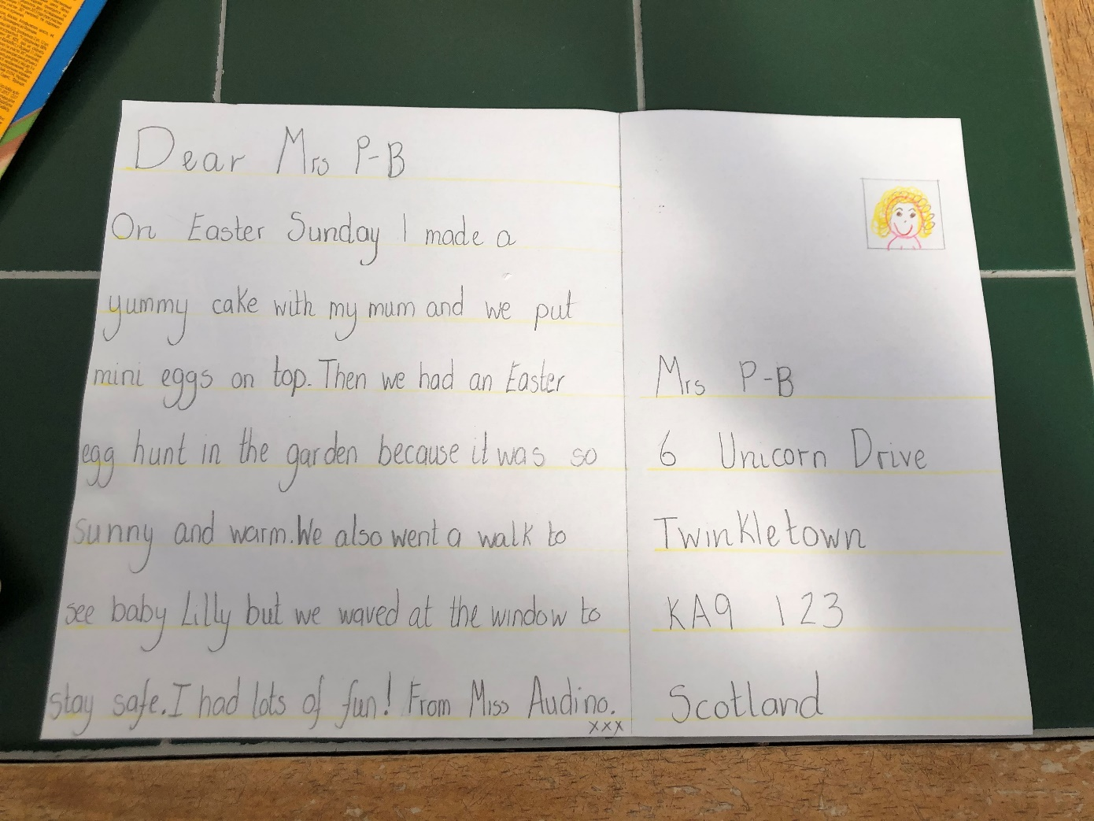
Here is one I made earlier.
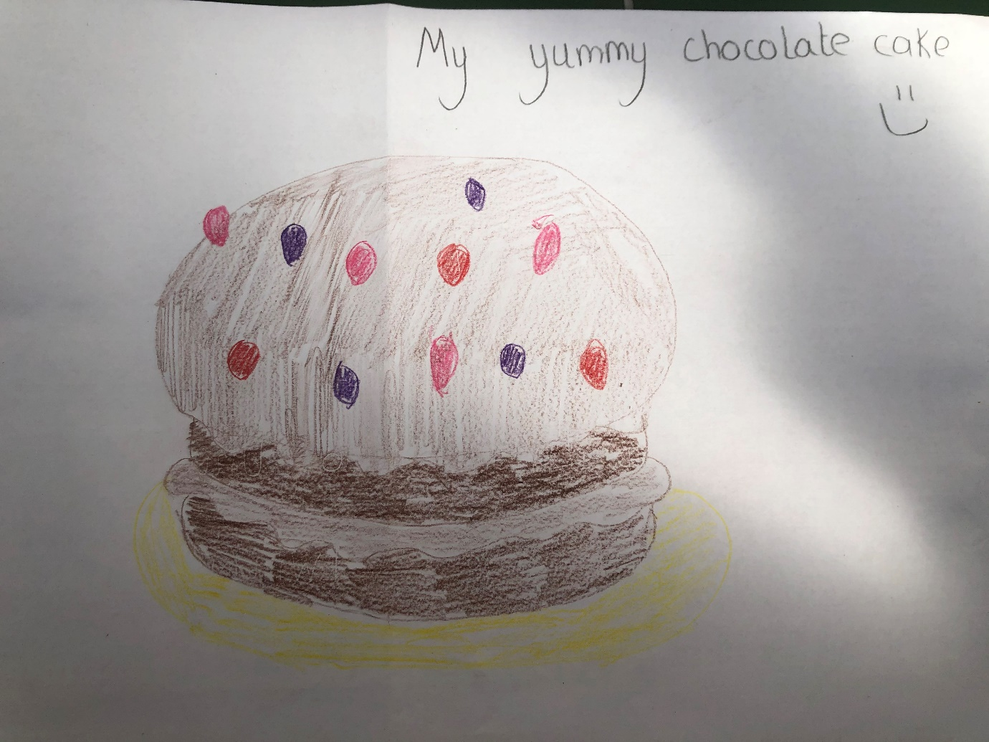

Have fun super star writers!

