We Love Reading
20/04/20
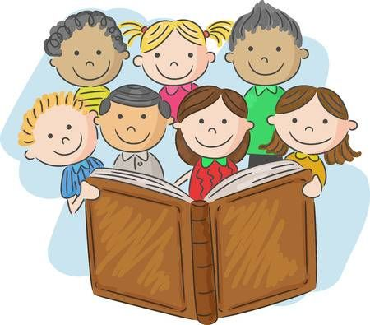
It has been great to see so many wonderful pictures of you reading together and we cannot wait to hear all about the reading you have been doing over the holidays. Keep up the super work Primary 1.

Oxford Owl Reading
A wonderful reading resource that we have used in class has become available online for free. It would be great if you could access ‘Oxford Owl e-books’ to read together with your children. There are also fun follow up activities to complete relating to each story book. Please see the steps below on how to access the website:

Instruction

- Copy this link into your web browser https://www.oxfordowl.co.uk/
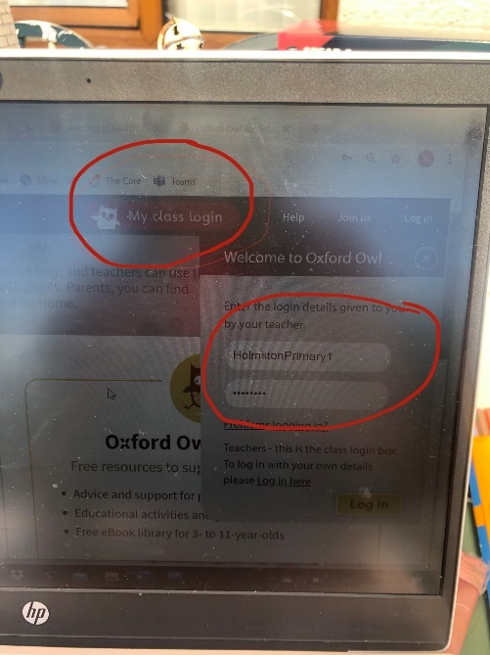
- Log into ‘My Class Log In’ at the top right-hand side of the web page. Log in using the details below:
- Username – HolmstonPrimary1
- Password – Scotland

- Select ‘My Bookshelf’ and search for the name of the book assigned by your class teachers: according to your reading group.
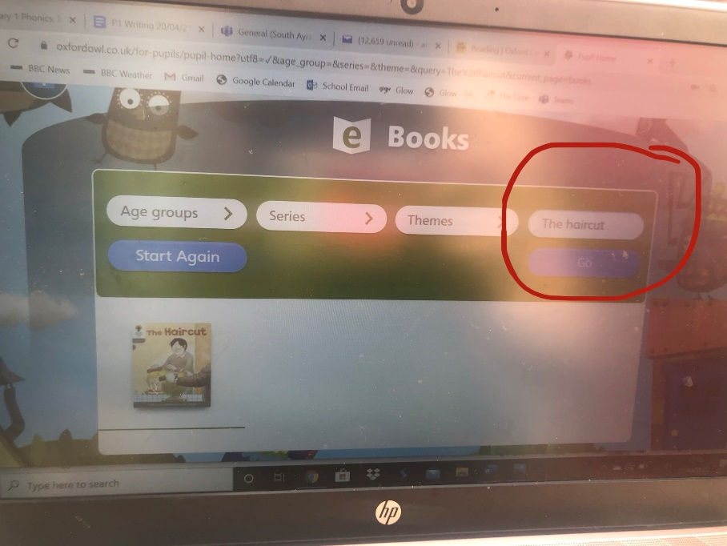

- Use the audio button to listen to the story together and turn the pages using the left and right arrows.
- Read the story supporting your child when needed and complete the ‘Play activities’ located at the top of the page.

Reading Books
Please search for the reading book allocated to your child’s reading group shown below:
- Pears – ‘Fetch’
- Apples and Bananas – ‘Spots’
- Strawberries and Grapes – ‘Big, Bad, Bug’ ( if completed please read ‘Kippers Diary).
- Oranges – ‘Big Feet’
It would be great if you could send us a video of your child reading in order to provide some feedback. You can send us a video in ‘Team Notebook’ by uploading the video onto your child’s individual folder. If you have any questions, please contact us both on Teams.

Reading Tips
- Say each sound before blending to read the word.
- Use your finger to follow the words on the page.
- Watch out for punctuation e.g. speech marks “”
question marks? and exclamation marks!
- Try to change the tone of your voice and use expression when someone is talking.

Most Importantly HAVE FUN you are FANTASTIC!

