Primary 1 Phonics
Monday 20th - Friday 24th April, 2020

Good morning, boys and girls! We hope you have had a lovely Easter with your family. We can’t wait to hear all about it!

This week, we will be revising two more sounds. These are:

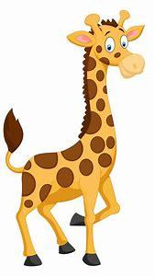
ch and ng

Remember, these are digraphs; two letters that come together to make just one new sound. We know how much you love Geraldine Giraffe so click on each of the links to see her looking for things featuring each of these sounds.

How many words can you think of?

Challenge: Can you think of 10?
ch ng
church king
chip lung
chop ring
chart song

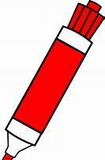Vowels 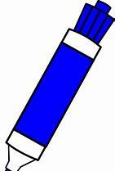Consonants 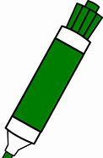Digraphs

It would be super if you could colour-code each of the sounds when writing your ‘ch’ and ‘ng’ words.

We can’t wait to see what you do at home! Ask a grown-up to help you upload your learning to GLOW. 😊

Challenge: Can you use each of the words in a sentence?
Remember to say them out loud.

Can you write one of your sentences?

Remember:

- A CAPITAL letter at the beginning and for special names.
- Finger spaces!
- A full stop at the end.
- To check for sense!

Links for Geraldine Giraffe:
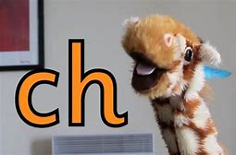 https://youtu.be/OyrYDitif1o
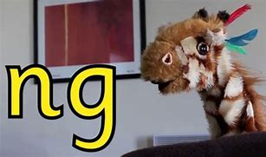 https://youtu.be/vQshNmncnBs
Just for fun!

You might want to make a video of your own, using the giraffe puppet you made before. We loved seeing your videos last time!

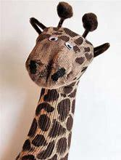
For a sock puppet, click on:
https://youtu.be/IL8uXeefyM4

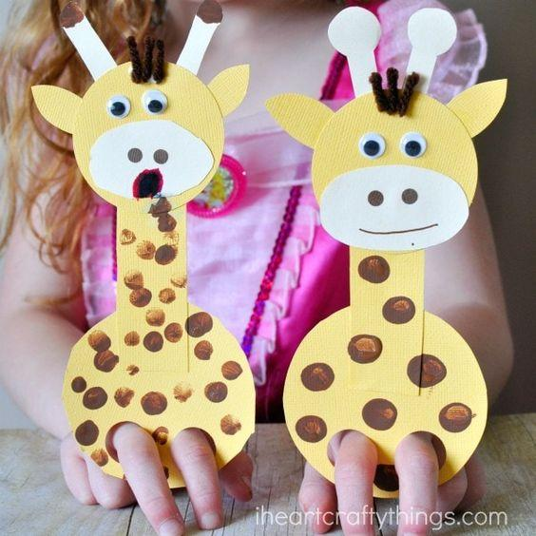
For a cardboard puppet, click on:
https://iheartcraftythings.com/giraffe-finger-puppet-craft.html

