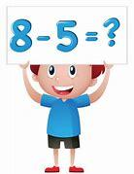
Primary 1 Numeracy
Monday 20th - Friday 24th April, 2020

This week, we will be thinking about strategies for ‘taking away’ mentally. However, if you still need to use concrete materials to do this, that is absolutely fine. We loved your ideas for taking away in real-life contexts at home so keep up this super learning! It’s great to see!
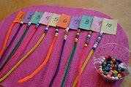

The subtraction beads are a super resource to use! Summer made these...way-to-go, Summer!

Keep using the flashcards. These will give you lots of practice. Don’t worry if you don’t have access to a printer, you can write the number sentences on post-its or pieces of paper instead.

Please continue to record your thinking using the correct mathematical symbols, for example:

9 - 3 =

Remember to say the number sentence out loud, for example:

9 take away 3 makes...

Or...

9 minus 3 equals...

Mental Strategies

- Put the BIG number in your head and count back.

You might want to use a number line for this, if it helps.
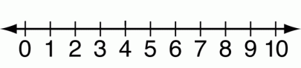

Watch this video for a reminder: https://youtu.be/P_ACet8m5-E

If you have chalk, you could make a giant number track outside (just like the one we have in school) for you to do the jumping and counting back. Upload a video of you doing this, we’d love to see it!

- ‘Zero the Hero’ - when subtracting 0 from any number, the number stays the same.
- ‘One for fun’ – when subtracting 1 from any number, all you need to do is think of the number BEFORE.
- ‘Two for you’ – when subtracting 2 from any number, just think of the number BEFORE then the number BEFORE that. It helps to whisper the number before but say the number before that out loud.
Remember: When taking away, you should always have less! That is, a smaller number. Unless, of course, you take away zero in which case, the number will stay the same.

Zero the Hero

9 - 0 = 3 - 0 =
1 - 0 = 7 - 0 =
6 - 0 = 4 - 0 =
8 - 0 = 5 - 0 =
2 - 0 = 0 - 0 =
10 - 0 =

One for fun

4 - 1 = 7 - 1 =
9 - 1 = 3 - 1 =
8 - 1 = 5 - 1 =
6 - 1 = 2 - 1 =
10 - 1 = 1 - 1 =
Two for you

10 - 2 = 7 - 2 =
9 - 2 = 3 - 2 =
8 - 2 = 5 - 2 =
6 - 2 = 4 - 2 =
2 - 2 =

Challenge
What happens when you take everything away?

10 - 10 = 3 - 3 =
7 - 7 = 5 - 5 =
8 - 8 = 9 - 9 =
4 - 4 = 6 - 6 =
2 - 2 = 1 - 1 =

Have fun, Math-magicians!

We can’t wait to hear how you get on!

