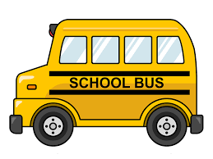
Recognising Nouns
Is it a thing?
Highlight it orange
Is it a person?
Is it a place?
Highlight it purple
Is it a person?
Highlight it yellow

Steven was getting ready for school. He brushed his teeth and ate his breakfast. He got his bag ready, put his jacket on and shouted “See you later!” to his mum as he headed out the door and walked to the bus stop.
Steven met his friends, Kevin and Jim, at the bus stop and they waited for the bus together. Kevin and Jim lived quite close to Steven. Jim stayed in a house in Green Street, Kevin lived in a flat on Sandy Road. They didn’t wait too long for the bus to come. When the bus came, they gave the bus driver their money and went to find a seat. There were lots of people on the bus- it was very busy!
Steven’s first class of the day was science. He liked science because his teacher, Miss Jackson, was very funny. At lunchtime, Steven went to the dinner hall to buy his lunch. He bought himself some pasta and an apple, and went to sit beside his friends.
After lunch, Steve, Kevin and Jim had art and then history. In history, they learned about William Wallace and about Scotland’s past.
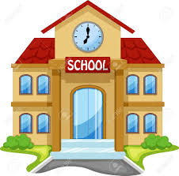
At home time, Steven and his friends walked to the bus stop to get home. They were all tired after their busy day!

