**Primary 1 Phonics** 

Monday 30th March - Friday 3rd April, 2020

Good morning, boys and girls! We hope you have had a lovely weekend with your family. We are so impressed with all your Home Learning!

This week, we thought it would be good to revise two of the sounds we learned previously. These are:

**sh** and **th** 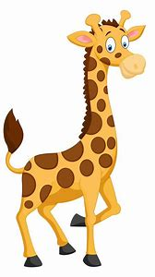

Remember, these are **digraphs**;two letters that come together to make just **one** new sound. We know how much you love **Geraldine Giraffe** so click on each of the links to see her looking for things featuring each of these sounds.

How many words can you think of?

**sh** **th**

**sheep thin**

**ship think**

**shop path**

**fish moth**

**Vowels 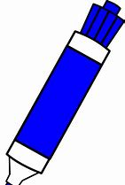Consonants  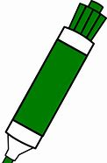Digraphs**

It would be super if you could colour-code each of the sounds when writing your ‘**sh**’ and ‘**th**’ words.

We can’t wait to see your learning! 😊

**Challenge:** Can you use each of the words in a sentence? Say

them out loud.

Can you write **one** of your sentences?

**Remember:**

* A CAPITAL letter at the beginning and for special names.
* Finger spaces!
* A full stop at the end**.**
* To check for sense!

Links for **Geraldine Giraffe**:

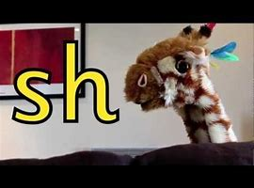<https://www.youtube.com/watch?v=nx2Tf9TE1bc>

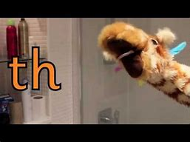<https://www.youtube.com/watch?v=6U354eD-hgQ>

**Just for fun!** 

You might want to try making your own giraffe puppet. 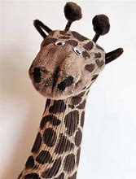

For a sock puppet, click on: <https://youtu.be/IL8uXeefyM4>

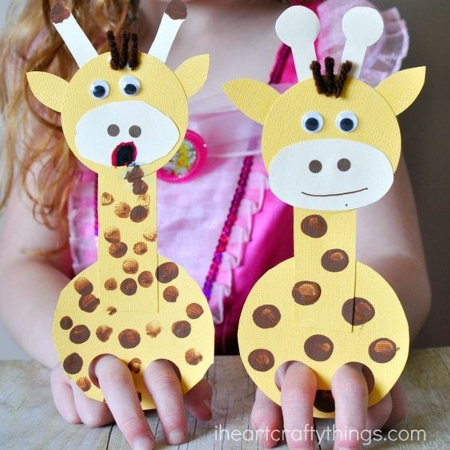

For a cardboard puppet, click on: <https://iheartcraftythings.com/giraffe-finger-puppet-craft.html>