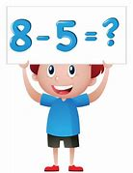
Primary 1 Numeracy
Monday 30th March - Friday 3rd April, 2020

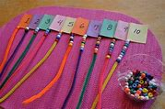
We hope you’ve enjoyed ‘taking away’ in everyday, real-life contexts. We are so impressed with just how creative you’ve been; for example, Max used pegs, pretending to be sharks eating lots of fish!

Did any of you make the subtraction beads?

Have you been using the flashcards? These will give you lots of practice.

Please continue to record your thinking using the correct mathematical symbols, for example:

7 - 4 =

Remember to say the number sentence out loud, for example:

7 take away 4 makes...

Or…

7 minus 4 equals...
This week we will be focusing on using a number line.
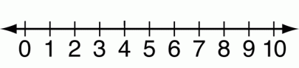
To do this, we need to count back.

This video will show you how:

https://youtu.be/P_ACet8m5-E

Practise doing this for the number sentences below:

9 - 5 = 4 - 2 = 6 - 5 = 7 - 3 =
10 - 2 = 8 - 5 = 5 - 1 = 3 - 3 =
2 - 1 = 9 - 6 = 7 - 5 = 8 - 0 =

Soon you will be able to do this mentally; that is, put the big number in your head and count back.

Remember: When taking away, you should always have less! That is, a smaller number.

Next week we will be thinking about other mental strategies.

Have fun, Math-magicians!
We can’t wait to hear how you get on!

