 | Monday | Tuesday | Wednesday | Thursday | Friday
morning | 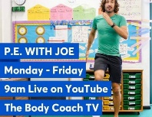  Joe Wicks – online fitness class  9:00 – 9:30
 | Handwriting & quick mental maths  Literacy  Spelling – new phoneme for the week (see P3 home letter for strategy ideas)  Writing  Talk4writing activity  See ‘teams’ for more details | Handwriting & quick mental maths  Literacy  Spelling – different strategy to practise your phoneme  Reading – non-fiction text | Handwriting & quick mental maths  Literacy  Spelling – write/type sentences with phonemes  Reading – read a book and retell in own words  Writing – Talk4writing activity See ‘teams’ for more details | Handwriting & quick mental maths  Literacy  Spelling x 4 – common words…  father head mother jump.  Reading – choose one of the Reading activities to complete with a book you are reading. | Handwriting & quick mental maths  Literacy  Secret spelling – ask someone to test you on this weeks words  Reading – make up 3 questions for your story for someone else to answer.
RELAX / SNACK
Mid morning | Numeracy  You tube songs for times tables  Skip counting 2,4,8,5,10  Play Multiply It! (See ‘Teams’ for game – if you don’t have a printer, this would be straight forward to make) | Numeracy  Skip counting 2,4,8,5,10  tables  Use your lego/counters to set out tables. Eg 2 towers of 5 = 2 x 5  Make a matching game with question to match an answer | Numeracy  Skip counting 2,4,8,5,10  tables  Sumdog – select times tables or complete challenge set | Numeracy  Skip counting 2,4,8,5,10  Write numbers lines for 2,4,8,5 and 10  Build up and make 2 and 4 times tables. You could use materials like lego bricks to help you. | Numeracy  Explore division using materials like lego bricks or figures.  Watch video -Year 2 sharing division  https://www.youtube.com/watch?v=h4S4rfMxnP8  Share given amounts into equal groups…  16 ÷4 = 8 ÷4 = 12 ÷4 =  And so on…
LUNCH
Afternoon | Science  Investigating magnets  See ‘Teams’ or home learning on school website for this. | Science  Investigating magnets  See ‘Teams’ or home learning on school website for this. | Art – Spring time  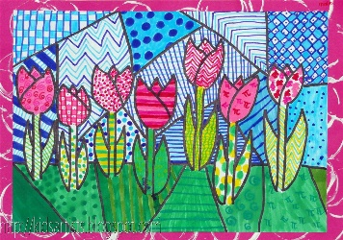  This would look great with pens, pencils or crayons. | Social Studies  See ‘teams’ for photos of our classroom.  Talk about the our Eqyptian topic using the photos to help you.  Share what you had been learning – and your favourite part with someone at home. | French  Watch French numbers videos 1-30 on youtube.  Recite numbers 1-30 in French.  Teach someone at home to have this conversation with you…  Comment Ca va? – How are you?  Tres Bien / pas mal / comme ci comme ca - Very good, not bad, ok  Et toi ? - And you ?
Team Primary 3 Mrs Messner Mrs Taylor

