Talk4Writing
Week beginning Monday 30 March 2020

Monday
Look very carefully at this picture.
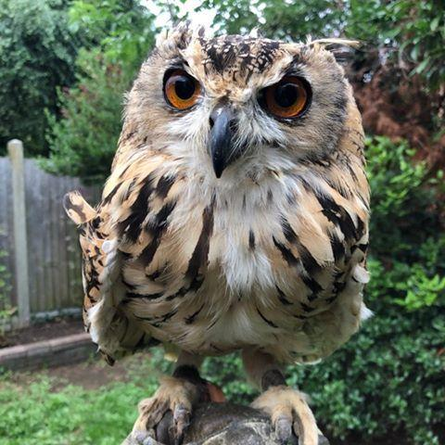

Copy the headings

eyes feathers beak

Under each heading write adjectives to describe each body part.
Also write what they remind you of, eg. eyes - like marbles

Wednesday
Look at the owl photo again.

Take your list of adjectives from Monday and use them to help you write some sentences about your owl.

You may wish to use this sentence to help you get started.

I slowly peered over the garden fence and there it was. Its……

Remember to check
- Capital letters and full stops
- Can you check any spellings you are unsure of?
- Does it make sense?
- If people haven’t seen the photo, would they be able to imagine it from your sentences?

