Magnets
This mini science project focuses on looking at:
- What happens when magnets are near each other?
- What are magnets attracted to?
- Can you design and make a game which has magnets?

Now this could be tricky. Do you have magnets in your house? Can you think where they might be? On a fridge door? As part of a game? Construction pieces? Train set?

If you are fortunate to find magnets, explore what they are attracted to. PLEASE DO NOT GO NEAR ELECTRICAL DEVICES!

Think about how you could share your findings. Here are a few ideas to help you.
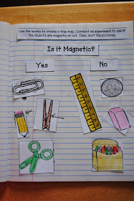
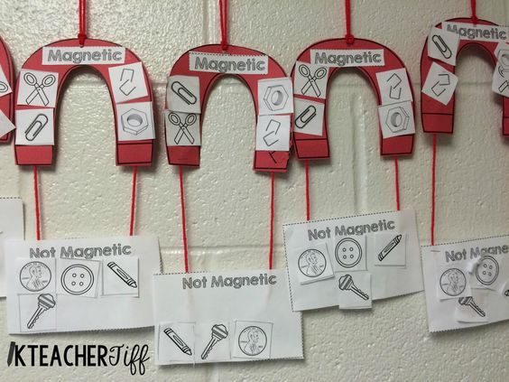

Magnet Power point – read and discuss
Have you tried putting two magnets together? In your own words, try to explain what is happening.
Draw a diagram of a magnet, label and describe what each part does.
Include these words in your work.
repel attract south north pole

Use the power point to help you get information if you do not have magnets. Or with help from an adult, have a look for your own information about magnets too.

Game design
Now that you have found out some information about magnets and how they work, your next task is to create a game which includes the use of a magnet. Now for some people you will not be able to make your game a reality at the moment, but do focus on the design.
- First of all think about your target audience – what age will your game be for? What kind of things is this age group interested in?
- Do you need to do some research?
- Brainstorm lots of ideas and then select your best one. Your last, wacky idea can sometimes be the best.
- Draw what your finished game would look like. (You may want to do a sketch, refine your ideas and then do a best copy.)
- Add labels to explain what things are. (Think about the labelled diagrams we looked at during our work on reading non-fiction texts.)
- You may need to include the rules required to play your game.

Here are some game ideas to get you thinking! When inventing, you can take an old idea and make it even better!

