SCIENCE PLAY: MAKE A HANGER BALANCE
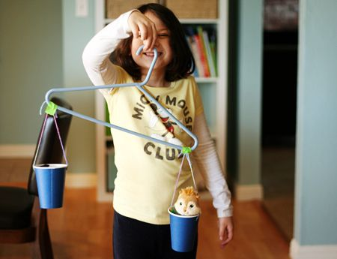

Materials:
- clothes hanger
- yarn or string
- paper or plastic cups (strawberry baskets work well, too)
- hole punch
- tape (optional)
You can see the simple assembly in the photo. Punch two holes in each cup, string with yarn, and tie to the hanger. Take turns holding the balance, or use a cabinet handle or door knob as a helper.
Once you have made your scales, you can have fun comparing the weight of different objects around the house.
You can also use Lego bricks to measure the weight of your objects. How many lego cubes does each object weigh?
Have fun !

