**Daily Activities – P3**

We thought we would list a few of the daily routines that the pupils are used to in class.

**9:00 – 09:30** - Handwriting common words and sentences - remembering correct letter formation, ascenders and descenders

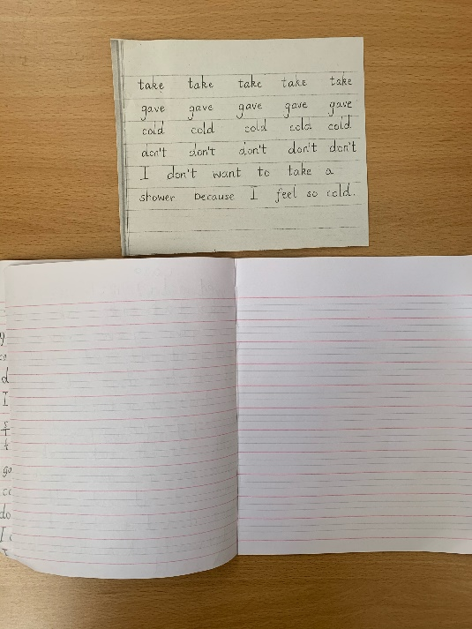

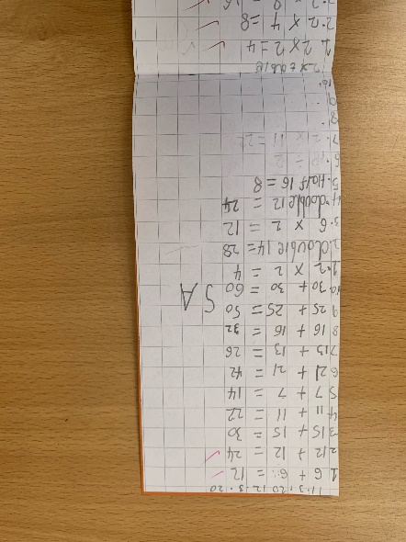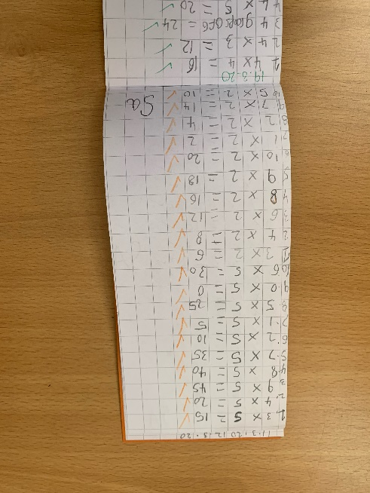Maths calculations – working on a selection of addition, subtraction, multiplication and division questions…

**9:30 – 10:30** Literacy Time

Pupils spend this time working on at least 3 literacy tasks

**10:45 – 11:00** Break

**11:00- 12:15** Maths

This time is usually committed to number and maths learning.

We always start with skip counting in 2,4,5,8 and 10s, then work on a selection of maths activities and written tasks

**12:30 – 1:15** Lunch

**1:15 – 1:30** Story time and Milk –teacher reads story while pupils relax, listen and drink their milk

**1:30 – 2:45** Interdisciplinary Learning

Sciences, topic work, art lessons