**Daily Activities**

We thought it might be useful to share some of the daily activities we do in class. The children **LOVE** these ☺

**Morning Jobs**

This typically follows the pattern described below:

* **Write a Sentence** – we give the children a sentence opener and encourage them to finish it. For example:

**Today I am feeling…because…**

Remember capital letters, finger spaces and full stops! ☺

* **Tricky Word** – the children write our word of the week.
* **Green Words** – the children sound-out then blend to read and write a selection of words made from our focus sounds.
* **Number Sentences** – the children practise addition and subtraction facts.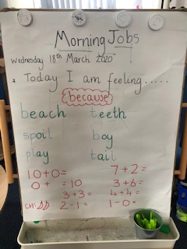

**Skills at Home**

Help around the house and practise the skills listed below:

* Make your bed every morning
* Set the table for meals
* Help to sort and organise the washing
* Keep your bedroom tidy
* Bake a cake
* Plant seeds and help in the garden ☺

We can’t wait to hear how you got on!

**Physical Exercise**

Try some of these websites to keep active at home:

* Cosmic Yoga
* Go Noodle
* Jump Start Johnny
* Zumba Kids
* Just Dance

**Social Skills**

Try playing some of these games at home:

* I spy…
* Charades
* Noughts and Crosses
* Jigsaws
* Snakes & Ladders
* Dominoes

Can you take turns? ☺

**Useful Websites**

* GLOW
* Sumdog
* Topmarks
* Forest Phonics
* ICT Games

Most importantly, enjoy spending time together as a family ☺