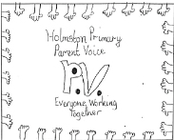
AGM
Tuesday 2nd October
7pm – 9pm
Staff Room, Holmston Primary School

Agenda
- Welcome and Notice of Meeting
- Apologies
- Constitution
- Election of Office Bearers
2018 / 19 – Chair
2018 / 19 – Vice Chair
2018/19 – Secretary
2018 / 19 – Treasurer
- Chair Persons Report
- Treasurers Report
- Head Teachers Report
- Adoption of AGM Action Log
- Halloween Disco – 26th October 2018
- Christmas Fair – Date tbc
- Future Events – Dates in diary …..
- AOCB
- Date of next meeting

