

**If you have any questions or comments please contact the   
 Community Learning and Development Team on:   
 CLD@south-ayrshire.gov.uk or 01292 559389***Here you can also find more about adult learning or services for preschool babies and children and their mums, dads and carers…….*

Ayr North Summer Holiday Calendar 2017

**Discounts** – Remember you can get discounts using your Young Scot Card throughout the Summer Holidays, T&C’s apply www.young.scot/discounts

**South Ayrshire Wide Programme**

For more details of Summer Camps, tennis, football and other activities go to:  
**Schools Out** - <http://www.south-ayrshire.gov.uk/school-holiday-activities/schools%20out.pdf>

**Young Scot** – <http://young>.scot/local-authorities/south-ayrshire/summer-programme

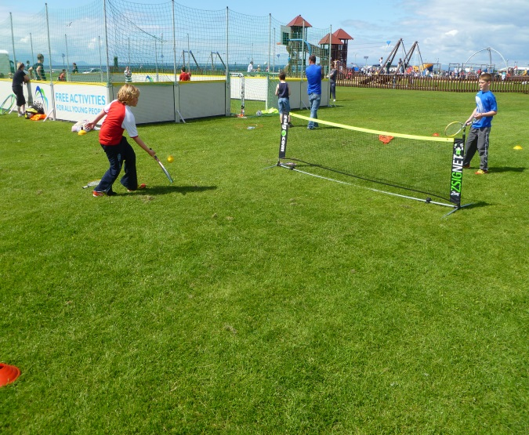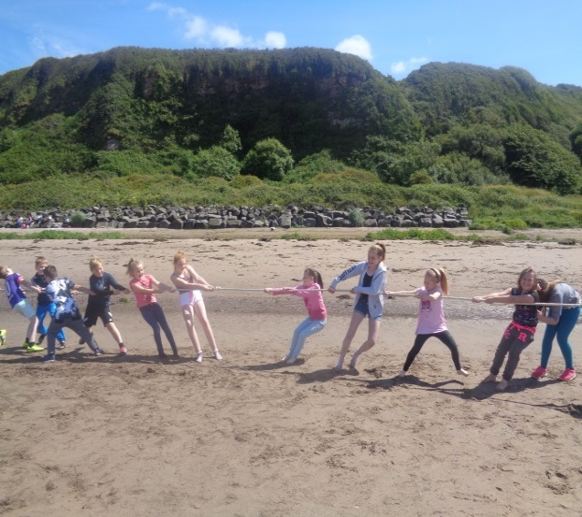

**Want to make a splash!**

Free swimming across all South Ayrshire Council pools all summer holidays, from 12pm-4pm and evenings.  Over 11’s bring your Young Scot Card.   
Check evening times and find out more at:   
http://www.south-ayrshire.gov.uk/leisure/swimming-pools/citadel/



Come along to the **Active Schools** FREE pop up sports sessions during the summer holidays. All activities will be published on our facebook and twitter pages, or call us on 01292 612868 for more information.

[www.twitter.com/activeschoolsSA](http://www.twitter.com/activeschoolsSA)

[www.facebook.com/activeschoolsSA](http://www.facebook.com/activeschoolsSA)

**Street Sports 2016**

**Tug of War 2016**



|  |  |
| --- | --- |
| **Venues** | |
| Braehead Primary School | Gouldstreet, Ayr, KA8 9PJ |
| Dalmilling Primary School | Harthall, Ayr, KA8 0PD |
| Domain Youth Centre | Glenmuir Place, Ayr, KA8 9RP |
| Lochside Community Centre | C:\Users\The Pumpers\AppData\Local\Microsoft\Windows\INetCache\IE\I9SAK15K\sonne-gelb[1].pngLochside Rd, Ayr KA8 9LH |
| Low Green | Esplanade- Near Children’s Play Area, KA7 1DR |
| Newton Primary School | Russell Drive, Ayr, KA8 8JL |
| Wallacetown Muga | Russell Drive, Ayr, KA8 8JL |
| Whitletts Activity Centre | Glenmuir Place, Ayr, KA8 9RW |

**Street Sports, swimming, trips, cooking, archery, youth clubs, sports activities and so much more…………..**

**Have fun & stay safe this summer!**



[](http://www.google.co.uk/url?sa=i&rct=j&q=&esrc=s&frm=1&source=images&cd=&cad=rja&uact=8&ved=0ahUKEwjiodH3443LAhVJnRoKHfv-CZ4QjRwIBw&url=http://www.south-ayrshire.gov.uk/youthforum/awards.aspx&psig=AFQjCNHkHoZ7uSNVPzTIia_nqlKDOg9tHg&ust=1456313170433817)





**For services with a *star*  
please contact your local youth club or CLD Officer to book a place. See contact details above.**

*Welcome to your summer holiday planner. There are lots of FREE activities on for children and young people 8 years and over.*

*For more information please see contact details over the page.*



| **Monday** | **Tuesday** | **Wednesday** | **Thursday** | **Friday** | **Saturday** |
| --- | --- | --- | --- | --- | --- |
|  |  |  | **29th June** | **30th June**  *STREET SPORTS 8 years above*  12:30pm - 3:30pm  Low Green | **1st July**  *GATEWAY GROUP*  (Young Adults with a disability)  1.00pm - 3.00pm  *STREET SPORTS 8 years above*  1.00pm – 4.00pm  Low Green |
| **3rd July**  *MULTI SPORTS FOR P1 – P7*  1.00pm – 3.00pm  Braehead Primary  *SENIOR YOUTH CLUB S1 - S6* 7.00pm - 9.00pm  Domain Youth Centre  *DRAMA GROUP*  6.30pm -8.30pm  Lochside Community Centre | **4th July**  *BIKE PROJECT*  2.30pm – 3.45 pm  Lochside Community Centre  *ACTIVITY GAMES Primary Age*  10am -11:30am  Braehead Primary  *DRAMA GROUP*  6.30-8.30pm  Lochside Community Centre | **5th July**  *MULTI SPORTS FOR P1 – P7*  1.00pm – 3.00pm  Newton Primary  *JUNIOR YOUTH GROUP P4-P7*  6.30pm -8.30pm  Domain Youth Centre  *DRAMA GROUP*  6.30pm -8.30pm  Lochside Community Centre | **6th July**  DRAMA GROUP  6.30 - 8.30pm  Lochside Community Centre | **7th July**  *STREET SPORTS 8 years above*  12:30pm - 3:30pm  Low Green  *MULTI SPORTS FOR P1 – P7*  1.00pm – 3.00pm  Dalmilling Primary | **8th July**  *GATEWAY GRO*UP  (Young Adults with a disability)  1.00pm - 3.00pm  Domain  *STREET SPORTS 8 years above*  1.00pm – 4.00pm  Low Green |
| **10th July**  *ACTIVITY GAMES Primary Age*  10:00am - 11:30am  Newton Primary  *MULTI SPORTS FOR P1 – P7*  1.00pm – 3.00pm  Braehead Primary  *ARCHERY S1+*  4.00pm - 6.00pm  John Pollock Centre  *SENIOR YOUTH CLUB S1 - S6* 7.00pm - 9.00pm  Domain Youth Centre | **11th July**  *ACE – PADDLE BOARDING S1+*  10.00am – 5.00pm  Meet at Domain YC *  *COOKING S1-S6*  1.30pm - 4.00pm  Domain Youth Centre *  *BIKE PROJECT*  2.30pm – 3.45 pm  Lochside Community Centre | **12th July**  *ACTIVITY GAMES Primary Age*  10:00am -11:30am  Braehead Primary  *BEACH SPORTS BBQ P4-P7*  10.00am – 4.30pm  Croy Shore  *MULTI SPORTS FOR P1 – P7*  1pm – 3pm  Newton Primary | **13th July**  *GOLF S1+*  1.30pm - 3.30pm  Meet at Domain YC *  *FISHING s1+*  5.00pm - 10.00pm  Meet at Domain YC * | **14th July**  *CYCLING AROUND CUMBRAE*  (Millport) S1+  10.00am - 5.00pm  Meet at Domain YC *  *STREET SPORTS 8 years above*  12:30pm - 3:30pm  Low Green  *MULTI SPORTS FOR P1 – P7*  1.00pm – 3.00pm  Dalmilling Primary | **15th July**  *GATEWAY GROUP*  (Young Adults with a disability)  1.00pm - 3.00pm  Domain  *STREET SPORTS 8 years above*  1.00pm – 4.00pm  Low Green |
| **17th July**  *ACTIVITY GAMES Primary Age*  10:00am -11:30am  Newton Primary  *MULTI SPORTS FOR P1 – P7*  1.00pm – 3.00pm  Braehead Primary  *SENIOR YOUTH CLUB S1 - S6* 7.00pm - 9.00pm  Domain Youth Centre | **18th July**  *ACE – GORGE WALKING S1+*  10.00am - 5.00pm  Meet at Domain YC *  *COOKING S1+*  1.30pm -4.00pm  Domain Youth Centre *  *BIKE PROJECT*  2.30 – 3.45 pm  Lochside Community Centre | **19th July**  *TRAMPOLINING AT RYZE S1+*  12noon - 4.00pm  Meet at Domain YC *  *ACTIVITY GAMES Primary Age*  12:30pm – 2:30pm  Dalmilling Primary  *MULTI – SPORTS FOR P1-P7*  1.00pm – 3.00pm  Newton Primary  *STREET SPORTS*  1.00pm – 4.00pm  Wallacetown Muga  *MOUNTAIN BIKING S1+*  5.00pm - 9.00pm  Meet at Domain YC *  *JUNIOR YOUTH GROUP FOR P4-P7*  6.30pm - 8.30pm  Domain Youth Centre | **20th July**  *9.30 am - P7’s TRANSITION GROUP HILLWALKING - 8*.00 pm* | **21st July**  *MULTI SPORTS FOR P1 – P7*  1.00pm – 3.00pm  Dalmilling Primary  *STREET SPORTS 8 years above*  12:30pm - 3:30pm  Low Green | **22nd July**  *GATEWAY GROUP*  (Young Adults with a disability)  1.00pm - 3.00pm  Domain  *STREET SPORTS 8 years above*  1.00pm – 4.00pm  Low Green |
| **24th July**  *ACTIVITY GAMES Primary Age*  10am – 11:30am  Newton Primary  MULTI SPORTS FOR P1 – P7  1.00pm – 3.00pm  Braehead Primary  *SENIOR YOUTH CLUB S1 – S6* 7.00pm - 9.00pm  Domain Youth Centre | **25th July**  *ACE - CANOEING S1+*  10am - 4.30pm  Meet at Domain YC *  *COOKINGS1+*  1.30pm - 4.00pm  Domain Youth Centre *  *BIKE PROJECT*  2.30pm – 3.45 pm  Lochside Community Centre | **26th July**  *ACTIVITY GAMES Primary Age*  12:30pm – 2:30pm  Braehead Primary  *TRAMPOLINING AT RYZE S1+*  12noon - 4.00pm  Meet at Domain YC *  *MULTI-SPORTS FOR P1-P7*  1.00pm – 3.00pm  Newton Primary  *STREET SPORTS*  1.00pm - 4.00pm  Wallacetown Muga  *MOUNTAIN BIKING S1+*  5.00pm - 9.00pm  Meet at Domain YC  *JUNIOR YOUTH GROUP P4-P7*  6.30-8.30pm  Domain Youth Centre | **27th July**  *INDOOR CLIMBING S1+*  1.00pm - 5.00pm  Meet at Domain YC *  *SKI-ING S1+*  6.00pm - 9.00pm  Meet at Domain YC * | **28th July**  *FARM PARK P4-P7*  1.00pm - 5.00pm  Meet at Domain YC *  *STREET SPORTS 8 years above*  12:30pm - 3:30pm  Low Green  *MULTI SPORTS FOR P1 – P7*  1.00pm – 3.00pm  Dalmilling Primary | **29th July**  *GATEWAY GROUP*  (Young Adults with a disability)  1.00pm - 3.00pm  Domain  *STREET SPORTS 8 years above*  1.00pm - 4.00pm  Low Green |
| **31st July**  *ACTIVITY GAMES Primary Age*  10am – 11:30am  Newton Primary  *MULTI SPORTS FOR P1 – P7*  1.00pm – 3.00pm  Braehead Primary  *ARCHERY S1+*  4.00 – 6.00pm  John Pollock Centre  *SENIOR YOUTH CLUB S1 – S6*  7.00pm - 9.00pm  Domain Youth Centre | **1st Aug**  *ACE – COASTEERING S1+*  10.00am - 5.00pm  Meet at Domain YC *  *COOKING S1+*  1.30pm - 4.00pm  Domain *Youth Centre \**  *BIKE* PROJECT  2.30pm – 3.45 pm  Lochside Community Centre | **2nd Aug**  *PLAYDAY AT KAY PARK P4-P7*  Kilmarnock  11.00am - 5.00pm  Meet at *Domain YC \**  *ACTIVITY* GAMES Primary Age  12:30pm – 2:30pm  Dalmilling Primary  *MULTI-SPORTS P1-P7*  1.00pm – 3.00pm  Newton Primary | **3rd Aug**  *GOLF S1+*  1.00p - 4.00pm  Meet at Domain YC*  *FISHING S1+*  5.00pm -10.00pm  Meet at Domain YC * | **4th Aug**  *SWIMMING & ICE SKATING S1+*  At Time Capsule  11.00am - 5.00pm  Meet at Domain YC *  *STREET SPORTS 8 years above*  12:30pm - 3:30pm  Low Green  *MULTI SPORTS FOR P1 – P7*  1.00pm – 3.00pm  Dalmilling Primary | **5th Aug**  *STREET SPORTS 8 years above*  1.00pm - 4.00pm  Low Green  *GATEWAY GROUP*  (Young Adults with a disability)  1.00pm - 3.00pm  Domain |
| **7th Aug**  *ACTIVITY GAMES Primary Age*  10am – 11:30am  Newton Primary  *MULTI SPORTS FOR P1 – P7*  1.00pm – 3.00pm  Braehead Primary  *SENIOR YOUTH CLUB S1 - S6* 7.00pm -9.00pm  Domain Youth Centre | **8th Aug**  *BIKE PROJECT*  2.30 – 3.45 pm  Lochside Community Centre | **9th Aug**  *ACTIVITY GAMES Primary Age*  12:30pm – 2:30pm  Braehead Primary  *MULTI SPORTS P1-P7*  1.00pm – 3.00pm  Newton Primary  *JUNIOR YOUTH GROUP P4 –P7*  6.30 - 8.30pm  Domain Youth Centre | **10th Aug** | **11th Aug**  *STREET SPORTS 8 years above*  12:30pm - 3:30pm  Low Green  *MULTI SPORTS FOR P1 – P7*  1.00pm – 3.00pm  Dalmilling Primary | **12th Aug**  *STREET SPORTS 8 years above*  1.00pm - 4.00pm  Low Green  *GATEWAY GROUP*  (Young Adults with a disability)  1.00pm - 3.00pm  Domain  *YOUTH BEATS S1+*  Youth Music Festival, Dumfries  P7-S6  2.00pm - 12.00midnight  Meet at Domain YC * |
| **14th Aug**  *SUMMER PARTY primary age*  1.00pm - 3.00pm  Newton Primary | **15th Aug**  *SUMMER PARTY Primary Age*  1.00pm - 3.00pm  Braehead Primary | **16th Aug**  *SUMMER PARTY Primary Age*  1.00pm - 3.00pm  Dalmilling Primary |  |  |  |



