**Standards and Quality Report 2022 - 2023**

**Heathfield Primary School and Early Years Centre**

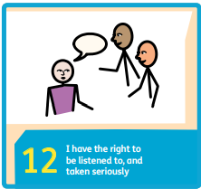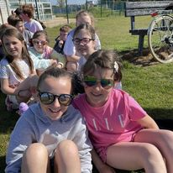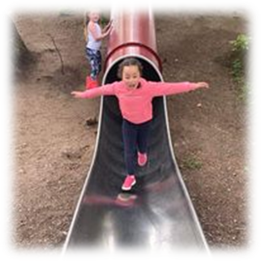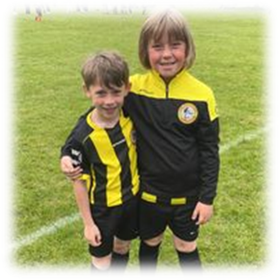

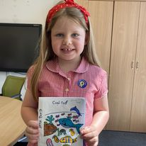

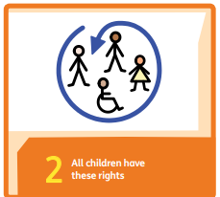

As a Rights Respecting School, we acknowledge the importance of Article 3 in all we do:

‘The best interests of the child must be a top priority in all actions concerning children.’

**Vision**

At Heathfield Primary and Early Years Centre we collaborate to provide an engaging curriculum for children to be successful learners, responsible citizens, confident individuals and effective contributors

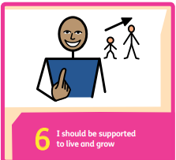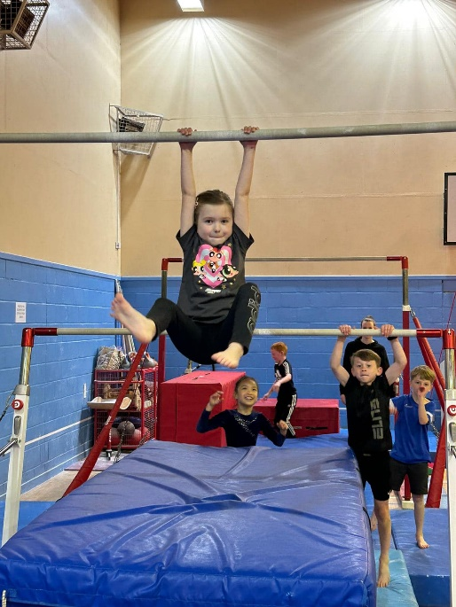

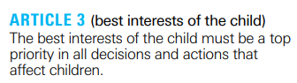

Ambitious Inclusive Supportive

**Aims**

We aim to:

• Promote high expectations

• Respect rights

• Provide a consistent and fair approach

• Meet all learners’ needs

• Champion physical, social, emotional and mental wellbeing for all

• Celebrate diversity and promote social justice

**Context of the School and Early Years Centre**

Heathfield Primary is a non-denominational school currently of 443 pupils serving the Heathfield area of Ayr. There is also an Early Years Centre running with 54 children accessing full day provision.

The Leadership Team comprises of the Head Teacher, two Depute Head Teachers and 1 FTE Principal Teacher, 0.6 FTE PT and 0.4FTE PT. In addition, we had one Principal Teacher paid through PEF. In 2022 – 2023 our teacher numbers were 25.7FTE. During this academic year both Depute Headteachers secured Headteacher posts and the acting PEF principal teacher secured a post as a Literacy Role within the Local Authority.

Currently, we have 75 children in receipt of free school meals and clothing grants identified through the FME process. This equates to 17% of our P1 - 7 population.

Attendance recorded in Term 3 2022 was 89.9% with 6.8% general absence and 3.3% absence attributed to COVID 19. The authority average for the same period was 88.6% with 8.3% general absence and 3.2% attributed to COVID 19. There have been no exclusions in the past academic year.

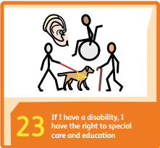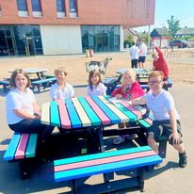

Pupils will develop efficacy in their learning journey through the Staged Intervention processes

Pupils;

* have opportunities to discuss their targets;
* have clear targets for specific needs with are measured by valid and reliable assessments;
* benefit from consistent approaches underpinned by wellbeing due to strong collaborative approach.

**School Improvement Priority 1**

**Meeting Learners Needs:**

To increase attainment through cohesive in systems, practices and pedagogy to ensure all learners’ needs are met.

To increase attainment through the definition of high-quality provision for meeting learners needs

In literacy pupils;

* needs are identified through rigorous tracking and data literate staff to ensure that accommodations, modifications and interventions are more appropriate to need;
* demonstrate increased engagement and participation in lessons as the learning, resources and environment are adapted to suit needs;
* are motivated, recognise and articulate the value of attending interventions and the impact on their own learning journey to maintain positive attitudes and ownership of the learning journey;
* needs are supported within class, within school and from a range of external agencies;
* benefit from strong home school partnerships through rigorous TAC system.

** Also see PEF evaluation for breakdown of interventions and impact

**Next Steps**

* To develop and embed new staffing structure to maintain high standard;
* To build consistent online systems to measure progress to streamline communication;
* To adapt new local authority paperwork and systems, so targets are pupils friendly.

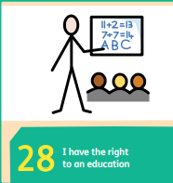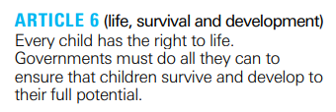

**Next steps**

* To build a writing portfolio to guide expectations, measure pace and progress and to ensure clear targets;
* To share learning with parents through new online platform;
* To embed South Ayrshire reads approach (see SIP 2023 – 2024)

**School Improvement Priority 2**

**LITERACY AND ENGLISH**

To raise attainment in writing through developing an engaging and rigorous curriculum based on approaches from Talk for Writing, Active Literacy and Play Based Learning (Primary 1 and 2 only).

Pupils:

* are more included due to the greater emphasis on listening and talking (oral approach);
* are achieving success through the emergent writing approach in Primary 1;
* have progress tracked and shared with parents;
* are exposed to a range of high-quality texts with greater consistency across all stages;
* have increased attainment and engagement in writing through improved skills and confidence.

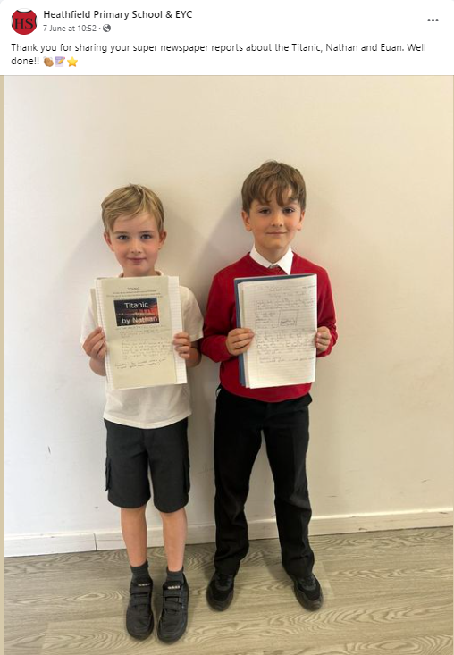

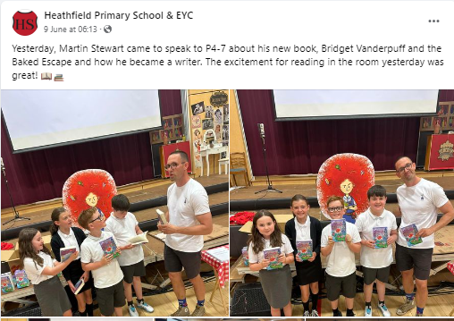

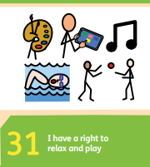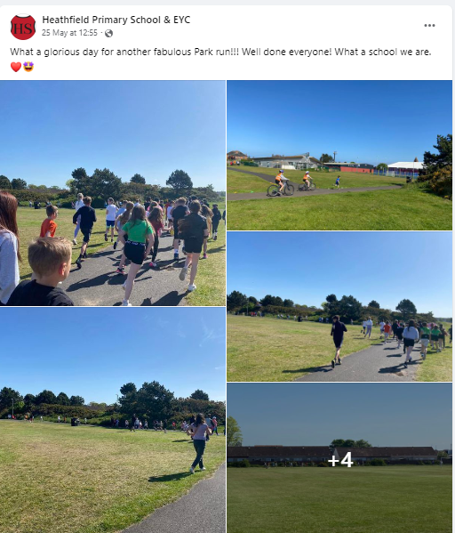

I am proud of team work and our progress made within planning.

Teacher August 2022

**Quality Indicator 1.3 Leadership of Change *Good***

* Developing a shared vision, values and aims relevant to the school and the community
* Strategic planning for continuous improvement
* Implementing improvement and change

Progress:

* High standards through quality learning and teaching. All pupils demonstrating progress and achievement.
* Rigorous data systems, particularly within Literacy and English, to identify pupils who are not demonstrating expected progress and implement appropriate.
* Well embedded Professional Development and Review (PDR and PRD) systems and regular attendance at quality training (T4W, Block Play, Leadership Development Programme).
* All staff demonstrate a commitment to educational values and have an awareness of social and economic context.
* Strong leadership at all levels to promote the vision which underpins continuous improvement with ongoing reflection and evaluation.
* Strong Leadership Team with shared vision and value, participating in rigorous and well-planned weekly meetings which include educational reading and research,
* Commitment to contribute to Local, Regional and National development groups (T4W, Mathematics, PBL, LDP 1 and 2)
* Quality time and space for staff to initiate well-informed change and collaborate to lead change and enhance practice (outdoor Learning, Pupil Council, Eco Schools, RRS, Anti Bullying)
* Regular opportunities and a range of approaches for self-evaluation, including the use of digital technologies.
* Quality dialogue and staff collaboration around creative learning and teaching approaches.
* The school visions, educational values and standards are shared with parents and the school community through social media and digital platforms.

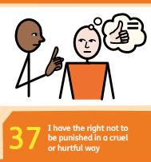

**Quality Indicator 2.3 Learning, Teaching and Assessment *Good***

* Learning and engagement
* Quality of teaching
* Effective use of assessment
* Planning tracking and monitoring

Progress:

* Commitment to the Rights of the Child, included in Citizenship, class lessons, weekly staff email and monthly parent newsletters. School received Silver Award in June 2023.
* Strong, welcoming and nurturing ethos underpinned by wellbeing and a commitment to positive relationships with staff, pupils, parents and wider community.
* Shared vision based on core values, shared during citizenship and the life and ethos of the school. Values adapted June 2023 in line with National Guidance. (All Learners in Scotland Matter: Our National Discussion).
* Almost all pupils are active participants and engaged in their learning and the majority of learners’ experiences are enjoyable, matched to their interests and needs.
* A range of learning environments are utilised to engage and challenge learners, e.g. outdoors (parks, playground, beach, local community) and local amenities (swimming pool, tennis club, gymnastics, park run) and educational visits (Dumfries House, Culzean, Belisle)
* Creative approaches to writing being developed through Talk 4 Writing, Interdisciplinary Learning approaches and Play Based Learning.
* Explanation and instructions are clear, staff use skilled questions to engage learners – observed during Peer Visits and staff dialogue.
* Curiosity is promoted through play in EYC and Primary 1 and through a blended play approach in Primary 2.
* Good use of SNSA, GL and Accelerated Reader data to provide a stimulus for Quality dialogue interrogating and moderating data within stages ensures all pupils are making progress.
* South Ayrshire frameworks used across the curriculums and guide medium term planning which is being developed and changes welcomed by staff.
* Positive feedback from parents after parent sessions and workshops including Numeracy and Mathematics, P1 and 7 information evening and Neurodivergent Think Tanks.

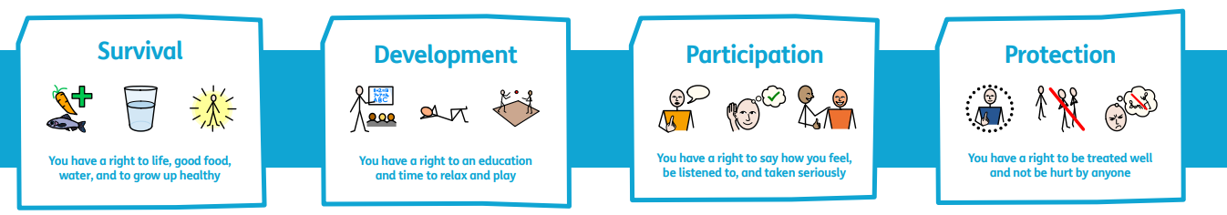

**3.1 Equality, Inclusion and wellbeing *Good***

* Wellbeing
* Fulfilment of statutory duties
* Inclusion and equality

Progress

* Whole stage participation in swimming (P3, 4 and 5), tennis centre (all), gymnastics (all), golf (P4 – 7), Park run (all)
* Wellbeing webs complete and discussed with pupils - this approach is being developed to a more efficient online form. 94% of pupils feel safe in school according to SAC wellbeing survey.
* Rigorous Team Around the Child approach with clear targets and effective partnership working. Over 70 pupils had TAC meetings, of this number 24 pupils’ families had a second TAC and 4 pupils had a third meeting.
* Pupil Council surveyed feelings for a Positive relationships Survey Review and found that the majority of children feel the school is welcoming and that they belong (85%) and that adults set high expectations on expected behaviour (87%). The Pupil Council then set targets for improvements and adaptations to our Positive Relationships Policy.
* Children in the EYC have access to the outdoor area at all times and there are opportunities for daily physical play and snack choices in EYC reflect current guidance and involve pupils, fresh water is available indoors and outside.
* All learners are included and supported in the life of the school through the wide range of events and participation, i.e. sports, clubs, local community walks and events, music festival, Scottish Poetry Event, etc
* 97% of parents reported that their child likes being at school and feels safe and 96% felt their child was treated fairly with respect.
* A range of religious and cultural festivals are celebrated throughout the year, i.e. Chinese New Year, Diwali, Holocaust Memorial Day.
* A greater number of resources and literature reflect the diversity within community as well as a commitment to a Cluster Woke Reading project
* A strong commitment to meeting learners needs through quality learning and teaching and a skilled and efficient Inclusion Team (see PEF evaluation for detailed breakdown of interventions and impact).
* The majority (59%) of pupils in Primary 7 and most (75%) pupils in primary 1 have no obvious tooth decay.

**3.2 Raising attainment and achievement G*ood***

* Attainment in literacy and numeracy
* Attainment over time
* Overall quality of learners' achievements
* Equity for all learners

Progress

* Accelerated Reading data is collated and analysed four times each year. Staff discuss standardised scores, reading ages and oral reading fluency and set targets based on the data. All stages demonstrated expected progress in average standardised scores with some showing accelerated progress, for example, Primary 3 made an increase of 12 standardised points and Primary 4 made an increase of 10.
* GL assessments for literacy and numeracy completed annually and data collated and analysed in comparison with AR data and used to support teacher judgements.
* ‘Cold’ and ‘hot’ writing pieces are assessed and progress is measured. Writing was moderated across the cluster to agree standards and explore a consistent assessment approach.
* Pupils have opportunities to perform during Scottish poetry competition, during class assemblies and through seasonal events, such as the fayres, McMillan Coffee Morning and whole school celebration assemblies.
* Staff are aware of the impact of poverty and the purpose of the of Pupil Equity Fund. They are aware of which pupils may be vulnerable to significant factors.
* In SNSAs, 96% of Primary 7 pupils score a band 7 or above in Reading and writing (74% Band 9+) and 96% in Numeracy. 93% of Primary 4 scored Band 5 and above in reading (75% Band 7+), 86% in writing and 91% in Numeracy. 97% of Primary 1 pupils scored a band 2 and above (85% Band 4+).
* Participation is sports is tracked and pupils are targeted and identified for specific activities. We have high participation in Active Schools events. We entered 14 sports festivals and 14 competitions with 17 Gold medals, 8 silver medals and 3 bronze medals.
* All children in the EYC have a personal care plan covering health, safety and welfare.

|  |  |  |  |  |  |
| --- | --- | --- | --- | --- | --- |
|  | ACEL data over time% | 20 - 21 | 21 - 22 | 22 - 23 | Progress |
| Literacy | P1 | 70 | 80 | 72 | +2 |
| P4 | 75 | 73 | 86 | +11 |
| P7 | 87 | 68 | 87 | 0 |
| P1, 4, 7 | 78 | 73 | 82 | +4 |
| Reading | P1 | 81 | 83 | 75 | -6 |
| P4 | 82 | 81 | 91 | +9 |
| P7 | 87 | 81 | 92 | +5 |
| P1, 4, 7 | 84 | 82 | 87 | +3 |
| Writing | P1 | 76 | 80 | 87 | +11 |
| P4 | 75 | 73 | 90 | +15 |
| P7 | 87 | 70 | 87 | 0 |
| P1, 4, 7 | 80 | 74 | 83 | +3 |
| Listening and Talking | P1 | 81 | 83 | 87 | +6 |
| P4 | 80 | 95 | 93 | +13 |
| P7 | 91 | 96 | 95 | +4 |
| P1, 4, 7 | 85 | 92 | 92 | +7 |
| Numeracy | P1 | 84 | 85 | 85 | +1 |
| P4 | 82 | 75 | 90 | +8 |
| P7 | 80 | 80 | 87 | +7 |
| P1, 4, 7 | 82 | 80 | 87 | +5 |



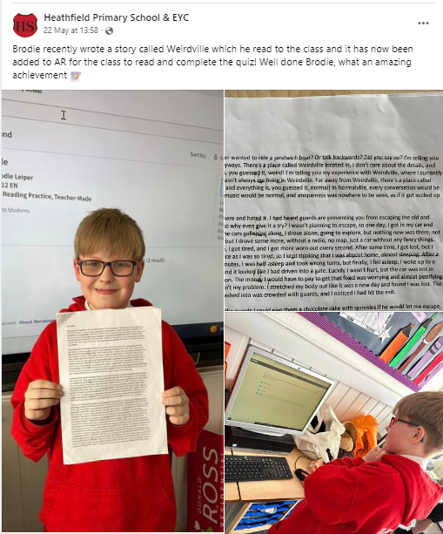

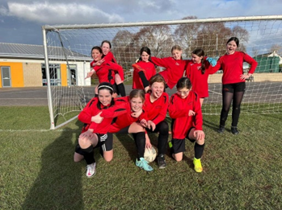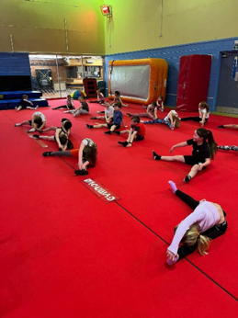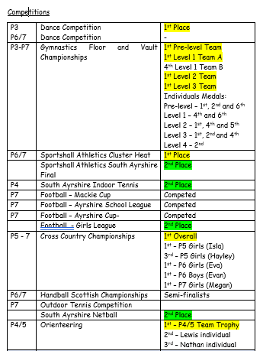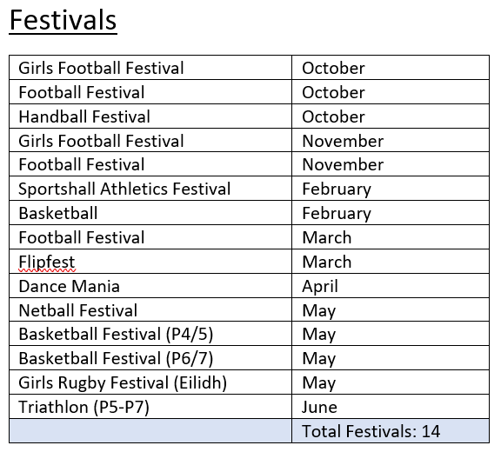

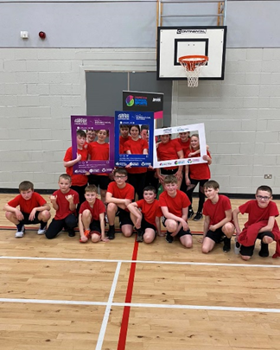

|  |  |  |  |  |
| --- | --- | --- | --- | --- |
|  | TAC x 1 | TAC x 2 | TAC x 3 |  |
| P1 | 5 | 8 | 1 | 14 |
| P2 | 2 | 6 | 1 | 9 |
| P3 | 11 | 5 |  | 16 |
| P4 | 8 | 2 |  | 10 |
| P5 | 7 | 1 |  | 8 |
| P6 | 7 | 2 |  | 9 |

Number of TAC meetings

