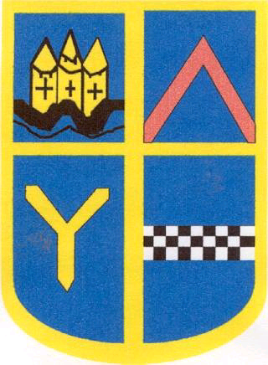

Ayr Grammar Primary
and
Early Years Centre

Safeguarding and Child Protection Policy
January 2022

Child Protection Coordinator – Alison Coxon, Depute Head Teacher
If unavailable please speak to Gail Gilbert, Head Teacher, or any member of the Senior Leadership Team

We at Ayr Grammar Primary and Early Years Centre believe that:
- Children and young people should never experience abuse of any kind
- We have a responsibility to promote the welfare and wellbeing of all children and young people, to keep them safe and to practise in a way that protects them
- All staff have an equal responsibility to act on any suspicion or disclosure that may suggest a child is at risk of harm
We recognise that:
- The welfare of children is paramount in all the work we do and in all the decisions we take and use GIRFEC practice and principles to guide us. Decisions must be based on the child or young person’s overall wellbeing – how safe, healthy, achieving, nurtured, active, respected, responsible and included they are – so that the right support can be offered at the right time
- Children and Young People have a right to expect that school staff will take any disclosure seriously
- We have an important role in teaching children about personal safety, giving them the skills, knowledge and understanding to keep themselves and their peers safe.
- All children, regardless of age, disability, gender reassignment, sex, sexual orientation, race, religion, or belief have an equal right to protection from all types of harm or abuse
- Some children are additionally vulnerable because of the impact of previous experiences, their level of dependency, communication needs or other issues
- Working in partnership with children, young people, their parents, carers and other agencies is essential in promoting young people’s welfare GIRFEC- Getting It Right For Every Child
- The child or young person – and their family – is at the centre of decision-making and the support available to them
- It is important to identify needs as early as possible early in order to avoid bigger concerns or problems developing.
United Nations Convention on the Rights of the Child
All children are protected under the United Nations Convention on the Rights of the Child. This document supports:
Article 2 -You have the right to protection against discrimination.
Article 3 - All adults should always do what is best for you.
Article 19 – You have the right to be protected from being hurt or badly.
Article 21 – You have the right to have the best care for you if you are adopted or living in care.
Article 23 – If you are disabled you have the right to special care and education to help you develop and lead a full life.
Article 33 – You have the right to be protected from dangerous drugs.
Article 34 – You have the right to be protected from sexual abuse.
Article 36 – You have the right to be protected from any exploitation.
Article 37 – You have the right not to be punished in a cruel or harmful way.
Article 39 – You have the right to help if you have been hurt, neglected or badly treated.
Definition of Child Abuse and Neglect from the National Guidance for Child Protection in Scotland, Scottish Government, 2021
‘Abuse and neglect are forms of maltreatment of a child. Somebody may abuse or neglect a child by inflicting, or by failing to act to prevent significant harm to the child. Children may be maltreated at home; within a family or peer network; in care placements; institutions or community settings; and in the online and digital environment. Those responsible may be previously unknown or familiar, or in positions of trust. They may be family members. Children may be harmed pre-birth, for instance by domestic abuse of a mother or through parental alcohol and drug use’
Types of Child Abuse

Sexual Abuse
Physical Abuse
Emotional Abuse
Neglect / Non - Organic Failure to Thrive
Domestic Abuse
Parental drug and/or alcohol misuse
Non - Engaging Families
Parental mental health problems
Child Sexual Exploitation
Children with disabilities
Female Genital Mutilation
Forced Marriage
Honour Based Violence
(This is not an exhaustive list)
Roles and Responsibilities of staff at Ayr Grammar Primary and Early Years Centre in relation to Child Protection
The Role and Responsibilities of All Staff Members:
• Keep up to date with any training requirements
Suspicion of abuse: If through conversation or contact with a child, a staff member has reason to suspect physical, sexual, or emotional abuse or neglect, they should do the following:
• Record the facts of any conversation in writing immediately afterwards using the exact words spoken not implied
• Not make assumptions about what the allegations might concern.
• If a member of staff is involved, appropriate steps must be taken to ensure the safety of the child and other children.
• Report the suspicion to the Child protection Coordinator immediately.
If a child discloses that they have been afraid in some way, the member of staff should:
• Observe Record Report
• Listen to what the child says. It is particularly important not to make any suggestions to the child regarding how the incident may have happened, therefore staff should not question the child, except to clarify what they are saying.
• Listen to what is being said without shock or disbelief
• Listen to what is being said but do not apportion blame
• Allow the child to talk freely-ask only open questions e.g. “Tell me more about.....” Do not press for detail, put forward your own ideas or use words that the child has not used themselves.
• Stay calm and reassuring
• Do not make promises that might be impossible to keep. Tell the child that you will have to tell someone else who will be able to help
• Stress that it was the right thing to tell
• Explain what has to be done next and who has to be told
• Pass the information to the Child protection coordinator without delay
• Record the facts of any conversation in writing immediately afterwards using the exact words spoken not implied
The Role and Responsibilities of the Child Protection Coordinator:
- Ensure that all staff and parents know who the Child Protection Coordinator is for our setting
- Ensure they are appropriately trained and keep knowledge up to date
- Act as source of support and expertise
- Keep written records of all concerns when noted and reported by staff, parents, community members or when disclosed by a child, ensuring that such records are stored securely and reported onward
- Ensure pastoral notes are relevant and up to date
- Refer cases of suspected neglect and/or abuse to social work or police in accordance with authority guidance and agree who will inform parents
- Check that all relevant agencies are informed, if referring, and complete the ‘Notification of Concern’
- Maintain positive working relationships with other agencies involved in child protection, such as social work and police, providing co-operation and assistance in interagency assessment
- Attend case discussions/child protection conferences
- Ensure that all staff receive appropriate training and understand their role in child protection
- Ensure all staff have read and understood this policy and know where to access further guidance if required
- Ensure that the policy is kept up to date

Information Sharing
Practitioners with child protection concerns may share relevant information in order to:
- Clarify if there is a risk of harm to a child
- Clarify the level of risk of harm to a child
- Safeguard a child at risk of harm
- Clarify if a child is being harmed
- Clarify the level of harm a child is experiencing
- Safeguard a child who is being harm

Contacts within South Ayrshire Council:
Social Work Initial Response Team - 01292 267675 or call 0800 328 7758 if out of hours.
Child Protection & Wellbeing Officer South Ayrshire Council Child Protection Officer – Jim Hendrie
01292 612719 07974 254272 Jim.Hendrie@south-ayrshire.gov.uk

Notification of Child Protection Concerns
Education.Secure@secure.south-ayrshire.gov.uk
and
InitialResponseTeam@south-ayrshire.gov.uk

Further Reading

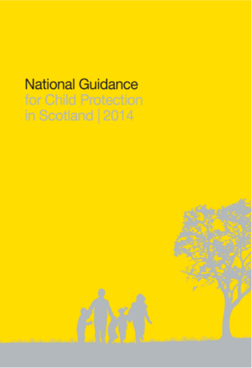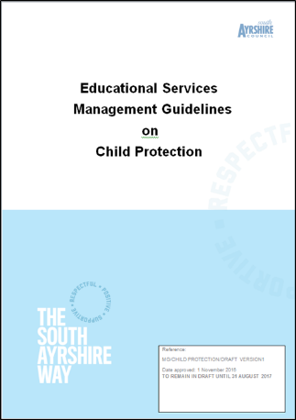

Useful Information and Websites
CPCs website - http://www.south-ayrshire.gov.uk/childprotection/
Barnardos - www.barnardos.org.uk (Child Sexual Exploitation material)
Female Genital Mutilation www.forwarduk.org.uk/key-issues/fgm
Shakti Women’s Aid is a Scottish based organisation which will provide information and advice to practitioners, 0131 475 2399, www.shaktiedinburgh.co.uk
Ayrshire GIRFEC website http://girfec-ayrshire.co.uk/
National Child Protection Guidance www.gov.scot/Resource/0045/00450733.pdf
National Risk Framework www.gov.scot/Resource/0040/00408604.pdf
Unicef – UN Rights of the child www.unicef.org/crc/

