Buzzbee’s news about P7
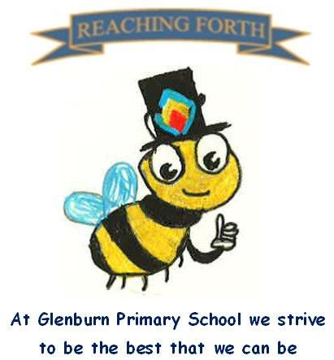

What are we learning this term?

Maths: Each Maths lesson begins with a mental maths activity. This term, we will focus on addition, subtraction, multiplication and division, including decimals, multiples, factors, prime numbers, estimating, number sequences, and simple expressions and equations. Children are encouraged to practise times tables and mental maths strategies regularly at home, as confidence with multiplication facts supports success across many areas of Maths.

Literacy: This term, both P7 classes will study The Boy in the Striped Pyjamas, linking closely with our World War II topic. Through the novel, pupils will develop reading comprehension, summarising, inference, and identifying key ideas.
Children will be encouraged to read for enjoyment every day, either from our school library or using books from home. Reading Olympics certificates will be awarded for successful comprehension quiz achievements. Daily phonics revision will support spelling and reading, and weekly writing lessons will focus on narrative, persuasive, and recount writing, often within the context of WWII.

Interdisciplinary Topic- World War II : Through this topic, pupils will learn about the Home Front, rationing, the Blitz, propaganda, Anne Frank and other significant events of World War II. They will also have opportunities to explore areas of personal interest through research and independent learning.

RME: Children will learn about pilgrimage, exploring important pilgrimage sites from major world faiths and understanding their significance to believers.

PE: Pupils will develop their teamwork and cooperation skills through a range of games, alongside learning rugby skills and completing Level 2 Bikeability later in the term.

Music: Music lessons will be taught by Mr Bentley on Wednesday mornings.

Things to remember:

Uniform – P7 pupils are expected to wear their black school sweatshirt with a white shirt or polo shirt, along with black trousers or a skirt. We kindly ask that leggings are not worn, as they are not part of the school uniform.

PE Kits – Children should change at school on PE days. Pupils should wear black shorts/leggings and a white T-shirt or polo shirt, along with gym shoes/trainers. Please ensure all PE kit is clearly labelled. No jewellery will be allowed to be worn during PE lessons. Earrings must be removed (not covered). We would suggest not wearing jewellery on PE days.

PE Days – P7S: Wednesday and Thursday
P7A: Wednesday and Friday.

Home Learning – Home learning will be issued on Mondays and should be returned by Thursdays. Due to Dolphin House, P7 home learning will not be issued until Monday 7 September.

Water bottles: Children are encouraged to bring a labelled water bottle to school each day. Please ensure that it contains water only.

Twitter/X – Follow our page, @glenburnprimary, for updates and news from the school.
Dates to Remember – Please refer to the school newsletter and the Dates for Your Diary section on the school website.

