Buzzbee’s News about P5
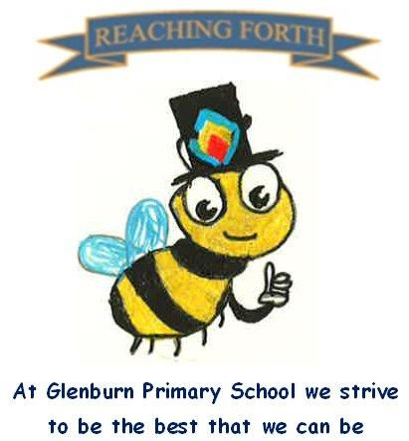

What are we learning this term?

Maths: Children will be covering a range of mental maths strategies at the beginning of every maths lesson, using the Samson maths programme. We will be extending our understanding of place value and focusing on addition, subtraction, multiplication and division calculations. We will also be learning about the properties of 2D and 3D shapes including their nets and investigating probability.

Literacy:
Writing: This term we will be focusing on recount, narrative and persuasive writing. These genres have clear links to our IDL topic of ‘Charlie and the Chocolate Factory’.
Reading: This term we are focusing on developing fluency and vocabulary through a range of fiction and non-fiction texts. We’re excited to explore Charlie and the Chocolate Factory together as we support children in becoming confident, fluent readers.
Spelling: We are beginning the Primary 5 SAR programme of spelling, focusing on phonics. Pupils are encoding and decoding words and creating their own word lists.

RME: This term we will be focussing on notable Christians and Saints with an emphasis on Nelson Mandela and the impact he had.

IDL: Our topic work this term will link in with our ‘Charlie and the Chocolate Factory’ novel.
We will be looking at the History of Chocolate, the journey of a cocoa bean and Fairtrade.

Things to remember:
Uniform and P.E. kit: Children are required to wear school uniform and appropriate P.E. kit at all times. Please name all uniform and kit.
NO jewellery at any time should be worn during a PE session and this includes earrings. South Ayrshire stipulates that:-
In South Ayrshire Council schools, all earrings and body piercing jewellery must be strictly removed for any Physical Education (PE) lessons or sporting activities. Thank you for your understanding.
Water bottles: Children are encouraged to drink water throughout the day. Please remember it should only be water and not diluting juice.
Our behaviour policy: As a Rights Respecting School, our behaviour policy focuses on our school values. Honesty, Respect, Responsibility, Friendship, Teamwork and Inclusion.

Other:
Homework– This is now issued on a Friday and returned on a Wednesday. Children are expected to take responsibility for their homework and ensure it is submitted to a high standard.

Children are encouraged to continue to practise times tables and other mental strategies at home as often as possible. Children could access Top Marks maths games to support them in this.

P.E. days-

P5C- Tuesday and Thursday

P5B- Tuesday and Friday

