Buzzbee’s news about P7
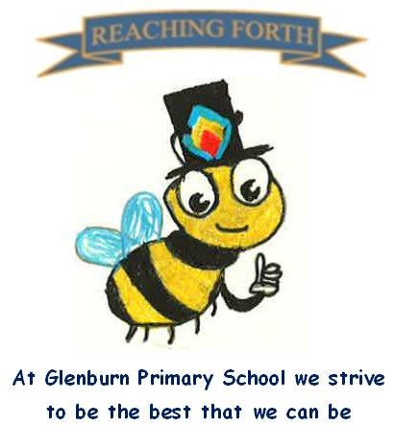

Term 4 - what are we learning this term?
Maths
We begin every maths lesson with mental maths, focusing on a range of skills where the pupils have the opportunity to explore different strategies and approaches. Children are also encouraged to practise mental maths at home, such as addition and multiplication facts. Useful apps/websites for this are Sumdog and Hit the Button. Upcoming topics will include angles, compass points, symmetry, area, perimeter and 3-figure bearings. This will be followed by revision of number concepts, including fractions, decimals and percentages and how to apply these skills in problem solving contexts.

Literacy
This term we will be reading a new class novel, ‘Goodnight Mister Tom’, by Michelle Magorian. Through reading this novel, the pupils will explore themes such as friendship, resilience, trauma and kindness. The novel will provide pupils with opportunities to explore characters in depth, develop empathy and engage with rich language and vocabulary. Pupils will continue to set weekly reading targets for their individual books which will be read at home.
Pupils are encouraged to read for pleasure and can take a book home from our school library.
Taught Writing lessons will continue to be once a week. This term, the writing styles we will focus on are narrative, personal and informative writing.

Inter-disciplinary learning topic:
Our science topic this term will be ‘Bio Systems: My Body’, where we will learn about the skeleton and circulatory, digestive and respiratory systems.
Pupils will study a range of artists and use these as inspiration to imitate and develop their own artwork.
In RME we will learn about different Creation Stories from the following religions: Christianity, Judaism, Hinduism, Islam and Sikhism, as well as the science perspective of biological and social evolution.
During Term 4, the children will work together to prepare and rehearse for their school show ‘Shrek’, as well as for their Leavers’ Assembly.

Things to remember:
Uniform – Children are expected to come in to school wearing either a shirt and Glenburn tie or a Glenburn polo shirt/jumper.

PE Kits – Children should change at school on PE days.
PE Days – P7M: Wednesday and Friday;
P7A: Tuesday and Wednesday.
Children are expected to wear black or navy shorts or leggings with a polo shirt or white t-shirt. Children are also expected to bring a pair of gym shoes/trainers for PE. Please label all PE kit items. This can be kept in class or brought in on the day.

Home Learning – Pupils will continue to work on their personal projects. These are due on Friday 22nd May. It is expected that pupils continue with their reading at home.

Water bottles: Children are reminded to bring in a water bottle. Please remember it should only be water and not diluting juice.

Twitter/X – Follow our page @glenburnprimary for updates.
Dates to Remember – please refer to school newsletter and “Dates for your Diary” on the website.

