Buzzbee’s News about P6
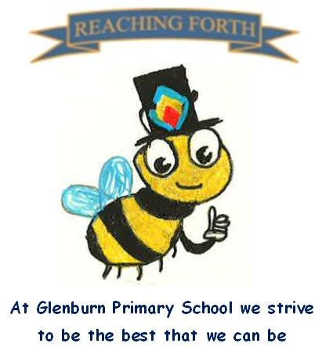

What are we learning this term?

Maths:
In Term 4, we will be learning about symmetry, function machines, measurement, volume, square numbers and will continue extending our understanding of place value, division and multiplication. The children will be covering a range of mental maths strategies at the beginning of every maths lesson. We will be continuing to work with our mental maths resource ‘SAMSON Maths’ which will reinforce number bonds and number facts. This will be taught at the beginning of maths lessons for 10-20mins.

Literacy:
This term we will be focusing on recount, poetry, and discursive writing.
We’re excited to be introducing literacy circles in class to help strengthen pupils’ reading skills. This approach encourages children to read carefully, fosters confidence, and use higher order thinking skills. We’re also continuing with our class novels, which highlight themes of racism and injustice!
We will continue to work on our encoding and decoding skills following the South Ayrshire Reads framework. We will also explore affixes, homophones, and prefixes respectively.

Inter-disciplinary learning topic:
Our topic this term is ‘Victorians’. As part of our Victorians topic, we’re looking forward to exploring a range of fun activities, including research tasks, creative tasks, and some role play to display our learning.

School trips- This term, we will visit Prestwick Aerosystems and Summerlee Museum, details to follow.






Things to remember:

Dates to Remember – please refer to the school newsletter for ‘dates for the diary.’
Home Learning – Homework will be issued on a Friday and collected on a Wednesday.

School Uniform: Children are required to wear school uniform, please ensure items are labelled to reduce clothes getting mixed up.
‘X’ (formerly) Twitter: Follow our page @glenburnprimary for updates
Water bottles:
Children are encouraged to drink water throughout the day. Please remember it should only be water and not diluting juice.

X (Twitter) – Follow our page @glenburnprimary for updates.

Other:
Children are encouraged to continue to practise times tables and other mental strategies at home as much as possible.

P.E
P6A – Tuesday and Thursday
P6N – Tuesday and Thursday
Please note, our focus this term will be field games and athletics.
In term 4, we try to take gym outdoors as much as possible. Please ensure your child has appropriate footwear.

