Buzzbee’s News about P5
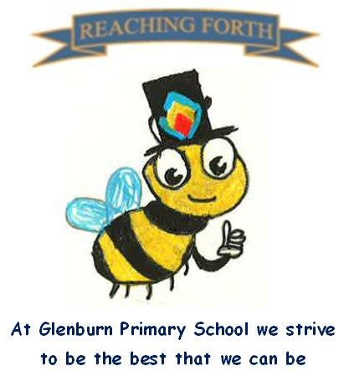

What are we learning this term?

Maths: Children will continue to cover a range of mental maths strategies and there will be a continued focus on Samson Maths mental strategies. This term we will be learning about time; including telling the time, looking at 12- and 24-hour time, am and pm and calculating durations. We will also be learning about angles and symmetry.

Literacy:
Writing: This term we will be focusing on narrative, personal writing and poetry. We will also be touching on other genres throughout the term as appropriate. Our writing will be linked to our Ancient Egypt IDL topic, where appropriate.
Reading: This term we will be focusing on developing pupils’ comprehension and reading skills through our class novel ‘The Boy at the back of the Class’. Pupils will also be following the Accelerated Reader programme in class. They will be choosing a book to read for enjoyment and will be given the opportunity to read every day in class. When finished a book, pupils will complete a comprehension quiz to demonstrate their understanding of what they have read.
Spelling:
We are continuing with the SAR programme of spelling, focusing on prefixes. Pupils are encoding and decoding words and creating their own word lists.

RME: This term we will be exploring the beliefs of Sikhism, focusing on the 5 Ks.

Interdisciplinary Learning: This term the class will be learning about Ancient Egypt. This term, we will be learning about Ancient Egypt and exploring different parts of this fascinating civilisation, including daily life, pharaohs, pyramids, gods and beliefs, and how people lived along the River Nile.
We will be taking our end of year class trip to the Science Centre in Glasgow to visit the Planetarium on Wednesday 28th May.

Things to remember:
P.E. days –
P5C: Monday and Wednesday
P5P: Monday and Wednesday
P5S: Wednesday and Thursday

Home Learning – Homework is given out on a Friday and is due in on the Wednesday of the following week. Pupils should keep their homework in their blue folder.

Uniform and P.E. kit: Children are required to wear school uniform. On P. E days pupils should bring a P.E. kit to change into. Earrings and other jewellery should not be worn for gym.
Water bottles: Children are encouraged to drink water throughout the day. Please remember it should only be water and not diluting juice. They will have the opportunity to refill their bottles in school.
Dates to Remember – Please refer to school newsletter and “Dates for your Diary” on the website.

